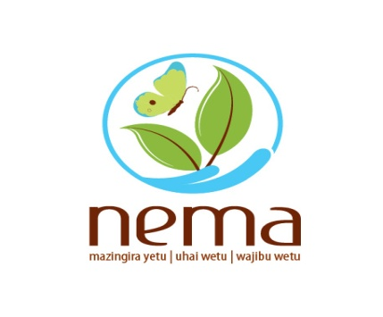

NATIONAL ENVIRONMENT MANAGEMENT AUTHORITY

The National Implementing Entity (NIE)

INCEPTION WORKSHOP GUIDANCE PACK
FOR
INTEGRATED PROGRAMME TO BUILD RESILIENCE TO CLIMATE CHANGE & ADAPTIVE CAPACITY OF VULNERABLE COMMUNITIES IN KENYA
April 2016

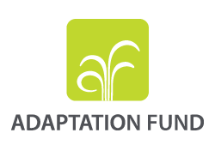
Inception workshop guidance notes
- Each EE is required to undertake an inception workshop as a first activity in the programme implementation.
- Inception workshops have been designed to ensure field level mobilisation of all relevant institutions and persons during take-off of implementation of the AF programme
- The budget for this workshop is provided for in the first quarter workplan disbursements.
- During these workshops, each EE is required to invite the County Commissioners office, County Government, NEMA County offices, all relevant line ministries, relevant CSOs, women groups, vulnerable group representatives, youth, and members of community representatives
- In this workshop, the EE-Sub EE is required to give a presentation on AF programme deliverables in that area, the specific target areas and the total programme budget for that project. Further, the participants should be taken through the Environmental and Social Policy of the Adaptation Fund, the Environmental and Social Management Framework, and the grievance redress mechanism of Kenya’s Adaptation Fund programme
- A discussion on formation of field level committee should be done, and where feasible, a list of nominated committee members generated.
- The representations of this committee must include a representative from the County Commissioners office, County Government, NEMA County offices, at least one representative from each of the following groups, CSOs, Women Groups, Vulnerable group representatives (e.g., PWDs, {Disabled}, Widows, The elderly, HIV), Youth, Community leader and members from relevant line ministries. The membership of this committee should not exceed 15 people.
- Each EE is requested to inform NIE their proposed dates for Inception in good time to allow NIE attend.
- The Inception Workshops should be held at place central to the Project area. County headquarters, Sub county headquarters are a preferred location for this activity.
- The chairman of the field implementation committee is NEMA’s County Director of Environment

