NEMA HOLDS THE FIRST KENYAN ADAPTATION FUND PROGRAMME STEERING COMMITTEE MEETING CHAIRED BY PRINCIPAL SECRETARY, CHARLES SUNKULI AT THE MINISTRY OF ENVIRONMENT HEADQUARTERS - 7TH MARCH 2017

The first Adaptation Fund National Programme Steering Committee (PSC) meeting, Chaired by Mr. Charles Sunkuli, Principal Secretary, Ministry of Environment and Natural Resources was held on 7th March 2017 at the Ministry Headquarters, NHIF Building. The Secretary to the PSC is Prof. G. Wahungu, Director General, NEMA. The PSC comprises the heads of the 11 executing entities and Transparency International.
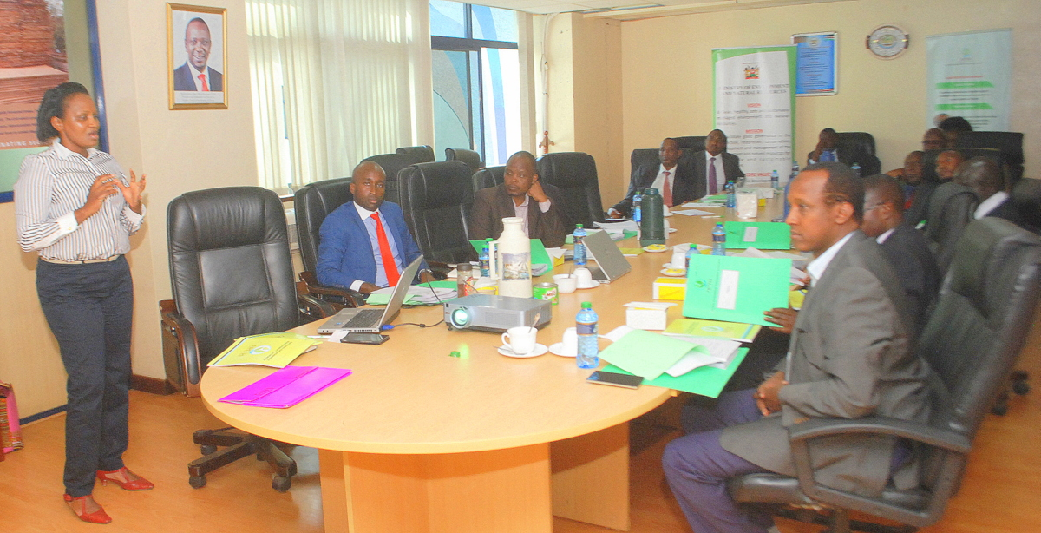
NIE Coordinator, Ms. Wangare Kirumba addressing participants during the meeting

The Adaptation Fund (AF) Kenya Programme Document establishes a Programme Steering Committee (PSC), whose role is to Oversight the Programme Implementation by a) Monitoring and ensuring coherence of the Adaptation Fund Programme implementation in Kenya, with national policies; b) providing national leadership in the Adaptation Fund Programme implementation process; c) receiving annual reports of the Adaptation Fund Programme implementation process and d) resolving national level conflicts of the AF Programme.
The National Environment Management Authority (NEMA) is the Adaptation Fund’s (AF) accredited National Implementing Entity (NIE) for Kenya. NEMA commenced implementing AF funded programme titled, ‘The integrated programme to build resilience to climate change & adaptive capacity of vulnerable communities in Kenya’ in 2016.

This programme is being implemented in 14 counties namely: Kilifi, Kwale, Taita Taveta, Moyale, Garissa, Wajir, Laikipia, Muranga, Kitui, Machakos, Makueni, Kajiado, Kisumu and Homa Bay. There are 11 government and non-governmental Executing Entities (EEs) and Sub-EEs implementing the Programme as follows: Kenya Forestry Research Institute (KEFRI) Coast Development Authority (CDA) and Tana & Athi Rivers Development Authority (TARDA), CARITAS Nyeri, Adventist Development and Relief Agency (ADRA) Kenya, NASARU Women Community Based Organization, Horn Aid (Kenya), Victoria Institute for Research on Environment and Development (VIRED) International, Kenya Redcross, Kenyatta University (KU) and World Vision (Kenya).

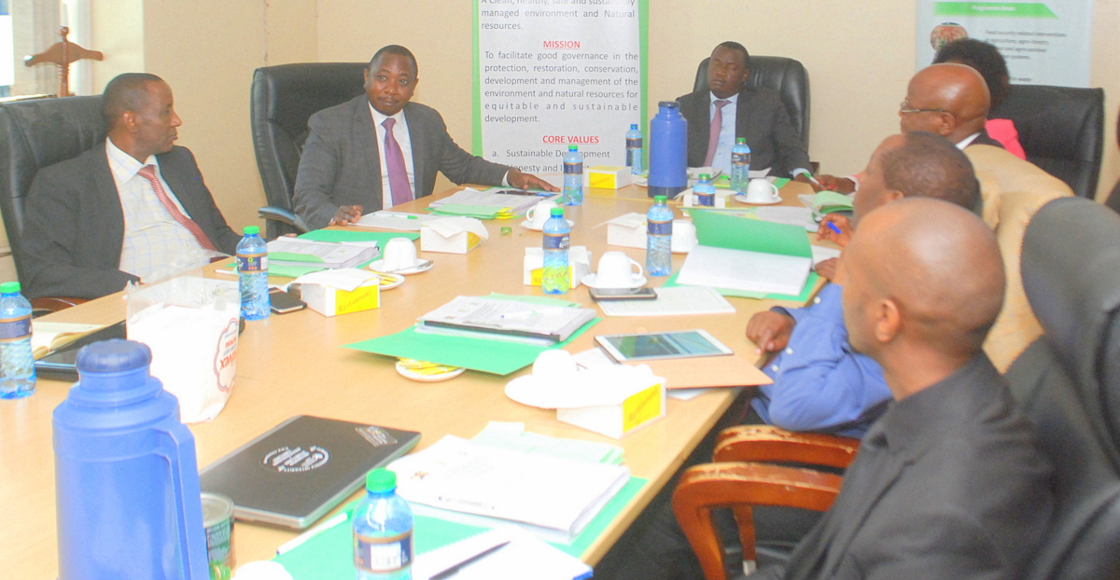
The high level participants meeting

During the meeting, members adopted the Programme Document and Contracts signed by EEs and Sub-EEs which bind them to execute what NEMA has also signed for with Adaptation Fund Board. The meeting also adopted the NIE Finance and Procurement Manual, Environment and Social Policy of the Fund, NIE Environmental and Social Management Framework, Governance of the Adaptation Fund Programme and the Grievance Redress Mechanism. The members agreed that future only one representative from Sub-EEs will attend the PSC meeting but on rotational basis. The EEs were asked to have meetings with their Sub-EEs to resolve conflicts and if the Sub-EEs is still aggrieved, then refer them to NEMA. The Principal Secretary Inaugurated the National Programme Steering Committee as agreed during the meeting.

The meeting also adopted the proposed Field Implementation Committee and its terms of reference. In future, work plans for the field visits shall be shared in advance to the EEs and Sub-EEs for smooth running of the programme.

