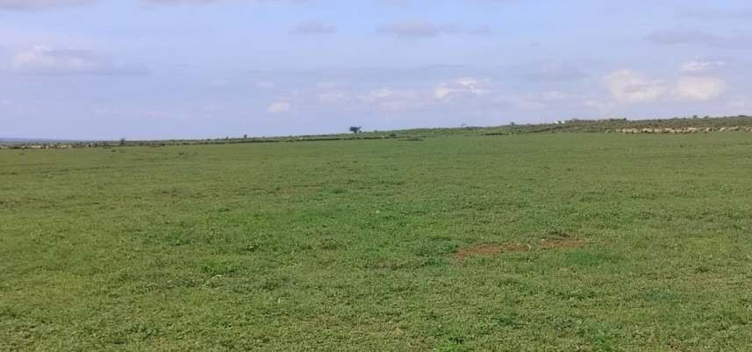
ENVIRONMENTAL IMPACT ASSESSMENT
STUDY REPORT
FOR THE
PROPOSED UMOJA SOLAR POWER PLANT ON LR NO 3250 IN
LAIKIPIA WEST SUB-COUNTY, LAIKIPIA COUNTY

GPS COORDINATES: Lat 0.2383096°, Long 36.6048706°

Proponent

Submitted to
UNIT 2HA INVESTMENT ENERGY
AFRICA LIMITED
First Floor, West Wing, Vienna Court, State
House Crescent Road, Nairobi
P.O.Box.53291-00100
Nairobi

NATIONAL ENVIRONMENT MANAGEMENT
AUTHORITY
NEMA Block, County Commissioners’ Compound

P. O. Box 679- 10400, Nanyuki
Laikipia County
E :
laikipia@nema.go.ke

JANUARY 2024

CERTIFICATION

LEAD EIA EXPERT
This Environmental Impact Assessment Comprehensive Project Report for Proposed Umoja Solar Power Plant has been prepared in accordance to the Environmental Management and Coordination Act, Cap 387 and the Environmental Impact Assessment and Audit Regulations, 2003 and their respective amendments. The information contained in this report was obtained from primary and secondary sources.


Name:

WILLIAM MUTAHI

Signature:

Date: 23RD JANUARY 2024

PROPONENT - UNIT 2HA INVESTMENT ENERGY AFRICA LIMITED
I hereby confirm that the contents of this Environmental Impact Assessment Comprehensive Project Report for Proposed Umoja Solar Power Plant are true to the best of my knowledge and undertake to implement the mitigation measures proposed in this report or any other instructions NEMA may deem appropriate in relation to the findings and as inspections may inform from time to time.

Name: HARUN AYDIN


Designation:

DIRECTOR/ROPONENT

Signature:

Date:

22
ND
JANUARY 2024

EXECUTIVE SUMMARY

Overview
This report details the findings of an Environmental Impact Assessment for the proposed Umoja Solar Power Plant on LR NO 3250 in Laikipia County. This Comprehensive Project Report has been prepared in accordance with the Environmental Management and Coordination Act, Cap 387, Environmental Impact Assessment and Audit Regulations of 2003 and their respective amendments.
UNIT 2HA Investment Energy Africa commissioned the Registered EIA experts to undertake an Environmental Impact Assessment and prepare a comprehensive project report for submission to National Environment Management Authority. The report addresses mitigation options for any potential impact and residual effects relevant to operational activities of the proposed projects, which would assist the Authority in making a decision regarding the project.

Nature of the proposed project
The proponent intends to develop a 50MW solar plant on 3,000 acres of land to the East of Pesi River. The land has a potential to accommodate a 600MW solar power plant /farm. The project is listed as a Medium Risk Project ((8) Power and infrastructure projects, including-(f) solar power farms or plants); thus, requiring the proponent to submit a Comprehensive Project Report. The proposed project will mainly comprise of the solar yard hosting solar modules/ panels and transmission infrastructure, offices, stores, staff housing and security infrastructure.
The project is estimated to cost KES. 155,474,085 as per the Bill of Quantities. The NEMA submission fee amounts to KES. 155474 as 0.1% of the project cost.

Location of the proposed project
The proposed project site is located approximately 10Km from Rumuruti Municipality off the Rumuruti – Nanyuki Road. The parcel was part of the Lombala Ranch, a privately-owned cattle ranch. It borders Thome settlement to the north, Ngorare ranch to the east and Bhora Farm to the south. The site is denoted by GPS Coordinates 37 N 233406.00 m E 26363.00 m N (Lat 0.2383096°, Long 36.6048706°) at 1849masl. Administratively, the site falls within Thome Sublocation of Salama Ward, Laikipia West Sub-County.
The land has over the years been under ranching. The owner also allowed for movement and existence of wildlife owing to the presence of wildlife-friendly land uses in the vicinity. A number of small-scale irrigation activities emerged along the Pesi River, which forms the western boundary of the project site. There are two high voltage electricity transmission line traversing the land; 400kv and 220kv, running from Rumuruti substation to Nanyuki.

Project Alternatives
Alternatives analysis is designed to bring environmental, economic and social considerations into the “up-stream” stages of development planning-project identification and earlier-as well as the later stages of site selection, design and implementation. Three options were considered in the analysis, namely, “No Project” Alternative, Alternative Location, and Alternative Land Uses. The analysis of determined that the proposed project remains the most suitable alternative in the prevailing and future circumstances.

Potential impacts and mitigation Measures
The analysis of impacts was based on the main project phases namely planning and design, construction, operations and decommissioning. The analysis and evaluation of potential impacts was undertaken through stakeholder consultations, a standard checklist and matrix. The identified impacts were then subjected to a criterion that was used to determine their characteristics and significance.
Some of the anticipated positive impacts will include:
- Direct and indirect employment opportunities, which will contribute to transfer of knowledge and skills and building of on-the-job skills for the locals.
- Contribute to low-carbon and affordable power generation and supply in the country.
- Replication of similar projects in the county, hence increased development and socio-economic profile of the county.
- Social development in the immediate vicinity and the county at large through Corporate Social Responsibility (CSR).
- There is a potential for the project to spur development in the neighbouring Thome and Matigari settlements as well as Rumuruti Municipality.
Environmental concerns that are associated with this project implementation with potentially negative impacts were established and included:
- Visual intrusion including effects of glint and glare from solar reflection
- Possible disruption of wildlife movement and attacks on staff
- Poor relationship and misunderstanding with the community due to loss of informal grazing areas and land for small scale irrigation.
- Occupational health and safety risks at the various work stations
This EIA report has recommended feasible mitigation measures contained in the Environmental Management and Monitoring Plan to avoid, reduce and eliminate these adverse impacts.

Conclusion and Recommendations
On the basis of the results of this EIA, it is apparent that, with the adoption and implementation of the Environmental Management and Monitoring Plan, the adverse impacts will be adequately mitigated against. In addition, foreseeable potential impacts will be forestalled before they occur thereby considerably limiting future environmental damage and ensuring the existence of a clean and healthy environment. Accordingly, as per Section 58 (1) and (2) of the Environmental Management and Coordination Act,1999 and Environmental Management and Coordination (Amendment) Act, 2015, we recommend that the proposed project be implemented and we recommend that Unit 2HA Investment Energy Africa Ltd. be issued with an Environmental Impact Assessment License for the Proposed Umoja Solar Power Plant in Laikipia County.

Table of Contents

- INTRODUCTION ............................................................................................................................ 1
  - Background ............................................................................................................................. 1
  - Project proponent .................................................................................................................... 1
  - Specific Objectives of the EIA ................................................................................................. 1
  - Terms of Reference ................................................................................................................ 2
  - EIA Process ............................................................................................................................. 2
    - Screening ........................................................................................................................ 2
    - Scoping ........................................................................................................................... 2
    - Analysis of Potential Impacts and identification of mitigation measures ......................... 3
    - Analysis of Alternatives ................................................................................................... 3
    - Preparation of an Environmental Management and Monitoring Plan ............................. 3
  - EIA Approach .......................................................................................................................... 3
    - Desk Study ...................................................................................................................... 3
    - Site Visit/On-site Validation ............................................................................................. 3
    - Stakeholder Consultations .............................................................................................. 3
  - Expected Outputs .................................................................................................................... 4
  - Study Team ............................................................................................................................. 4
- REVIEW OF RELEVANT POLICY AND LEGAL FRAMEWORK ................................................... 5
  - Introduction .............................................................................................................................. 5
  - Policy Framework .................................................................................................................... 5
    - National Environment Action Plan (NEAP) ..................................................................... 5
    - National Environmental Policy, 2013 .............................................................................. 5
    - National Energy Policy, 2018 .......................................................................................... 6
    - The 2021 FiT Policy ........................................................................................................ 6
    - Renewable Energy Auctions Policy, 2021 ...................................................................... 6
    - National Land Policy, 2009 ............................................................................................. 6
    - Kenya Vision 2030 .......................................................................................................... 7
    - Least Cost Power Generation Expansion Plan (2021-2030) .......................................... 7
  - National legislation .................................................................................................................. 7
    - The Constitution of Kenya (2010) ................................................................................... 7
    - Environmental Management & Coordination Act (EMCA), Cap 387 .............................. 7
    - The Energy Act, 2019 ..................................................................................................... 8
    - Climate Change Act, 2016 .............................................................................................. 8
    - Occupational Safety and Health Act, 2007 ..................................................................... 8
    - National Construction Authority Act, 2011 ...................................................................... 9
    - Wildlife Conservation and Management Act, 2013 ......................................................... 9
    - Public Health Act, Cap. 242 ............................................................................................ 9
    - Physical and Land Use Planning Act, 2019 .................................................................... 9
    - The Traffic Act, 2012 ..................................................................................................... 10
  - Regulatory framework ........................................................................................................... 10
    - Environmental (Impact Assessment and Audit), Regulations, 2003 and Environmental
(Impact Assessment and Audit), (Amendment)Regulations, 2019 .............................................. 10
    - Water Resources Regulations, 2021 ............................................................................ 10
    - Environmental Management and Coordination (Water Quality Regulations), 2006 ..... 11
    - Environmental Management and Coordination (Waste Management) Regulations,
2006 11
    - Environmental Management and Coordination (Noise and Excessive Vibration, and
Pollution Control) Regulations, 2008 ............................................................................................ 11
    - Energy (solar photovoltaic systems) Regulations, 2012 ............................................... 11
  - Relevant institutions .............................................................................................................. 12
  - International Conventions and Treaties ................................................................................ 12
- DESCRIPTION OF THE PROPOSED PROJECT ....................................................................... 13
  - Background to solar power in Kenya .................................................................................... 13
  - Project Background ............................................................................................................... 13
  - Project Design ....................................................................................................................... 14
    - Solar Yard ..................................................................................................................... 15
    - Monitoring System......................................................................................................... 16
    - Surveillance and security system .................................................................................. 16
    - Office and Staff Quarters area ...................................................................................... 16
  - Project Inputs ........................................................................................................................ 17
    - Construction Materials .................................................................................................. 17
    - Labour ........................................................................................................................... 17
    - Waste Management ...................................................................................................... 17
    - Energy ........................................................................................................................... 18
    - Water ............................................................................................................................. 18
  - Project phases and activities ................................................................................................. 18
  - Project cost ............................................................................................................................ 19
- BASELINE INFORMATION OF THE PROJECT AREA ............................................................... 20
  - Project Location..................................................................................................................... 20
  - Biophysical Baseline Conditions ........................................................................................... 20
    - Climate .......................................................................................................................... 20
    - Topography ................................................................................................................... 22
    - Geology ......................................................................................................................... 23 4.2.4 Soils ............................................................................................................................... 23
    - Hydrogeology ................................................................................................................ 23
    - Hydrology ...................................................................................................................... 24
    - Flora .............................................................................................................................. 24
    - Fauna ............................................................................................................................ 24
  - Social Economic Setting ....................................................................................................... 25
    - Land tenure and use ..................................................................................................... 25
    - Demographics ............................................................................................................... 25
- STAKEHOLDER CONSULTATION ............................................................................................. 27
  - Introduction ............................................................................................................................ 27
  - Impacts identified by stakeholders ........................................................................................ 27
    - Positive impacts ............................................................................................................ 27
    - Negative impacts and mitigation measures .................................................................. 27
- POTENTIAL IMPACTS AND THEIR MITIGATION MEASURES ................................................ 29
  - Impact Identification .............................................................................................................. 29 6.2 Impact Prediction .................................................................................................................. 29 6.3 Types of Impacts ................................................................................................................... 29
  - Significance of impacts ......................................................................................................... 30
  - Results of the Impacts Analysis ............................................................................................ 30
    - Positive impacts ............................................................................................................ 30
    - Negative impacts ........................................................................................................... 31
6.6 Climate change assessment ................................................................................................. 35
    - Climate change risk assessment .................................................................................. 35
    - Climate change vulnerability assessment ..................................................................... 35
    - Results of the assessment ............................................................................................ 35
- ANALYSIS OF ALTERNATIVES .................................................................................................. 37
  - Introduction ............................................................................................................................ 37
  - Assessment and Evaluation of Alternatives .......................................................................... 37
    - “No Project” Alternative ................................................................................................. 37
    - Alternative Location ....................................................................................................... 38
    - Alternative Land Use ..................................................................................................... 38
  - Results of the Analysis .......................................................................................................... 39
- ENVIRONMENTAL MANAGEMENT AND MONITORING PLAN ................................................ 40
  - Overview ............................................................................................................................... 40
  - Monitoring approach ............................................................................................................. 40
  - Grievance Redress Management Plan ................................................................................. 47
- DECOMMISSIONING PHASE ..................................................................................................... 48
  - Overview ............................................................................................................................... 48
  - Rationale for decommissioning ............................................................................................. 48
  - Anticipated activities .............................................................................................................. 48
- CONCLUSIONS AND RECOMMENDATIONS ............................................................................ 49
  - Conclusion ............................................................................................................................. 49
  - Recommendations ................................................................................................................ 49 REFERENCES ...................................................................................................................................... 50

ANNEXES
Appendix A: Stakeholder Consultation Documents
Appendix B: Proponent’s Registration Documents
Appendix C: Land Ownership Documents Appendix D: Bill of Quantities
Appendix F: Project Designs
Appendix F: Expert Practising License

List of Tables, Figures and Photos

Table 1: Summary of project phases and activities .............................................................................. 18 Table 2: Annual Rainfall for Rumuruti Station ....................................................................................... 21
Table 3: Population of the project area ................................................................................................. 26
Table 4: Potential negative impacts during construction phase ............................................................ 32
Table 5: Potential negative impacts during operations phase .............................................................. 33
Table 6: Climate change risks ............................................................................................................... 36
Table 7: Environmental Management and Monitoring Plan for the proposed project........................... 41

Figure 1: General operations of a solar PV power plant ....................................................................... 15
Figure 2: General site layout ................................................................................................................. 17 Figure 3: Proposed project location ...................................................................................................... 20
Figure 4: Monthly sun hours, radiation, and evapotranspiration rate ................................................... 21
Figure 5: Photovoltaic potential of Kenya ............................................................................................. 22
Figure 6: Land use within Laikipia ......................................................................................................... 25

Photo 1: Livestock grazing at a section of the proposed project site .................................................... 14
Photo 2: A section of the site with Acacia trees and native grass species ........................................... 24
Photo 3: Stakeholders during the consultation meeting ....................................................................... 28

 | LIST OF ACRONYMS
BoQ | Bill of Quantities
Cap. | Refers to ‘chapter’ in the Laws of Kenya
CFA | Community Forest Association
DOHSS | Directorate of Occupational Health and Safety Services
EA | Environmental Audit
EIA | Environmental Impact Assessment
EMCA | Environmental Management and Coordination Act
EMMP | Environmental Management and Monitoring Plan
GPS | Global Positioning System
KEBS | Kenya Bureau of Standards
KM | Kilometre
KNBS | Kenya National Bureau of Statistics
M a.sl | Metres above Sea Level
m | Metre
m3 | Cubic Metres
mm | Millimeter(s) (A unit of measuring length)
NEMA | National Environment Management Authority
OSHA | Occupational Health and Safety Act
P. O. | Post Office
PID | Potential Induced Degradation
PIN | Personal Identification Number
PPE | Personal Protective Equipment
SMBB | Super Multi Bus-Bar
spp. | Species
WRA | Water Resources Authority
WRUA | Water Resource Users Association

1 | INTRODUCTION

1.1 Background
This report details the findings of an Environmental Impact Assessment for the proposed Umoja Solar Power Plant on LR NO 3250 in Laikipia County. This Comprehensive Project Report has been prepared in accordance with the Environmental Management and Coordination Act, Cap 387, Environmental Impact Assessment and Audit Regulations of 2003 and their respective amendments. This legal and regulatory framework was enacted to promote sustainable development through the integration of environmental, economic and social aspects in the development process in Kenya. The concept of sustainable development emphasizes on efficient use of non-renewable resources, conservation of renewable resources, protection of human environment, not exceeding the lands/ecosystem carrying capacity and sharing of resources equitably. Pursuit of sustainable development is guided by environmental, social, cultural and ethical considerations.
UNIT 2HA Investment Energy Africa commissioned the Registered EIA experts to undertake an Environmental Impact Assessment and prepare a report for submission to National Environment Management Authority. This Environmental Impact Assessment is geared towards facilitating sustainable management of the environment for long term ecological and socio-economic benefits. It involved critical examination of the effects of both negative and positive impacts of the project, how it affects people, their property and the environment. It has also defined measures to mitigate the negative impacts, while maximizing on the positive ones. Information contained in this report is expected to assist NEMA in making a decision regarding the implementation of the project.

1.2 Project proponent
The project proponent is a duly registered company in Kenya as UNIT 2HA. Investment Energy Africa Ltd. Under the Companies Act, 2015. The proponent intends to set up the solar power plant on a 3,000 acres piece of land registered as LR. No. 3250. The proponent’s registration and land ownership documents are provided in Appendices B and C respectively.

1.3 Specific Objectives of the EIA
The main purpose of this Environmental Impact Assessment is to assist the proponent, NEMA and all other stakeholders in understanding potential environmental and social consequences of the proposed project and thus provide a basis for making informed decisions.
The key objectives of this EIA included:
- To evaluate the local environmental and land use conditions to determine the compatibility of the proposed project with the surroundings.
- To identify and evaluate the significant environmental impacts associated with the proposed project. iii.) To assess the environmental costs and benefits of the proposed project to the local and national economy.
- To evaluate and select the best project alternative from the various options.
- To incorporate environmental management plans and monitoring mechanisms during implementation and operation phases of the project.

1.4 Terms of Reference
The general Terms of Reference for this report was to conduct an Environmental Impact Assessment for the proposed solar power plant in accordance with the Environmental (Impact Assessment and Audit) Regulations, 2003 and the Environmental Management and Coordination Act, 1999.
The specific terms included:
- Description of the nature of the project covering description of the proposed project’s operations, components and stages (design, construction and operation phases),
- Description of the location of the project comprising of the existing environmental conditions, land ownership, and conformity to land use planning,
- Description and analysis of the national legislative and regulatory framework, international guidelines, international conventions and treaties, related to the proposed project,
- Identifying potential environmental and social impacts and scale, both positive and negative emerging from all phases of the proposed project,
- Gathering and collating views and perceptions of the public and other stakeholders on the proposed project,
- Assessing waste generated and the disposal methods,
- Evaluating of the occupational health and safety issues related to the proposed project,
- Identifying and analyzing alternatives to the proposed project including project site, design, and technologies,
- Developing mitigation measures for the adverse impacts
- Developing an Environmental Management and monitoring Plan (EMMP) for the proposed project and baseline data for environmental monitoring,
- Compiling the findings into an Environmental Impact Assessment Comprehensive Project Report and submission of copies of the report to the proponent and NEMA to guide the implementation decisions on the proposed project.

1.5 EIA Process
The EIA process commenced during the initial stage of the project cycle to allow for the integration of environmental considerations into the final project design. The stages of the EIA process are summarised in the following sections.

1.5.1 Screening
Project screening was done in order to generate a description of the project and ascertain the possible effects on the environment and socio-economic spheres. This step was mainly guided by the prevailing legal framework and the cause-effect principle. The project is listed as a Medium Risk Project ((8) Power and infrastructure projects, including-(f) solar power farms or plants); thus, requiring the proponent to submit a Comprehensive Project Report.

1.5.2 Scoping
Scoping involved identification of key issues and stakeholders to be covered by the EIA process. It was mainly done through discussions with the proponent representatives, review of legal framework, and documentation related to the project. Scoping also facilitated the selection of appropriate study methodologies and determination of data availability and data gaps.

1.5.3 Analysis of Potential Impacts and identification of mitigation measures
This stage involved determining the nature, scale, magnitude, likelihood, extent, effect as well as possibility for reversibility of possible impacts. This information was used to identify and evaluate technically feasible and appropriate mitigation as well as attribute responsibility in the mitigation plan. This was done for the four project phases namely, planning and design, construction, operations, and decommissioning.

1.5.4 Analysis of Alternatives
After the analysis of potential impacts and the identification of mitigation measures, analysis of options and alternative ways to meet the same objectives was considered. This was aimed at identifying the least damaging option in terms of alternative designs, location, technologies and operation. The process was guided by clearly articulated project objectives so that the analysis of alternatives does not digress into the consideration of irrelevant options.

1.5.5 Preparation of an Environmental Management and Monitoring Plan
The Environmental Management and Monitoring Plan (EMMP) sets out the indicators, timeframe, cost and responsibility for the management of the impacts and implementation of the mitigation measures. The EMMP is elaborated to sufficient detail to address the identified adverse impacts. Some of the areas that have been covered in the EMMP include but are not limited to: Description of prioritized mitigation activities, timelines and resources to ensure delivery of the EMMP, estimated costs as well as monitoring strategies.

1.6 EIA Approach
The approach of this study was structured such as to cover the requirements under the EMCA, Cap 387 as well as the EIA/EA Regulations, 2003 and Legal Notice 31 & 32 of 2019. It largely involved an understanding of the project background, preliminary designs and implementation plan as well as commissioning. The following were the main strategies employed during the study.

1.6.1 Desk Study
The EIA team reviewed literature that was relevant to the proposed project. This included the review of the Environmental Management and Co-ordination Act, (EMCA), the Environmental Impact Assessment (EIA) Regulations, 2003, Crops Act,2013, Water Act, 2016, and Occupational Safety and Health Act, 2007 among other legislation, relevant studies and reports on similar projects. Other documents reviewed related to the baseline information of the project area including demographics, geology, climate, hydrology and socioeconomic profile of the project area among other important aspects.

1.6.2 Site Visit/On-site Validation
The site visit at was conducted covering areas where the proposed project components will be situated. During the field investigations, the study team collected information on the biophysical and socio-economic environment of the proposed site area and its environs. The observations covered biophysical and socioeconomic environments including landscape, soils, hydrology, and presence of nearby sensitive receptors, flora and fauna. Photographs were also taken where necessary.

1.6.3 Stakeholder Consultations
Relevant stakeholders were contacted and their opinion sought on the proposed development. The main purpose of carrying out the stakeholder consultation is to collate and incorporate their input into the project development to safeguard the environment. Stakeholder consultation was carried out through administration of questionnaires and a community consultative meeting(baraza). The filled stakeholder consultation forms are provided in Appendix A.

1.7 Expected Outputs
The output of the study is an Environmental Impact Assessment Project Report containing:
- Executive summary of findings
- Baseline information of the project area
- Review of relevant policy and legislations
- Project activity description
- Evaluation of project activity-impact identification and formulation of recommended mitigation measures
- Environmental Management and Monitoring Plan
- Conclusion and recommendations

1.8 Study Team
This ESIA was carried out by a multi- disciplinary team of experts encompassing collation and analysis of relevant socio-economic and biophysical data. The team was comprised of:
- Sociologist & Climate Change Specialist – Lead Expert
- Environmentalist & Associate EIA Expert
- Land Use Planning & Associate EIA Expert
- Civil Engineer

2 | REVIEW OF RELEVANT POLICY AND LEGAL FRAMEWORK

2.1 Introduction
The project proponent is expected under law and best practice to consider and exercise the principles and guidelines of environmental management as follows: -
- Sustainability: The project proponent is expected to use resources sustainably and ensure the potential of natural resources to meet the needs of present and future generations is not compromised.
- Intergenerational Equity: The project design should use both natural and man-made resources in a way that does not compromise current generation of resource users.
- Prevention: The proponent should institute measures to prevent occurrence of negative environmental impacts.
- Precaution: Uncertainty or absence of scientific evidence should not hinder the establishment of appropriate mitigation measures.
- Polluter Pays Principle: The proponent should bear the costs or compensate for any damage caused by the project activities e.g. damage to private property or public goods such as access roads.
- Public Participation: Involvement of the local community and environmental democracy in the project is vital as a requisite for project sustainability.
- Cultural & Social Principal: The project design should ensure that technologies to be introduced do not conflict with the existing environmental management systems.

2.2 Policy Framework
The following are some of the policies that are relevant to the proposed project:

2.2.1 National Environment Action Plan (NEAP)
NEAP was a deliberate policy effort to integrate environmental considerations into the country’s economic and social development, informed by the premise that economic and social development programmes that disregard environmental sustainability have negative impacts on ecosystems. This integration process was to be achieved through a multi-sectoral approach to develop a comprehensive framework to ensure that environmental management and the conservation of natural resources are an integral part of societal decision-making.
The project proponent has undertaken this EIA with the aim to ensure that the proposed project has taken due regard to relevant environmental management issues. Stakeholders were also involved in identifying and recommending mitigation measure for potential environmental concerns arising from the project.

2.2.2 National Environmental Policy, 2013
The policy seeks to develop an integrated approach to environmental management, strengthening the legal and institutional framework for effective coordination and promoting environmental management tools. The broad objectives of policy include:
- Optimal use of natural land and water resources in improving the quality of human environment;
- Sustainable use of natural resources to meet the needs of the present generations while preserving their ability to meet the needs of future generations;
- Integration of environmental conservation and economic activities into the process of sustainable development; and
- Meet national goals and international obligations by conserving bio-diversity, arresting desertification, mitigating effects of disasters, protecting the ozone layer and maintaining an ecological balance on earth.

This EIA has developed an environmental management and monitoring plan to mitigate the impacts that may result during the construction and operation phases of the proposed project.

2.2.3 National Energy Policy, 2018
The overall objective of this Energy Policy is to ensure affordable, competitive, sustainable and reliable supply of energy at the least cost in order to achieve the national and county development needs, while protecting and conserving the environment for inter-generational benefits.
With regard to renewable energy including geothermal, hydro, solar, wind, ocean energy, biomass, biofuels, biogas and municipal waste, the policy is cognizance of the fact that they can supply our energy needs and those of future generations in a sustainable way if effectively harnessed through careful planning and advanced technology. In addition, renewable energy has potential to enhance energy security, mitigate climate change, generate income, create employment and generate foreign exchange savings.
The proponent intends to contribute to achievement of strategic objectives of this policy through utilization of renewable energy and diversification of energy sources in the country.

2.2.4 The 2021 FiT Policy
The FiT Policy is an instrument for promoting generation of electricity from renewable energy sources by guaranteeing a pre-determined tariff for producers for a period of 20 years. The 2021 FiT Policy has now been limited to small scale biomass, biogas and small hydro projects (of up to 20 MW).
All solar and wind power projects, as well as other renewable energy projects larger than 20MW will be procured under the Auctions Policy rather than the FiT Policy. Solar and wind projects approved under the 2012 FIT Policy, whose PPAs have not been signed shall be transitioned to the Auctions Policy framework. 2.2.5 Renewable Energy Auctions Policy, 2021
This REAP outlines the approach to renewable energy procurement in Kenya based on competitive auctions. The policy applies to all Solar and Wind power projects, as well as other RE projects larger than 20MW. The primary objective of this policy is to procure renewable energy capacity at competitive prices and aligned to the Least Cost Power Development Plan (LCPDP)/Integrated National Energy Plan (INEP). The Energy sector has identified a number of areas which could benefit from localized generation that would provide voltage support, improve power quality and stimulate demand growth.
The REAP outlines the auction mechanism and bidding process and empowers the Ministry of Energy to outline requirements for site selection in order to participate in the auctions.

2.2.6 National Land Policy, 2009
The National Land Policy address the critical issues of land administration, access to land, land use planning and environmental degradation. The policy recognizes the need for security of tenure for all and secures the rights over land as well as provides for sustainable growth, investment and the reduction of poverty.
As relates to environmental conservation, the policy provides actions for addressing the environmental problems such as the degradation of natural resources, soil erosion, and pollution and recommends for appropriate waste management systems and procedures. The policy goes further to advocate for environmental assessment and audit as a land management tool to ensure environmental impact assessments and audits are carried out on all land developments that may degrade the environment and take appropriate actions to correct the situation. Additionally, the policy advocates for the implementation of the polluter pays principle which ensures that polluters meet the cost of cleaning up the pollution they cause.
During project implementation, the proponent will ensure environmental protection of the subject land the project is being developed as well as ensure the proposed project aligns to key principles and guidelines on land use and environmental conservation.

2.2.7 Kenya Vision 2030
The Kenya Vision 2030 is Kenya’s long term development blueprint, that aims to create a globally competitive and prosperous country providing high quality of life for all its citizens by the year 2030. The blue print identifies energy as one of the infrastructure enablers of its socio-economic pillar. Sustainable, competitive, affordable and reliable energy for all citizens is a key factor in realization of the Vision.
The proposed project is expected to contribute towards the achievement of various aspects of the Vision 2030 blue print in regard to role of enhanced water supply in employment and wealth creation.

2.2.8 Least Cost Power Generation Expansion Plan (2021-2030)
The plan is intended to articulate Government commitment to the power sector recovery and is intended to align with development partners medium term view of the necessary recovery strategy and necessary interventions. It is also prepared within the disruptive environment of COVID19, which has not only affected economic growth but has also slowed down sector activities in generation capacity development as well as implementation of transmission lines projects.

2.3 National legislation

2.3.1 The Constitution of Kenya (2010)
Article 42 of Bill of Rights of the Kenyan Constitution provides that every Kenyan has a right to a clean and healthy environment, which includes the right to have the environment protected for the benefit of present and future generations through legislation and other measures. The Constitution of Kenya provides for sound management and sustainable development of all of Kenya’s projects, both public and private investments. It also calls for the duty given to the Project proponent to cooperate with State organs and other persons to protect and conserve the environment as mentioned in Part II of Chapter 5 on Land and Environment.

2.3.2 Environmental Management & Coordination Act (EMCA), Cap 387
This Environmental Impact Assessment was carried out in accordance with Sections 58 to 67 and 138. The Act requires that that all projects listed under the second schedule of the Act undertake an EIA and submit it to NEMA for licensing before commencement. With respect to the amended Second Schedule, the proposed project activities fall under (8) Power and infrastructure projects, including-(f) solar power farms or plants). Part VII on Environmental Audit and Monitoring section 68 and 69 also underscore the need to undertake Environmental Impact Assessments of all projects likely to cause negative impacts to the environment.
This EIA project report serves as an indication of the proponent’s adherence to the Act and its subsidiary regulations.

2.3.3 The Energy Act, 2019
The act was enacted to consolidate laws relating to energy and to provide a clear guidance on the sharing of functions by National and County Government in relation to the energy sector. In essence, the national government is responsible for policy formulation and integrated energy planning and regulation as well as offer technical support to County Governments. On the other hand, County Governments are responsible for among other things provision of land and rights of way for energy infrastructure and regulation and licensing of retail petroleum service stations.
Section 75 states that the Cabinet Secretary shall promote the development and use of renewable energy technologies, including but not limited to biomass, biodiesel, bioethanol, charcoal, fuelwood, solar, wind, tidal waves, hydropower, biogas and municipal waste.
Section 170 of the act allows for the development of energy infrastructure on, through; over, or under any private, public and private land. This should also conform to other relevant laws.
The proponent will obtain the relevant certifications and also adhere to the provisions of this act throughout the project cycle.

2.3.4 Climate Change Act, 2016
This act provides that actions by government of Kenya must aim to realisation of low carbon climate resilient development. The law further provides for development of a five-year National Climate Change Action Plan (NCCAP), which identifies priority sectorial actions economy-wide and sets out the necessary inputs to mainstream both mitigation and adaptation actions.
This EIA takes cognizance of the need to consider climate vulnerability assessment to enhance the proposed project’s performance in terms of climate change mitigation and adaptation.

2.3.5 Occupational Safety and Health Act, 2007
This Act provides for the safety, health and welfare of workers and all persons lawfully present at workplaces where any person is at work, whether temporarily or permanently. Part II of the Act on General Duties states the following:
- Section 6 (1) that, “Every occupier shall ensure the safety, health and welfare at work of all persons working in his workplace”.
- Section 6 (2) (b), “Arrangements for ensuring safety and absence of risks to health in connection with the use, handling, storage and transport of articles and substances”.
- Section 6 (2) (c), “The provision of such information, instruction, training and supervision as is necessary to ensure the safety and health at work of every person employed”.
Part VI, Sections 47 to 54 on Health General Provisions requires work places to be kept clean, properly ventilated, have enough lighting, have floors properly drained and have sanitary conveniences.
This EIA has recommended that the proponent and contractors hired to undertake various activities should safeguard the safety of those employed at the site throughout the project lifecycle.

2.3.6 National Construction Authority Act, 2011
The National Construction Authority (NCA) was established under an Act of parliament to oversee the construction industry and coordinate its development. Section 15 (1) of the Act states that; “A person shall not carry on the business of a contractor unless the person is registered by the Board under this Act”. The proponent of the proposed project will therefore select a contractor who is registered with NCA. According to the Act, "Construction works" means the construction, extension, installation, repair, maintenance, renewal, removal, renovation, alteration, dismantling, or demolition of-
- Any building, erection, edifice, structure, wall, fence or chimney, whether constructed wholly or partly above or below ground level;
- Any road, harbour works, railway, cableway, canal or aerodrome;
- Any drainage, irrigation or river control works;
- Any electrical, mechanical, water, gas, petrochemical or telecommunication works; or
- Any bridge, viaduct, dam, reservoir, earthworks, pipeline, sewer, aqueduct, culvert, drive, shaft, tunnel or reclamation works, and includes any works which form an integral part of, or are preparatory to or temporary for the works described in paragraphs (a) to (e), including site clearance, soil investigation and improvement, earth-moving, excavation, laying of foundation, site restoration and landscaping.

2.3.7 Wildlife Conservation and Management Act, 2013
The Wildlife Conservation and Management Act, 2013 was enacted “to provide for the protection, conservation, sustainable use and management of wildlife management in Kenya and for connected purposes.” While its main focus is on addressing threats to wildlife conservation and securing an efficient management of wildlife, the Act also seeks to ensure communities benefit from these natural resources such as from bio-prospecting of natural resources within wildlife conservation areas.
The project area is known to host considerable wildlife population; hence the project proponent is encouraged to protect fragile ecosystems and habitats within the land and maintain known wildlife dispersal zones.

2.3.8 Public Health Act, Cap. 242
Part IX, section 115, of the Act states that no person or institution shall cause nuisance or condition liable to be injurious or dangerous to human health. As well, section 116 of the act requires local Authorities to take all lawful, necessary and reasonably practicable measures to maintain their jurisdiction clean and prevent occurrence of nuisance or condition liable to be injurious or dangerous to human health. Further, part XII, Section136, states that all collections of water, sewage, rubbish, refuse and other fluids which permits or facilitates the breeding or multiplication of pests shall be deemed nuisances and are liable to be dealt with in a manner provided for by this Act.
The proponent shall endeavour to provide waste management for both liquid and solid wastes during the construction and operations phases of the proposed project.

2.3.9 Physical and Land Use Planning Act, 2019
The act provides guidance on the planning, use, regulation and development of land. The County
Government approves various land uses within its jurisdiction as per the Development Control provisions contained in the Third Schedule. Section 5 stipulates the principles and norms of physical and land use planning as including, among others;
- Physical and land use planning shall promote sustainable use of land and livable communities which integrates human needs in any locality;
- Development activities shall be planned in a manner that integrates economic, social and environmental needs of present and future generations;
- Physical and land use planning shall be comprehensive, sustainable and integrated at all levels of government, taking into consideration the interests of all parties concerned;
- Physical and land use planning shall take into consideration long-term optimum utilization of land and conservation of scarce land resource including preservation of land with important functions;
- Physical and land use planning shall be inclusive and must take into consideration the culture and heritage of people concerned; and
- Physical and land use planning shall take into account new approaches such as transit-oriented development, mixed land-uses, planning for public transport and non-motorized transport among others to achieve sustainable development and more efficient use of natural resources.
In line with this Act, the proponent should obtain approval from the relevant county government agencies when undertaking various activities as it may be required during the life of the project.

2.3.10 The Traffic Act, 2012
The Traffic Act, 2012 gives provisions and guidelines that govern the Kenyan roads transport sector. These guidelines are essential to private, public and commercial service vehicles in ensuring safety and sanity on the roads hence ensuring the environment; the human being a component is safeguarded.
In ensuring compliance to this Act contractors and the proponent shall ensure that all site drivers and all material suppliers to the site satisfy the provisions as stipulated in Act.

2.4 Regulatory framework
2.4.1 Environmental (Impact Assessment and Audit), Regulations, 2003 and Environmental

(Impact Assessment and Audit), (Amendment)Regulations, 2019
The regulations require that EIA and EA be conducted in accordance with the issues and general guidelines spelled out in the second and third schedules of the regulations. The amendment regulations under Legal Notice 32 of 2019 state that proponent undertaking a project specified as a Medium-Risk Project in the Second Schedule of the Act shall submit a Comprehensive Project Report of the likely environmental effects of the project.
Section 17 details the need for public consultation to seek the views of persons who may be affected by the project. The regulations also stipulate that a project report shall be prepared by an environmental impact assessment expert registered.
This EIA Project Report has been prepared in line with the required procedures. The process also sought the views of the various stakeholders through questionnaire survey, direct interviews and short on-spot interviews.

2.4.2 Water Resources Regulations, 2021
The regulations were enacted to align with the Water Act, 2016 and the wider reforms in the water sector. Part VIII of the regulations provides for conditions of authorisation, permits, and approved water uses,
Specifically, section 75 requires an applicant of a water resources use permit to show compliance with the provisions of the Environmental Management and Coordination Act, 1999 as well as membership to a water resources user’s association.
Section 84. (1) stipulates that a person in possession of a valid water use permit or who is required to have a valid permit for water use, shall pay to the Authority water use charges on the basis of the water abstracted, diverted, obstructed or used including energy derived from a water resource at the appropriate rate as set out in the Second Schedule.
On pollution, Part VI, Section 61. (1) states that no person shall discharge or apply any poisonous, toxic, noxious or obstructing matter, radioactive waste or other pollutants or permit any person to dump or discharge such matter into a water resource unless the discharge of such poisonous, toxic, noxious or obstructing matter, radioactive waste or pollutant is authorised by the Authority and treated to permissible standards.
The proponent should make necessary application to WRA in regard to utilization of water resources and development of distribution infrastructure.

2.4.3 Environmental Management and Coordination (Water Quality Regulations), 2006
These regulations provide for the sustainable management of wastewater resulting from various activities in Kenya. They empower NEMA in consultation with other agencies to take measures to ensure compliance with the stipulated standards. The regulations specify discharge limits for various environmental parameters into public sewers and the environment. Non-compliance with any provision of the regulation carries a penalty.
2.4.4 Environmental Management and Coordination (Waste Management) Regulations, 2006 These regulations are comprehensive and covers the management of all kinds of waste in Kenya. it provides for the general requirement to ensure waste segregation and adopting appropriate and environmentally acceptable disposal mechanisms.
This report identifies safer ways of waste disposal to help the project proponent in meeting requirements as per these regulations.
2.4.5 Environmental Management and Coordination (Noise and Excessive Vibration, and

Pollution Control) Regulations, 2008
Section 3 (1) of these regulations prohibit the causing of loud, unreasonable, unnecessary or unusual noise which annoys, disturbs, injures or endangers the comfort, repose, health or safety of others and the environment. The regulations also state that ‘No worker shall be exposed to noise level excess of the continuous equivalent of 90 dB for more than 8 hours within any 24 hours’ duration’.
Noise levels emanating from the various project’s activities will be managed appropriately as per the provisions of these regulations.

2.4.6 Energy (solar photovoltaic systems) Regulations, 2012
These regulations apply to a solar PV system manufacturer, importer, vendor, technician, contractor, system owner, a solar PV system installation and consumer devices and also where alternate current electricity is involved the Electric Power (Electrical Installation Work), Rules, 2006, shall apply.
The Regulations states that “A person shall not design or install any solar PV system unless he is licensed by the Commission”. It continues to state that to be licensed by the Commission as a technician; a person shall be required to have the prescribed qualifications and experience as set out in the First Schedule, and appropriate certification recognized by the Commission.

2.5 Relevant institutions
Some of the relevant institutions in implementation of environment, health and safety aspects relating to the proposed farm include;
- National Environment Management Authority: The National Environment Management Authority (NEMA) is the governing body which oversees the application of the Environmental Management and Coordination Act, Cap 387 and its subsidiary regulations. It is particularly responsible for approving various developments that undertake Environmental Impact Assessments as well as Environmental Audits for on-going projects.

- National Construction Authority: National Construction Authority (NCA) is responsible for ensuring adherence to proper construction standards and practice. The authority also registers contractors for different classes of contract works including building and construction works.

- Ministry of Energy (MOE); Responsible for policy formulation and monitoring of policy implementation to enable an environment conducive for efficient operation and growth of the sector. It sets the strategic direction for the growth of the sector and provides a long-term vision for all sector players.

- Energy and Petroleum Regulatory Authority (EPRA); responsible for economic and technical regulation of the energy sector. Functions include Licensing of power sector facilities and technicians, Energy audit, tariff setting and sector oversight, regulations development and implementation including compliance and enforcement among others.

- Rural Electrification and Renewable Energy Corporation: Among its functions include to develop, promote and manage in collaboration with other agencies, the use of renewable energy and technologies, including but not limited to biomass (biodiesel, bio-ethanol, charcoal, fuel-wood, biogas) municipal waste, solar, wind, tidal waves, small hydropower and co-generation but excluding geothermal.

- The Kenya Power and Lighting Company is the system operator and the main off-taker in the power market buying bulk power from all power generators on the basis of negotiated Power Purchase Agreements (PPAs) for onward supply to consumers. It also owns and operates part of the existing transmission infrastructure and most of the interconnected distribution network.

2.6 International Conventions and Treaties
Kenya has ratified a number of international treaties, conventions and protocols to assist in environmental protection and conservation as well as promoting sustainable development. They include;
- Sustainable Development Goals
- The World Commission on Environment (the Brundtland commission of 1987).
- Convention on Biological Diversity (CBD) 1993.
- United Nations Framework Convention on Climate Change 1992.

3 | DESCRIPTION OF THE PROPOSED PROJECT

3.1 Background to solar power in Kenya
The promotion of renewable energy sources such as solar, wind and geothermal has been at its peak owing to the increased demand for energy, increased environmental awareness and promotion climate change adaptation and resilience. Kenya is well endowed with requisite resources (i.e. high level of solar isolation, wind in the rangelands and geothermal within the Great Rift Valley) for the utilization of these alternative energy sources.
In Kenya, solar energy has widely been used at small scale levels for generation of electricity using photovoltaic systems, particularly in areas not served by the national power grid. It is also used for drying agricultural produce such as coffee, cereals, vegetables, fish, hides and skins; and heating of water. According to the National Energy Policy, 2018, the use of solar energy is facilitated by Kenya’s strategic location along the Equator where there is adequate solar insolation all year round with moderate to high temperatures estimated at 4-6kWh/m²/day. Indeed, this immense potential is yet to be fully utilized at a large-scale level. The percentage of solar energy harnessed for commercial and domestic applications is insignificant relative to the potential. Solar energy can be used for lighting, heating, drying and generating electricity.
Presently, solar power generating projects in Kenya can broadly be classified as off-grid, mini-grid and large-scale on grid. The off-grid category represents pico-applications, such as solar lanterns and small mobile-phone chargers and solar home systems while the Mini-grids include stand-alone PV systems installed at institutional and at village levels and may also include hybrid systems with solar PV component. The large-scale or utility-scale category includes systems connected to the power grid. The proposed project falls in this category.
The government has continuously sought-after initiatives aimed at ensuring maximization of such resources. However, due to underlying challenges such as financial costs, the government has encouraged private investors to fill the existing gaps. One approach has been through offering an enabling policy and regulatory framework for the promotion of clean and renewable energy alternatives in general. This includes the Climate Change Action Plan, the Energy Policy, the Energy Act, Updated Least Cost Energy Production Plan, the Power Purchase Agreement, Sessional Paper No. 4 of 2004 on Energy and the Feed-in-Tariff Policy.
The Feed-in-Tariff (FiT) Policy, 2021 and the Renewable Energy Auctions Policy, 2021 allow power producers to sell renewable energy generated electricity to an Off-taker at a pre-determined tariff for a given period of time. This policy framework is aimed at providing investment security, political and market stability that further enhance the feasibility of private power production such as the proposed project.

3.2 Project Background
The proponent intends to develop a 50MW solar plant on 3,000 acres of land to the East of Pesi River. The land has a potential to accommodate a 600MW solar power plant /farm. The land has over the years been under ranching. The owner also allowed for movement and existence of wildlife owing to the presence of wildlife-friendly land uses in the vicinity. A number of small-scale irrigation activities emerged along the Pesi River, which forms the western boundary of the project site. There are two high voltage electricity transmission line traversing the land; 400kv and 220kv, running from Rumuruti substation to Nanyuki.
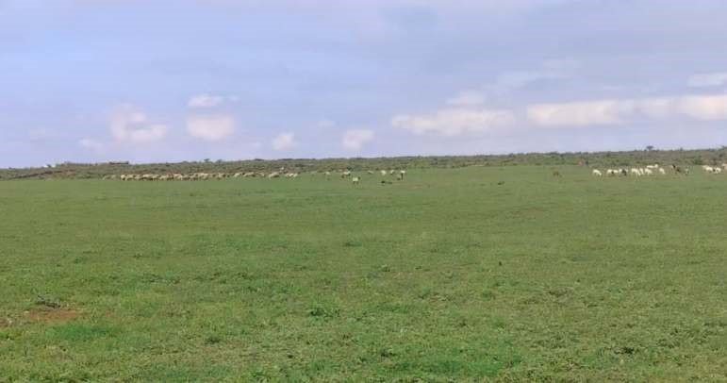

Photo 1: Livestock grazing at a section of the proposed project site
The project is expected to contribute to the overall plan to enhance power supply in Kenya. The proponent will obtain the requisite permits and licenses to generate and transmit power in accordance with the legal framework in Kenya.
The project proponent is also expected to partner with both the government (national and county levels) from project planning to implementation and operations. Indeed, this will enhance project success and alleviate any obstacles and concerns that may affect implementation as well as generation of beneficial impacts besides power generation. This includes benefits to the local community through employment, income diversification, and social development projects.
Overall the project will contribute to the increasing need and investments in climate change adaptation and resilience. As a renewable source of power, solar energy has the potential to help reduce carbon dioxide and other greenhouse emissions by replacing traditional sources of electricity e.g. fossil fuels. Additionally, the generation of hydro-power, which contributes to the largest portion of electricity supplied in Kenya. This has been significantly affected by the decreasing and erratic rainfall as a result of climate change.

3.3 Project Design
Photovoltaic (PV) power uses solar panels to convert sunlight into electricity by converting the solar radiation into electricity. The power plant uses multiple panels, a direct current (DC) / alternating current (AC) convertor, racking system that holds the solar panels, electrical and communications interconnections and supporting infrastructure such as drainage systems, security infrastructure, stores and internal roads. Figure 1 illustrates the key components of a solar PV power plant while Figure 2 shows the general layout of the proposed project.
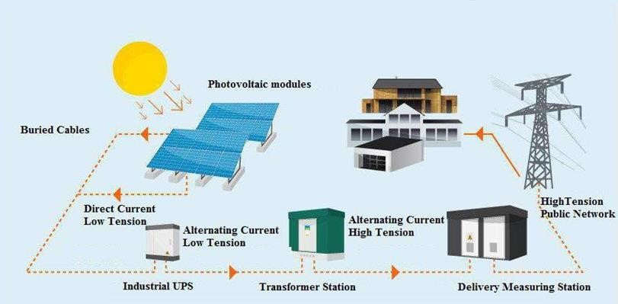

Figure 1: General operations of a solar PV power plant
The main components as per the project design includes;

3.3.1 Solar Yard
The solar yard will comprise of the area under modules/panels and transmission points. The power conversion source will be done by photovoltaic modules that convert sun light directly to electricity. The modules will be Tiger Neo N-type 78HL4-(V) 615-635-Watt Mono-Facial Modules. The dimensions are 97.05×44.65×1.38 inch. These modules are based on SMBB Technology which provides a better light trapping and current collection to improve module power output and reliability. The modules have an excellent Anti-PID performance guarantee via optimized mass-production process and materials control. Additionally, these modules are durable against extreme environmental conditions such as high salt mist and ammonia resistance.
For the fixation structures, the design may use a single axis tracker solution consisting of an electromagnetic group equipped with a frame to hold the photovoltaic panels and rotation system to rotate the panels to their optimum position. This system consists of a rotational axis oriented to the East-West, with +50º mobility, with which the panels reach their optimum position with respect to solar radiation, thus increasing the energy captured by the system with respect to the fixed structures.
The supporting structure for the panel grid consists of C shaped structural profiles called pillars, made of hot dip galvanized steel in accordance with the appropriate standards. Mounted on these pillars is a square structural profile, onto which is fitted the grid of modules. The grid consists of structural profiles, with length equal to the width of the grid, any clips for supporting and securing the panels. These rows are connected to each other by means of a linear drive shaft. Each tracker is equipped with a local control system based on a commercial for the following functions:
- Astronomical calculation with a deviation greater than 0.015º. It includes the possibility of specifying slope angles East-West and North –South.
- Pointing control by means of an analogic inclinometer and a frequency adjuster
- “Backtracking” while eliminates shadowing from a new row of trackers to the next, improving production performance while saving on space.
- Parameters setting and start up using a commercial handy Communications interface

3.3.2 Monitoring System
The monitoring system is vital for the reporting and O&M services. Its major advantage is the improvement of PV plant system efficiently keeping a structured form of presenting information to the stakeholders e.g. regulators. In general, these systems acquire data from several PV plant devices and create a historical database with this data. By early detection of equipment malfunction of failure, the system set grounds for maximization of energy production and down time reduction.
This system can present hourly, the following main data:
- Current at the input of the second level of junction boxes closed to the inverters
- Voltage and current values at the inverter input side
- Grid phase voltage and inverter output power
- Energy produced
- Environmental Pressure
- Modules temperature
- Wind speed
The data will be processed to create reports that will be an important tool for operation and maintenance.

3.3.3 Surveillance and security system
The surveillance and security system main components will include:
- Intruder Alarm System – Video analysis and Infrared technology, to ensure an effective protection around the perimeter;
- Video Surveillance System– Cameras (dome cameras) able to inspect the whole PV Plant area, as well as the required equipment to manage all the video information;
- Control Centre, Transformer Centre and Inverter Centre Protection – Security system, able to detect intruders;
- Suppressive Lighting – A suppressive light system, triggered by an alarm sent by any of the systems (Intruder Alarm System, Video Surveillance System, Transformers Centre and Control Centre).

3.3.4 Office and Staff Quarters area
There will be two office spaces, that is, for the main contractor and the sub-contractor. The areas will also host quarters for a number of personnel working at the farm. The offices will comprise of containers placed on concrete platforms. Appropriate number of sanitation facilities will be provided for the staff. This EIA encourages the proponent and contractors to ensure proper aeration and use of natural light within these structures.
Other structures will include stores for varied materials, canteen, and a dispensary to provide first aid services in the event of injuries or sickness amongst the staff.
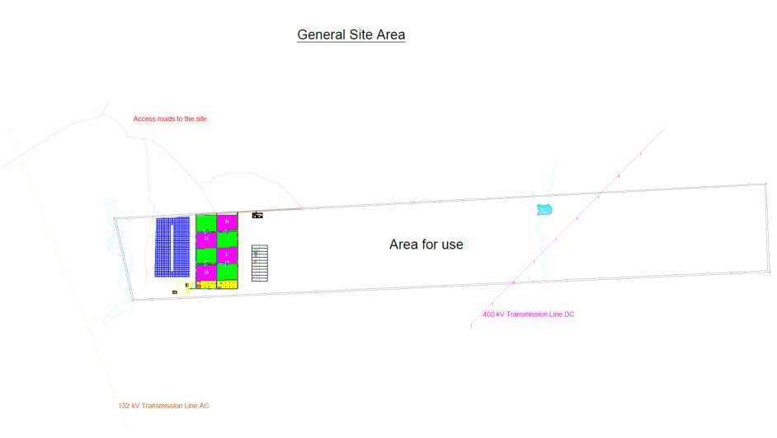

Figure 2: General site layout

3.4 Project Inputs

3.4.1 Construction Materials
Some of the materials to be used in the construction works will include aluminum, steel, soil borrow material, cement, ballast, sand, pipes, water and stones. Materials will be procured from licensed dealers and especially those who have complied with the environmental management guideline policies and conform to NEMA standards. Re-usable materials that remain upon completion will be kept and used to repair the system.

3.4.2 Labour
This will consist of both skilled and non-skilled workers. Skilled labour will be utilized in running equipment while non-skilled labour will be employed where appropriate. Use of manual labour for various tasks during the construction phase will not only provide for more employment opportunities but also ensure lesser impact in terms of noise, air pollution and incidences of oil leaks if machinery were to be used. The proponent will engage registered and licensed entities for the different tasks as it may have been prescribed by relevant legislation

3.4.3 Waste Management
During construction phase, the proponent recommends that waste management be initiated from the early stages of procuring of materials for construction. This will help avoid excess materials and ensure the acquisition of materials is in line with the design and specifications of the buildings. Handling of materials which includes storage and subsequent use will also be well managed to reduce any form of wastage that may culminate to more wastes at the site.

3.4.4 Energy
A back-up generator will be installed to augment the supply, especially in times of low solar insolation and outages.

3.4.5 Water
The project has a number of water supply options including utilization of ground water, abstraction from the river and rainwater harvesting. Owing to the decrease in rainfall and over abstraction in the upstream sections, abstraction from the nearby Pesi river would not adequately support activities at the solar farm. Groundwater development (borehole) presents a more reliable option with rainwater harvesting as a supplemental source. The modules and other structures are expected to passively collect huge amounts of rainwater, which can be stored for use.

3.5 Project phases and activities
- Planning and design phase
This phase essentially involved surveying, design of various project components, and acquisition of project approvals. The Environmental Impact Assessment was also a key component of this phase.
- Construction phase
The construction phase will involve development of abstraction and distribution infrastructure. The specific elements will include selection of contractors and recruitment of staff to execute different tasks in the construction phase. The delivery of materials and actual undertaking of works will mark the completion of this phase.
- Operations phase
Activities within this phase will include power generation, transmission and various aspects of project operations and maintenance.
- Decommissioning
The decommissioning phase involves the ceasing of the project activities or change of ownership. Although, this phase is not foreseen in the near future, some of the activities involved may include dismantling of the project, rehabilitation or transfer of ownership. This phase will be guided by a detailed decommissioning plan as highlighted in Chapter 9 of this report.

Table 1: Summary of project phases and activities
Phase | Main activities |  | Inputs
Planning and design | - Budgeting and development of plans and Bills of quantities  - Obtaining approvals and other statutory obligations | • •  • | Financial resources  Community support  Consultancy services
Construction | - Transport and storage of construction material  - Sites preparation and mobilization of construction personnel  - Construction waste Management | • •  • | Material Labour  Waste management
Phase | Main activities |  | Inputs
Operation | - Commissioning the completed works  - Power production  - Regular inspection, repair and maintenance. | •  • | Regular inspection. Material for repairs
Decommissioning | - Change of ownership  - Rehabilitation and/or restoration | • | Labour

3.6 Project cost
The implementation of the proposed project will be based on the applicable standards in Kenya and international best practice. The proponent has committed to follow the due procedures as stipulated by the relevant government authorities and as has been designed by experts/ consultants. Environmental guidelines, health and safety measures will be at the core of the project implementation.
The project is estimated to cost KES. 155,474,085 as per the summary Bill of Quantities in Appendix D. The NEMA submission fee amounts to KES. 155474 as 0.1% of the project cost.

4 | BASELINE INFORMATION OF THE PROJECT AREA

4.1 Project Location
The proposed project site is located approximately 10Km from Rumuruti Municipality off the Rumuruti – Nanyuki Road. The parcel was part of the Lombala Ranch, a privately-owned cattle ranch. It borders Thome settlement to the north, Ngorare ranch to the east and Bhora Farm to the south. The site is denoted by GPS Coordinates 37 N 233406.00 m E 26363.00 m N (Lat 0.2383096°, Long 36.6048706°) at 1849masl. Administratively, the site falls within Thome Sublocation of Salama Ward, Laikipia West Sub-County.
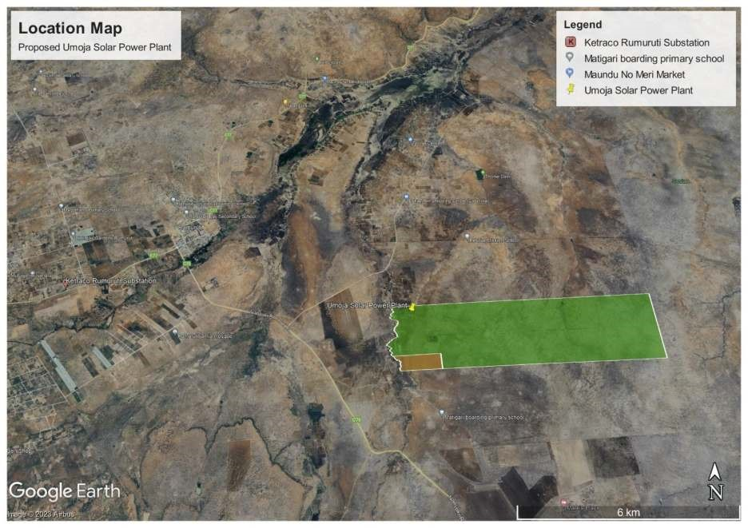
Figure 3: Proposed project location

4.2 Biophysical Baseline Conditions

4.2.1 Climate
The variability and distribution of annual rainfall is high in the County. Increase in both variability and distribution along the same gradient has been documented. The annual rainfall distribution is closely related to altitude. Higher altitude areas such as those on the foot slopes of Mt. Kenya, Aberdare Ranges and the eastern rift valley show higher rainfall compared to lower altitude of the Laikipia plateau. The amount of mean annual rainfall drops along a steep gradient, from 800-900 mm at the foot of both massifs to under 500 mm in the northern part of the county. Long term rainfall analysis done by Berger (1987) does not reveal any trends that could be useful for future rainfall prediction. The analysis however reveals series of below average rainfall which is an important factor in determining the survival of rainfall dependent production systems such as small-scale farming systems
Data from Kenya Meteorological Department for Rumuruti rainfall station shown in Table 2 below shows that the project area received an average of 845mm for the period between 2008 and 2020.

Table 2: Annual Rainfall for Rumuruti Station
 | Year | Rainfall (mm)
1. | 2008 |  | 741
2. | 2009 |  | 535
3. | 2010 |  | 1069
4. | 2011 |  | 1342
5. | 2012 |  | 822
6. | 2013 |  | 1156
7. | 2014 |  | 554
8. | 2015 |  | 713
9. | 2016 |  | 849
10. | 2017 |  | 685
11. | 2018 |  | 723
12. | 2019 |  | 775
13. | 2020 |  | 1015
 |  | Total | 10979
 |  | Average | 845
Source: Kenya Meteorological Department, 2020
Temperatures are highest in the months of January to mid-March before the rainy season and lowest in the months of July to August. Data for Rumuruti Station from CLIMWAT climatic database shows that the maximum temperatures are highest in February and March recording 27.7⁰c and 27.5⁰c respectively.

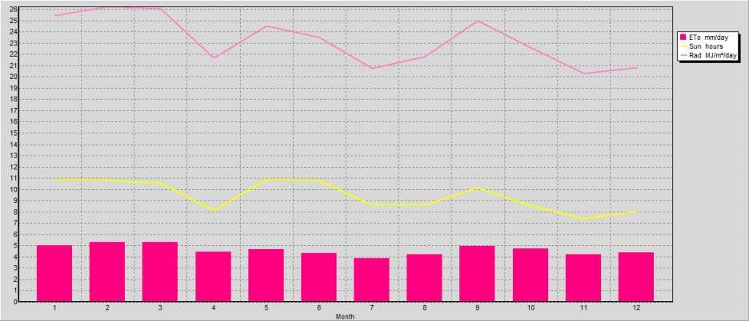

Figure 4: Monthly sun hours, radiation, and evapotranspiration rate
Source: FAO-CLIMWAT/CROPWAT
Figure 4 above shows monthly averages for evapotranspiration (ET₀), sun hours and radiation for Rumuruti Station. The average ET0 is 4.63mm/day with the highest, 5.33mm/day being recorded in February. Evaporation exceeds rainfall in the area as resulting in widespread moisture deficit just like the rest of the County.
The project area receives an average of 9.5 hours of sun in a year. This underpins the viability of the project in the area. It results to an average radiation of 23.2MJ/m²/day, which is adequate for meaningful solar power production. This is corroborated by the solar atlas map shown below.
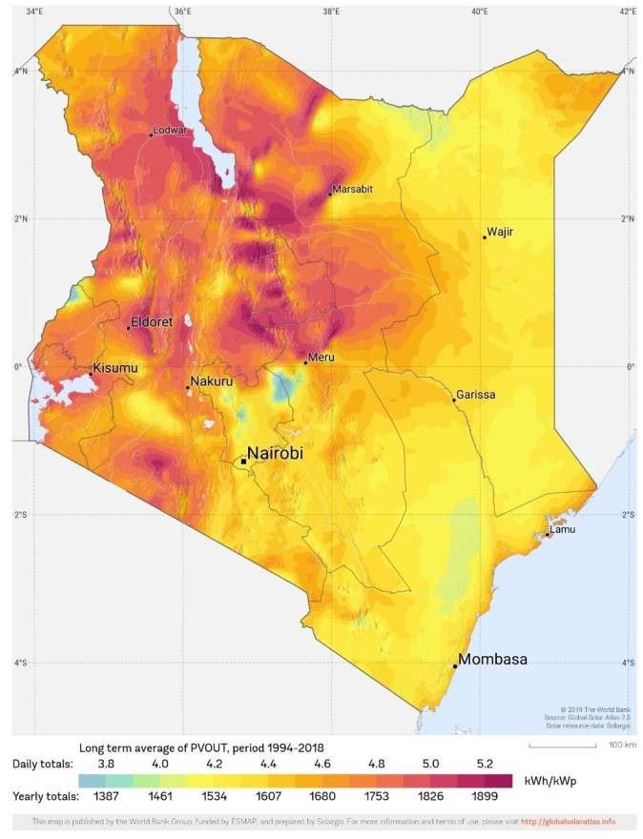

Proposed
Project site

Figure 5: Photovoltaic potential of Kenya
Source: World Bank Global Solar Atlas

4.2.2 Topography
The project is located within the Laikipia plateau that is characterized with rolling low hills and altitude ranging between 1200m-2,600 m above sea level. The plateau is dissected by two main rivers namely Ewaso Narok and Ewaso Ng’iro. The Pesi river flows in a northern westerly direction to join Ewaso Narok downstream. Altitude within the project area ranges between 1880m to the east of the project site to 1839m above sea level along the Pesi River.

4.2.3 Geology
Generally, the whole of Laikipia County is underlain by metamorphic rocks of the Pre-Cambrian forming part of the extensive African Basement Complex. The western parts of the county including Rumuruti comprise of build-up of extensive flows of phonolite lavas originating from the Aberdares and the edge of the Rift Valley eastern escarpment. There are two main types of lava sheets of phonolitic composition namely, Nyahururu phonolites and Rumuruti Phonolites. The latter are found within the north western section of Laikipia County including Rumuruti and areas of Sosian and Kirimun. Some of the characteristic rocks of igneous volcanic origin are exposed in some areas. The lavas weather chemically to form clays and the soils associated with them are dominantly clay textured.

4.2.4 Soils
Soils around Rumuruti, Sosian and Kirimun, which cover the project area, are directly related to the parent rock and to an extent the relief of the area. These soils are associated with nearly flat to gently undulating volcanic plateaus with a slope of 1-8%. The project site falls within the flat to nearly flat physiographic unit. These soils are very deep and moderately well drained to imperfectly drained cracking clay. They also range between dark greyish to very dark grey in colour. The dark cracking clays have moderate surface drainage, but imperfect to poor internal drainage especially when the moisture content is high. Cracking clays are difficult to till; they are very sticky and plastic when wet, and extremely hard when dry.
These soils are known to have adequate amounts of potassium and other bases. However, the levels of phosphates are variable and may require application. Additionally, moderate organic matter and nitrogen levels, have rendered these areas suitable for extensive grazing with other areas subdivided for subsistence crop production.

4.2.5 Hydrogeology
The hydrogeology of the project area is influenced by the geology, precipitation, weathering processes, and to an extent the gradient change. The geology of the area is characterized by igneous volcanic rocks of varying depths. Essentially, groundwater in volcanic rocks is limited to fractures and erosion levels within the volcanic succession. Lavas are not water bearing because of their un-fractured and impervious character. The recharge mechanism and the rate of replenishment of the confined aquifers which underlie the volcanic rock.
The available data indicates that shallow water often occur within 100 m depth while a deeper aquifer could persist from 176 to 214 m below ground level. The fact that the static water level is generally way above these aquifers suggests that they are perched, and rather very significant. The average main water strike occurs at 121m below ground level. The average static water level is 41.8 m below ground level, static level at the proposed site is expected to be at a similar depth.
Yields of boreholes within Rumuruti Plateau phonolites on average falls towards the east, although some studies indicate that there is considerable ground water potential with no depletion envisaged in the near future. Although the recharge mechanisms are not known, the two major processes include direct recharge at surface and indirect recharge via faults or neighbouring aquifers. The groundwater quality in the area is generally fair with typically low total dissolved solids and high bicarbonate. However, in most of the deeper volcanic aquifers, fluoride concentrations are above the maximum WHO recommended level of 1.5 ppm.

4.2.6 Hydrology
The drainage within the larger project area is generally influenced by the presence of Ewaso Narok River and Ewaso Narok Swamp to the west of the project site. The Pesi River influences the immediate hydrology of the site and it is a major tributary of the Ewaso Narok River. These rivers rise from the Aberdares Ranges and drain into the larger Ewaso Ng’iro River. The drainage of the project site thus flows in a northern westerly direction.

4.2.7 Flora
The vegetation distribution in general is strongly influenced by altitudinal diversity, with dry forest occurring on the highest elevation and a gradient of Acacia-Themeda bush on the plains. The predominant vegetation species in the area comprise of Acacia drepanolobium, Euclea divinorum, Acacia nilotica, Tarchonanthus camphoratus, Acacia drepanalobium, Acacia xanthlophloea, Carissa edulis, Croton spp, Tarchonantus Camphoratus, Syzygium guineense bush lands.
Historical land management and use at the site has led to reduction in shrubland and trees. They can, however, be spotted in different points on the farm. The dominant grass communities including Themeda triandra, Pennisetum mezianum, Pennisetum schimperia and Setaris phacelata. Others include cactus, Euphorbia spp. and Aloe among others.
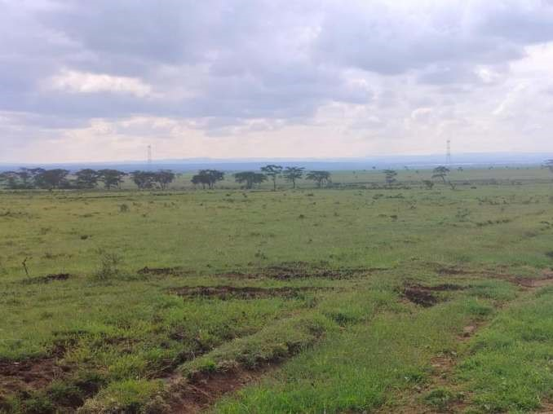

Photo 2: A section of the site with Acacia trees and native grass species

4.2.8 Fauna
Laikipia County has some of Kenya’s richest ecosystems in terms of number of endangered wildlife species and supports high densities of large mammals. The history of wildlife in Laikipia dates to the pre-colonial period. The pastoralist Laikipia Maasai community was then few in number, sparse in settlement and nonsedentary. These dynamics meant that there was insignificant competition for resources between wildlife and the community as opposed to the current situation.
However, wildlife populations have declined substantially in the past 20 years largely attributed to increase of immigrant farming communities considerably reducing wildlife habitat and inevitably resource competition. The ranch hosts populations of wildlife consisting of elephants, warthogs, dik-diks, impalas, gazelles, buffalo, plains zebra and giraffes among other small game. The project site does not host any resident wildlife population. However, herbivores such as zebras can be spotted grazing in the area.

4.3 Social Economic Setting

4.3.1 Land tenure and use
Several land uses are discernible in Laikipia County. These can be broadly divided into large-scale ranches, pastoralist, small-scale farms, unsettled land, forest reserves and urban centres. Laikipia County has undergone through major land use/ ownership transformation within three important historical eras of Kenyan history: pre-colonial, colonial and post-independence era. The project area is mainly a livestock production zone owing to its location in a transition between agro ecological zones 3 and 4 which cover Rumuruti and the drier zones in the north of the county. It is also suitable for wheat farming although it is hindered by a number of factors such as low financial capability and lack of access to machinery.
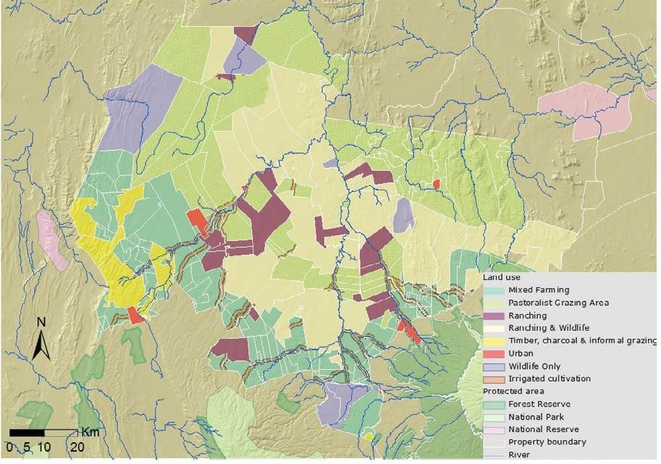

Figure 6: Land use within Laikipia
Project Site

4.3.2 Demographics
Laikipia County’s population is diverse or heterogeneous in its composition comprising pastoralists in the north east and agro-pastoralists in the rest of the County. Population figures in various parts of the County are related or linked to specific issues such as agro-ecological zones, security of subsistence, off-farm activities, migration trends and wildlife problems. The average population density in as per the 2019 Census stood at 55 persons per square Kilometre.
Thome sub-location has a population of 11,355 and a population density of 25. This is significantly low compared to the county average rendering the area a sparsely populated region.

Table 3: Population of the project area
 | Total | Male | Female | Household  s | Land Area (Km²) | Density
Thome | 11,355 | 5,688 | 5,667 | 2,540 | 459.7 | 25
Mathira | 3,007 | 1,491 | 1,516 | 669 | 221.4 | 14
Thome | 8,348 | 4,197 | 4,151 | 1,871 | 238.2 | 35
Source: 2019 Kenya Population and Housing Census: Volume II

5 | STAKEHOLDER CONSULTATION

5.1 Introduction
Public consultation is an essential element of an Integrated Environmental Impact Assessment. Reference is made to Section 17 of the Environmental (Impact Assessment and Audit) Regulations, 2003, which states that the proponent shall in consultation with the authority, seek the views of persons who may be affected by the project. The role of public consultation and involvement in EIA process is to enhance the quality, comprehensiveness and effectiveness of the assessment and ensure that the public views are adequately taken into consideration in decision making process.

5.2 Impacts identified by stakeholders
Stakeholders’ comments were sought through a consultative meeting held on 8/12/2023 at Rescue Primary School. The meeting provided a platform to inform the community on the proposed project as well as collate their opinions on the anticipated negative and positive impacts associated with the proposed project. The identified impacts are outlined below;

5.2.1 Positive impacts
The following potential positive impacts of the proposed developments were highlighted by the stakeholders during public consultation process;
- Creation of both direct and indirect employment opportunities or income generating opportunities during different project phases.
- Availability of alternative environmentally friendly energy sources
- Increased development in the area
- Optimal use of land that has largely lied idle

5.2.2 Negative impacts and mitigation measures
Negative impacts identified and their mitigation measures include;
- Alteration/Loss of wildlife habitat during the construction phase.
o Proper construction practices should be followed focusing on minimal environmental disturbance.
- Possible injuries to workers during the construction works o The contractor should provide appropriate PPEs
- Wildlife attacks on construction and maintenance personnel o Ensure those undertaking construction and maintenance works liaise with KWS for safety.
The minutes and filled questionnaires are provided in Appendix A.

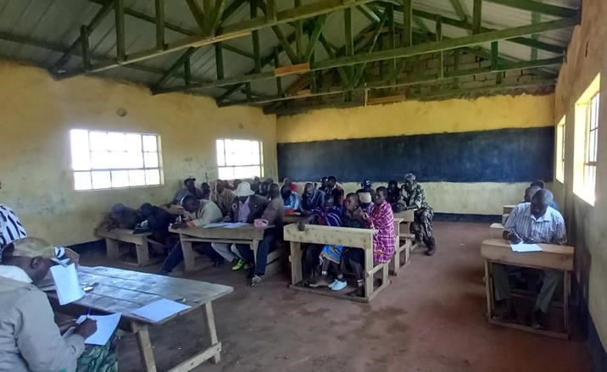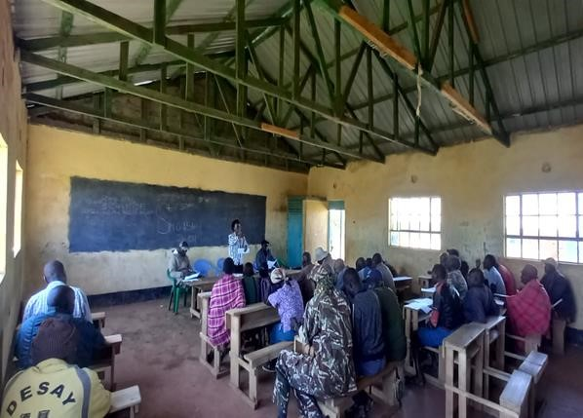

Photo 3: Stakeholders during the consultation meeting

6 | POTENTIAL IMPACTS AND THEIR MITIGATION MEASURES

6.1 Impact Identification
The identification of impacts in the assessment generally used the following methods:
- Compilation of a comprehensive list of key environmental and social impacts such as changes in air and water quality, noise levels, wildlife habitats, biodiversity, landscape, social and economic systems, cultural heritage, settlement patterns, and employment levels.
- Identification of all the sources of impacts such as dust, spoils, vehicles emissions, water pollution, et al. using checklists and networks. This was followed by listing possible receptors in the environment (i.e., community) through surveying the existing environmental and socioeconomic conditions and consultation with concerned parties.
- Identifying and quantifying various environmental and socio-economic impacts through the use of a standard checklist. The checklists were complemented by an impact identification matrix.

6.2 Impact Prediction
Prediction of impacts technically characterized the causes and effects of impacts, and their secondary and synergistic consequences for the environment and the local community. It involved examination of each impact within a single environmental parameter into its subsequent effects in many disciplines (e.g., deterioration of water quality, destruction or disruption of economic activities and resulting socio-cultural changes). The process is anchored on physical, biological, socioeconomic, and anthropological data and techniques. In quantifying impacts, socio cultural models, economic models, and expert judgments were employed. It is worth noting that all prediction techniques of environmental impacts, by their nature, involve some degree of uncertainty. The impacts were identified at the following four phases;
- Planning and design phase
- Construction phase
- Operation phase
- Decommissioning phase

6.3 Types of Impacts
The project activities are likely to result in social and environmental impacts. The impacts will be defined as: -
- Positive Impact: A change which improves the quality of the environment (for example by increasing species diversity; or improving the reproductive capacity of an ecosystem;
- Neutral Impact: A change which does not affect the quality of the environment.
- Negative Impact: A change which reduces the quality of the environment (for example, lessening species diversity or diminishing the reproductive capacity of an ecosystem, or damaging health or property or by causing nuisance).
The potential impacts of the project fall under two broad categories of bio-physical (natural) and socioeconomic environments. A matrix table was used to analyse these impacts.

6.4 Significance of impacts
The identified impacts were then subjected to a criterion that was used to determine their characteristics and significance. The parameters used in this particular study include:
- Direction: will the impact generate a beneficial or adverse change?
- Extent: will the impact affect a small, medium or large area?
- Duration: the period over which an impact will be felt. Is it short-term or long-term?
- Reversibility: the permanence of the impact. Is the impact reversible particularly for negative ones?
- Imminence: the possibility of the impact occurring as predicted.
Impact analysis and evaluation results for both the construction and operational phases of the proposed project are presented in the following sections.

6.5 Results of the Impacts Analysis
The positive and negative impacts arising from the proposed project are outlined below;

6.5.1 Positive impacts
The positive environmental, social and economic impacts associated with the various phases of the proposed project are outlined below.
During the Planning and Design phase
- Awareness creation on the proposed project through the various consultations, which improves the quality and sustainability of the project
- Professional employment opportunities particularly for consultants e.g. Environmentalist, Engineers and Sociologists, among others, providing a gain of fees for services rendered which has some positive impact on the economy in general.
- Sourcing of relevant legal documentation thus ensuring compliance, and alleviating the risks of the project being stopped by relevant authorities due to non-compliance.
- Revenue for the government during the approval processes.
During construction Phase
The following are some of the immediate benefits associated with the project:
- Provision of employment opportunities for both skilled and semi-skilled.
- Transfer of knowledge and skills and building of on-the-job skills for the locals since the artisans and casual workers will remain behind after the construction phase.
- Indirect employment opportunities to those involved in supply and delivery of various materials and services.
- Boost to local businesses as materials and services will be sourced from the immediate neighbourhood and major towns in the county e.g. food and materials
- Improvement of access roads to facilitate delivery of materials, hence benefiting other users in the area.
- Revenue to the government through payment of taxes.
During operational phase:
The project is likely to have the following positive impacts:
- Contribute to low-carbon and affordable power generation and supply in the country.
- Replication of similar projects in the county, hence increased development and socio-economic profile of the county.
- Improved visibility and security from project lighting in the immediate site location thus improving security in the area.
- Job creation for both skilled and unskilled labor.
- Social development in the immediate vicinity and the county at large through Corporate Social Responsibility (CSR).
- There is a potential for the project to spur development in the neighbouring Thome and Matigari shopping centres as well as Rumuruti Municipality.
During decommissioning
The following are possible positive impacts of the project in the event of decommissioning:
- Any potential hazards associated with the project components would be forestalled;
- Employment creation for professionals and semi-skilled workers.
- In the event of transfer to a new owner, the costs and impacts associated with the new project will be forgone.

6.5.2 Negative impacts
Following the identification of possible negative impacts resulting from the proposed project activities, this EIA has recommended feasible and cost-effective measures to prevent or reduce the severity of negative impacts to acceptable levels and to enhance positive impacts for the improvement of overall benefits of the project. It is imperative that the efforts proposed to provide solutions to environmental problems should have an in-built poverty alleviation component within the beneficiary communities.
The mitigation measures for specific adverse impacts under the different project phases are presented in the table below:
Planning and Design
There is a possibility of a misunderstanding between various stakeholders and heightened expectations and speculations about the proposed project. Additionally, there may be conflicts with relevant authorities if the proponent does not obtain the requisite certifications before commencement of operations.
These will be mitigated through;
- Providing all the financial and technical facts of the project to the authorities and relevant stakeholders.
- Document any concerns raised and address them as they occur, particularly those that directly relate to the proposed project.
- Liaise with relevant authorities and obtain requisite permits and licenses.
Construction phase
Negative impacts are most common in the construction phase. However, most of the impacts in this phase are usually temporary and resolve as soon as the construction is completed. The potential negative impacts in the construction phase are outlined in the table below;

Table 4: Potential negative impacts during construction phase
Potential negative impact |  | Proposed Mitigation Measure
Biodiversity loss and soil erosion during site clearing, material, movement around the site. | o o | Proper delineation of the project to avoid indiscriminate clearing of vegetation.  Ensure traffic follows designated access routes or reroute access road to a less vegetated areas.
 | o | Rehabilitate any borrow pits by replacing the top soil and reestablishing indigenous vegetation.
 | o | Replace any vegetation damaged accidentally.
 | o | Incorporate appropriate soil erosion control measures e.g. maintaining good ground cover, eliminate unsightly soil heaps, and undertake works during the dry season to prevent erosion from surface runoff.
 | o | Ensure the project activities do not lead to significant alteration of landscape.
Generation of wastes/debris/litter from off-cuts of pipes and metal, cement bags, containers etc. | o | Contractor/proponent to take preventative measures through use of Bill of Quantities and purchase only what is needed to minimize possibility of waste; Ensure that only essential construction materials are delivered to the site
 | o | Ensure proper storage and handling of materials to reduce wastes.
 | o | Non-biodegradable wastes that cannot be reused or recycled will be disposed of at a designated waste dumpsite off the project sites.
 | o | Spread the excavated soil to prevent unsightly heaps of soil and re-use in landscaping.
 | o | Sell wastes to credible recyclers and fabricators
 | o | Preserve reusable wastes such as pieces of metal for future use in maintenance works.
 | o | Ensure no waste is left at the proposed site upon completion.
Pollution as a result of poor handling chemicals, lubricants and fuel | o | Ensure proper measures of storing and handling chemicals and other potentially hazardous fluids/substances.
 | o | Ensure prompt cleaning/ management of such spills.
 | o | Regular servicing of machinery and equipment
 | o | Maintenance activities should adhere to sound environmental practices.
 | o | Maintenance activities of vehicles and machinery should be carried out in a designated workshop.
Disruption of serenity within the vicinity | o | The Contractors will keep noise level within acceptable limits as stipulated in EMCA, Noise Regulations.
 | o | Workers on site during use of machinery that generate noise should be provided with appropriate PPE.
 | o | Proper scheduling of materials delivery to minimize noise pollution.
Air pollution from dust and emissions during movement of vehicles and machinery | o o o | Apply dust suppression measures along access roads.  Provide appropriate PPE such masks where necessary. Maintain equipment fleet in good working condition to reduce emissions.
Possible accidents owing to the slight increase in traffic along the road. | o | Sensitize drivers to observe traffic rules and speed limits, particularly near the shopping centers and schools.
 | o | Loading on traffic to be controlled to comply with government regulations.
 | o | Engage authorities and local actors during delivery of sensitive and unusually wide loads to the site.
 | o | Erect warning and advisory signage where appropriate.
Health and safety issues such injuries to the workers. | o | Contractor vetting to ensure compliance with legal requirements governing suitability for the specific job.
 | o | The contractor to provide workers with PPEs, which include gloves, boots, goggles, aprons, ear protection, etc.
Spread of communicable diseases and other infections | o | Provide appropriate/adequate facilities to maintain proper sanitation and personal hygiene facilities
 | o | Sensitize personnel on proper sanitation and hygiene
 | o | Adequate ventilation and spacing of accommodation
 | o | Observance of protocols for COVID 19 prevention
Erosion of good morals as a result of influx of workers from other areas | o o | Create awareness among workers on good morals  Enforce rules and regulations governing the conduct of employees.
 | o | Provide social/recreational amenities to reduce idleness outside working hours.
 | o | Increase awareness of immorality and effects of related diseases e.g. HIV/AIDS
Substandard works - Possible deviation from the initial intentions and specifications | o o | Ensure merit is major consideration in selection of contractors, suppliers, and personnel.  Ensure stringent monitoring system is put in place to inform the implementing entities.
 | o | Continuously sensitize workers on the project specifications and requirements.

Operations phase
The potential negative impacts and their mitigation measures are outlined below.

Table 5: Potential negative impacts during operations phase
Potential negative impact | Proposed Mitigation Measure
Poor surface drainage system resulting to soil erosion, water stagnation, and changes in local hydrology | - Harness rain water within the solar park for use in various activities  - Paving of the side walkways and parking areas using pervious materials such as cabro-paving to encourage water recharge and reduce run-off volume  - Integrate rain gardens into the landscape design for water retention.  - Maintain a good vegetation cover.
Security issues including vandalization of infrastructure | - Provide security guards and facilities  - Adequate lighting and alarm system should be installed at strategic points.  - Collaborate with the local community and local administration to avert security and vandalism of infrastructure.

Visual intrusion including effects of glint and glare from solar reflection | ▪ | Ensure use of local materials to enhance the projects blending to the local context, where possible and appropriate
 | ▪ | Erect signage on road to warn road users of the potential risk from glint
 | ▪ | Incorporate anti-reflective coating to reduce intensity of the reflected light from the solar panels.
 | ▪ | Ensure proper tilt angle for the solar panels to manage the path of reflected rays.
Increased demand for water at the facility | ▪ | Diversify water sources for the site including comprehensive rainwater harvesting.
 | ▪ | Ensure water used at the facility meets the recommended quality standards.
 | ▪ | Proper maintenance of water supply infrastructure at the solar park.
 | ▪ | Sensitize workers and guests on sound water use practices e.g. by placing advisory notices around the facilities.
Increased demand for energy at the facility | ▪  ▪ | Adopt comprehensive use of solar energy at the facility.  Limit use of diesel-powered generators in order to minimize air pollution related
Possible disruption of wildlife movement and attacks on staff | ▪ | Engage with neighbouring land owners and KWS on existing wildlife corridors.
 | ▪ | Allow for wildlife movement along historical corridors to minimize disruptions.
 | ▪ | Enforce strict security procedures with regular improvements to respond to different security threats and trends.
 | ▪ | Create awareness to staff and visitors of wildlife attack responses
 | ▪ | Develop wildlife barriers around accommodation facilities.
Poor relationship and misunderstanding with the community including loss of informal grazing areas and land for small scale irrigation. | ▪ ▪  ▪ | Provide timely notices to those currently using the land, albeit informally to avoid significant disruptions of livelihoods.  Commit to undertake consultations with the community where appropriate.  Support local social development initiatives as part of CSR.
 | ▪ | Engage in various community activities including joining communitybased groups e.g. WRUA and security.
Solid and liquid waste generation at the site | ▪ | Provide separate and color-coded bins for different types of wastes to support reuse and recycling.
 | ▪ | Create awareness among the workers on the need to separate biodegradable and non-biodegradable wastes
 | ▪ | Install appropriate and effective systems to manage black and grey and locate away from water sources to avoid contamination.
 | ▪ | Undertake regular monitoring of waste management infrastructure to ensure timely detection of inadequacies.
 | ▪ | Adhere to the subsidiary regulations of EMCA, 1999 on waste management
Occupational health and safety risks at the various work stations | ▪  ▪ | Keep a general accident inventory at the site  Provide and enforce use of protective clothing and equipment such as gloves, boots, aprons, ear protection, etc.
 | ▪ | Prepare evacuation plans including provisions for emergency exits, fire alarms and First Aid kits
 | ▪ | Assign duties and use of equipment to qualified personnel only.
 | ▪ | Ensure occupational health and safety awareness creation before and continuously on the job.
 | ▪ | Provide appropriate facilities and equipment e.g. chairs and machines to proactively prevent adverse health impacts.
Risk of fire break out at the site | ▪ | Ensure regular monitoring of power use and connections
 | ▪ | Install fire extinguishers at strategic location for ease of access
 | ▪ | Sensitize personnel on proper handling of flammable substances and response to fires at the facility.
Issues/ sanctions relating to lack of adherence to relevant national and international regulatory provisions | ▪  ▪ | Develop a monitoring system for all components of the project lifecycle.  Engage qualified entities where necessary.
 | ▪ | Employ holistic and appropriate approaches in project monitoring.

6.6 Climate change assessment

6.6.1 Climate change risk assessment
Climate risk assessment component focused on the projected changes in climatic conditions, aspects to be affected (e.g. biodiversity and livelihoods), likelihood of occurrence, and the resulting consequences. The impact of the project activities in aggravating or mitigating effects of climate change was also assessed.
It focused on the following elements;
- Trends of climate variables - The main aspects analyzed were rainfall and temperature patterns for the project area.
- Projected Impacts - The most relevant direct and indirect hazards and impacts were evaluated as well as elements that are at the most risk e.g. biodiversity, health and safety, and livelihoods.
- Likelihood of occurrence - Possibility of the risks occurring to facilitate decision making based on the degree of uncertainty.
- Timescale - The projected time span of the risks; short, medium or long term.
According to the Laikipia County Climate Risk Profile (2015), there have been a moderate increase in temperatures by 0.2⁰C between 1981 and 2005 while rainfall during the short rains increased by over 50mm. The slightly increasing temperatures have resulted in an increase in heat stress days leading to prolonged drought incidences. The increasing precipitation during the second season being associated with the risk for flash floods.

6.6.2 Climate change vulnerability assessment
Vulnerability assessment was concerned with the understanding the exposure, sensitivity, and adaptive capacity of the project settings (natural and socio-economic components) and project activities respectively. The same approach used in the identification of potential impacts was employed. It focused on;
- Exposure; Amount and rate of change experienced from direct and indirect impacts of climate change e.g. changes in rainfall patterns and habitat changes respectively.
- Sensitivity; The degree to which the different elements in the project area would be affected by climate change e.g. hydrology.
- Adaptive capacity; Ability of the elements to cope and persist under changing conditions.

6.6.3 Results of the assessment
Based on the desk studies and site visits conducted during this EIA, the most significant climate related risks and hazards in the project area outlined below.

Table 6: Climate change risks
 | Risk | Impact on the project | Risk  Classification | Adaptation/Mitigation Measures
(i) | Changes in  temperatures | - Increased operating challenges to solar PV Plants such as lower cell efficiency and energy output  - Heat waves stress on roads, buildings and other  infrastructure  - Reduced electricity carrying capacity of transmission lines  - Increased losses within the substation and transformers | Medium | Adopt appropriate engineering designs incorporating natural aeration techniques.
(ii) | Floods  (Flash/surface floods/River floods) | - Increased risk of accelerated surface run-off, soil erosion and sedimentation load at site affecting land and drainage  - Access / approach roads could be damaged or washed out or segments could be eroded.  - Affected life span of solar park infrastructure | Low | Undertake flood risk assessment to inform project design and implementation.
(iii) | Water availability | - Reduced frequency of precipitation affecting water availability and water quality  - Increased risk of corrosion of steel infrastructure (lattice towers) with a corresponding increase in humidity  - Increased risk of drought episodes and dust damage to solar PV plants  - Less water availability for PV panel cleaning and maintenance of vegetation within the solar park | Medium | Diversification of water sources and invest in adequate storage to cushion the facility from water shortage shocks.
The energy sector is vulnerable to projected changes in mean climate conditions such as temperature and precipitation. Climate variability is expected to increase in a warmer climate; and in the frequency and intensity of weather events such as floods and droughts.
The proponent is encouraged to develop a climate-proof solar plant infrastructure with the design, operation and maintenance standards integrating measures to improve flood resilience. However, these changes in are not anticipated to be significant over the design life of the solar plant (+25 years).

7 | ANALYSIS OF ALTERNATIVES

7.1 Introduction
This section is a requirement by law and is critical in consideration of the ideal development with minimal environmental disturbance. The following feasible land-use options will be compared in terms of cost and benefit criteria: environmental impacts, social acceptability, economics (including productivity of land-use) and design feasibility. The general principle involved in identifying alternative option(s) to a proposed development is to ensure that the option chosen would result in optimal social, environmental and capital benefits not only for the developer, but also for the environment and stakeholders in the area.

7.2 Assessment and Evaluation of Alternatives
In the assessment of the proposed project alternatives, this study considered four main alternatives namely:
- “No Project” Alternative
- Alternative location
- Alternative land uses

7.2.1 “No Project” Alternative
The “No Project” alternative could exacerbate the deficit in electricity production and would hinder the diversification of energy sources in Kenya. Foregoing the development and installation of Kenya’s solar resource will result in greater reliance on thermal and hydropower Projects. Hydropower Projects are however vulnerable to the recurrent droughts seen in Kenya in recent years, an issue which is expected to be exacerbated given prevailing climate change perspectives. Conversely, the “No Project” alternative could lead to a longer-term reliance on fossil fuel generation (domestic or imported) which would contribute to GHG emissions. The “No Project” alternative would result in:
- Slower transition to 85% electricity generation from renewable energy target o Reduced or delayed diversification of Kenya’s generation portfolio
- Potential increase of imports of fuel for fossil fuel power plants with lower capacity factors and higher energy costs
The environmental impact of the no Project alternative would mean no impact to the existing habitats, assuming no alternative development takes place. However, as mentioned above, the “no Project” alternative creates the need for an alternative energy source to meet the country ‘s demand for reliable electricity supply. Depending on the alternative source selected, there is potential for this additional source to produce harmful pollutants and in the case of wind, have increased habitat take per megawatt during the Project lifecycle.
From a socio-economic perspective, there is some opportunity for local employment mainly during construction of the Project, including training opportunities for local people. The land proposed would not require physical displacement and subject to adequate compensation for land use at the Project site, the impact on communities is expected to be comparatively low to alternative options.
Selecting the “No Project” alternative would delay the diversification of Kenya’s energy sources and ultimately would detract from the goal of the Kenyan energy sector to ―ensure sustainable, adequate, affordable, competitive, secure and reliable supply of energy to meet national and County needs at least cost, while protecting and conserving the environment. Furthermore, the “no Project” alternative would contribute to a continued electricity price volatility nationally.

7.2.2 Alternative Location
This option is based on the criteria that the proposed development is to be sited in a zone planned for other developments or there is need to preserve any threatened, endangered, rare or unique species of plants or animals found at the site or the site is in or close to ecologically sensitive area.
The EIA processes established that the project is not out of character from the surrounding. Therefore, the proposed development cannot be an impediment to any other developments since it is compatible with adjacent facilities. There are no physical, biological, cultural and socio-economic features of special concern at the site.
If this option is selected the proponent is required to look for an alternative site either within or outside the zone. This implies that the proponent has to buy or lease another piece of land elsewhere since at the moment, the proponent does not have an alternative site. It might take a very long time looking for and finding a similar sized land and completing all official transactions relating to change of land ownership. There is also no guarantee that the land would be available, and if such land is available, its cost might be beyond affordable for the proponent.
The processes of designing and planning will have to be started over again. The proponent will need to reengage professionals like architects, EIA experts, land surveyors and physical planners to assess the viability of the new site. Additional costs will arise from the design and approval of the building plans for the new site.

7.2.3 Alternative Land Use
This option allows the developer to explore other alternative land uses for the site other than the proposed solar plant project. Alternative land uses that were considered in the analysis include
- Wheat Growing
Under this scenario, the proponent will engage in commercial large-scale wheat production. The impact of wheat farming on the environment is minimal with little irrigation and agro-chemical lesser chemicals are required during the growing period as compared to intensive commercial farming. Additionally, wheat provides cover against soil erosion. However, yields have over the years been affected by rainfall variability as well as theft of the produce. The venture would also register lesser employment opportunities compared to the prospects associated with the proposed project.
In the wake of increased need for local and foreign investments in energy, crucial for economic growth and employment creation, it is critical for environmentally sustainable land uses to be considered. Such land uses must be geared towards meeting the twin goals of environmental conservation and economic growth. From the above analysis, the status quo/continuation of wheat growing will not optimally contribute to these goals.
- Livestock production
The project area falls within agro-ecological zone suitable for ranching. The expansive land would provide ample space with a carrying capacity for productive beef and dairy production. The market for livestock products is ever-increasing in the local and regional markets. However, there is need to ensure the ecological carrying capacity is not exceeded leading to adverse effects such as loss of vegetation cover and soil erosion. These would have a significant impact on the infiltration rates and overall productivity of the land. Livestock production using appropriate management principles and practices is a viable enterprise but its profitability is far much lower compared to the proposed enterprise. Additionally, rampant cases of livestock theft may hinder the profitability of the venture. Under this project context this scenario is not desirable.
- Ecotourism
Ecotourism also offers a practical alternative to the proposed project. The proponent would develop an ecotourism facility including holiday homes or a lodge and provide an environment for the existence of a number of wildlife species. Tourism is one the main activities with tremendous growth in recent years, particularly in Laikipia. The tourists are being drawn by the prospect of seeing the unusual or spectacular scenery and unique plants and animals in their native habitats, as well as any cultural and historical features found in these areas. However, this scenario would not adequately respond to the existing livelihood challenges in the project area. To a larger extent, it would only serve the economic interests of the proponent with minimal benefits to the local community and the country. The issues of human wildlife conflicts may also arise from the existence of wildlife species in the farm.

7.3 Results of the Analysis
Analysis of alternatives determined that the proposed project remains the most suitable alternative. Essentially, it is more compatible with the prevailing ecological conditions, enhanced water security as well as provide direct and indirect socio-economic benefits. The proposed project is expected to contribute to the Kenyan Government policy documents including Kenya Vision 2030 and the Bottom- Up Economic Transformation Agenda (BETA). Under the proposed development alternative, the proponent would be issued with an EIA license upon approval of the project report by NEMA.
This EIA Project Report has appraised the project to ascertain its potential impacts and practical mitigation measures. Therefore, if all measures provided are implemented, the proposed project will not have significant adverse impacts.

8 | ENVIRONMENTAL MANAGEMENT AND MONITORING PLAN

8.1 Overview
The development of an Environmental Management and Monitoring Plan (EMMP) is an important process of ensuring project sustainability and environment protection. Whereas efforts are usually made to develop mitigation measures for a proposed project, it is during the operation lifespan of the project that actual impacts are noted or experienced. The EMMP is, therefore, an important element for monitoring of the progress of mitigation measures being implemented while also monitoring adverse impacts that were not earlier considered or anticipated.
The Environmental Management and Monitoring Plan will provide the basis for the implementation of the mitigation measures and provide a benchmark for the monitoring of the environmental performance of the proposed project through internal and external audits. The Environmental Management and Monitoring Plan has the important advantages of improving operational efficiency, promoting overall environmental protection, and occupational health and safety.

8.2 Monitoring approach
The EMMP involves measurement of relevant parameters and setting benchmarks, at a level of details accurate enough, to distinguish the anticipated changes. Monitoring aims at determining the effectiveness of actions to improve environmental quality; as regards the proposed project activities. The basic activities for a sound monitoring programme for the project, once it starts operating, should at least include the following parameters:
- Collection and analysis of relevant environmental data of the project site including: soil and air quality, biological diversity, hydrology and type and quantity of wastes generated.
- Identification of unexpected environmental and social impacts
- Formulation of counter-measures to mitigate the unexpected negative impacts while comparing them with actual impacts as identified during the assessment.
- Co-ordinate and do follow-up management and monitoring of the mitigation measures.
The EMMP for the proposed project is presented in the table below.

Table 7: Environmental Management and Monitoring Plan for the proposed project
Negative impact |  | Mitigation Measure | Monitoring Indicators | Budget (*000) | Responsibility
 |  | Planning and Design Phase
Lack of cooperation and understanding amongst various stakeholders on various components of the project. | ▪  ▪  ▪ | Enhance consultations and stakeholders’ scope of coverage during EIA study  Provide technical and socio-economic facts about the proposed project.  Set -up a preliminary grievance mechanism. | - Consultation approaches adopted  - EIA study approach  - Concerns raised  - Grievance redress mechanism | 3,000 | Proponent Consultants
Conflicts with relevant authorities due to failure to comply with pertinent legal and regulatory provisions. | ▪  ▪ | Obtain all the necessary certifications and permits. Continuously engage relevant authorities on the project implementation and compliance. | - Concerns raised  - Permits obtained | 2,000 | - Agencies  - Proponent  - Consultants
 |  | Construction Phase
Biodiversity loss and soil erosion during site clearing, material, movement around the site. |  | - Proper delineation of the project to avoid indiscriminate clearing of vegetation.  - Ensure traffic follows designated access routes or reroute access road to a less vegetated areas. o Rehabilitate any borrow pits by replacing the top soil and re-establishing indigenous vegetation. o Replace any vegetation damaged accidentally.  - Incorporate appropriate soil erosion control measures e.g. maintaining good ground cover, eliminate unsightly soil heaps, and undertake works during the dry season to prevent erosion from surface runoff.  - Ensure the project activities do not lead to significant alteration of landscape. | - Vegetation density and  diversity  - Location of site camp  - Soil conservation measures. | 5,000 | - Proponent  - Consultants  - Contractors

Generation of  wastes/debris/litter from offcuts of pipes and metal, cement bags, containers etc. | o  - o  o  - o o | Contractor/proponent to take preventative measures through use of Bill of Quantities and purchase only what is needed to minimize possibility of waste; Ensure that only essential construction materials are delivered to the site Ensure proper storage and handling of materials to reduce wastes.  Non-biodegradable wastes that cannot be reused or recycled will be disposed of at a designated waste dumpsite off the project sites.  Spread the excavated soil to prevent unsightly heaps of soil and re-use in landscaping.  Sell wastes to credible recyclers and fabricators Preserve reusable wastes such as pieces of metal for future use in maintenance works.  Ensure no waste is left at the proposed site upon completion. | ▪  ▪ | Reuse/ Recycling  activities adopted  Implementation of 5R principle. | 2,000 | ▪  ▪  ▪ | Proponent  Consultants  Contractors
Pollution as a result of poor handling chemicals,  lubricants and fuel | o  o  o o o | Ensure proper measures of storing and handling chemicals and other potentially hazardous fluids/substances.  Ensure prompt cleaning/ management of such spills.  Regular servicing of machinery and equipment Maintenance activities should adhere to sound environmental practices.  Maintenance activities of vehicles and machinery should be carried out in a designated workshop. | ▪  ▪ | Handling procedures Issues reported | 500 | ▪  ▪  ▪ | Proponent  Consultants  Contractors
Disruption of serenity within the vicinity | o  o  o | The Contractors will keep noise level within acceptable limits as stipulated in EMCA, Noise Regulations.  Workers on site during use of machinery that generate noise should be provided with appropriate PPE.  Proper scheduling of materials delivery to minimize noise pollution. | ▪  ▪  ▪  ▪ | Noise levels  Change in animal  behaviour PPEs provided  Work schedule | 1,500 | ▪  ▪  ▪ | Proponent  Consultants  Contractors

Air pollution from dust and emissions during movement of vehicles and machinery | o o o | Apply dust suppression measures along access roads.  Provide appropriate PPE such masks where necessary.  Maintain equipment fleet in good working condition to reduce emissions. | ▪  ▪ | Dust suppression measures and frequency of application.  Visual levels of vehicle/machinery and dust emissions | 650 | ▪  ▪  ▪ | Proponent  Consultants  Contractors
Possible accidents owing to the slight increase in traffic along the road. | o  o o o | Sensitize drivers to observe traffic rules and speed limits, particularly near the shopping centers and schools.  Loading on traffic to be controlled to comply with government regulations.  Engage authorities and local actors during delivery of sensitive and unusually wide loads to the site. Erect warning and advisory signage where appropriate. | ▪  ▪  ▪  ▪ | Road safety  sensitization measures.  No. of accidents/traffic issues reported.  Speed limit  mechanisms in place Code of conduct for  drivers | 1,000 | ▪  ▪  ▪ | Proponent  Consultants  Contractors
Health and safety issues such injuries to the workers. | o  o | Contractor vetting to ensure compliance with legal requirements governing suitability for the specific job.  The contractor to provide workers with PPEs, which include gloves, boots, goggles, aprons, ear protection, etc. | ▪  ▪ | PPEs availability  Competency of the  contractors | 850 | ▪  ▪  ▪ | Proponent  Consultants  Contractors
Spread of communicable diseases and other  infections | o o o o | Provide appropriate/adequate facilities to maintain proper sanitation and personal hygiene facilities  Sensitize personnel on proper sanitation and hygiene  Adequate ventilation and spacing of accommodation  Observance of protocols for COVID 19 prevention | ▪  ▪  ▪ | Health and safety  protocols  General housekeeping No. of personnel on  site | 450 | ▪  ▪  ▪ | Proponent  Consultants  Contractors
Erosion of good morals as a result of influx of workers from other areas | o o o o | Create awareness among workers on good morals Enforce rules and regulations governing the conduct of employees.  Provide social/recreational amenities to reduce idleness outside working hours.  Increase awareness of immorality and effects of related diseases e.g. HIV/AIDS | ▪  ▪  ▪ | Health and safety  protocols Code of conduct  Health records | 200 | ▪  ▪  ▪ | Proponent  Consultants  Contractors

Substandard works -  Possible deviation from the initial intentions and  specifications |  | o Ensure merit is major consideration in selection of contractors, suppliers, and personnel. o Ensure stringent monitoring system is put in place to inform the implementing entities. o Continuously sensitize workers on the project specifications and requirements. | - Monitoring system  - Entities hired  - Sensitization approaches | 60,000 | ▪  ▪  ▪ | Proponent  Consultants  Contractors
 |  | Operations Phase
Poor surface drainage system resulting to soil erosion, water stagnation, and changes in local  hydrology | ▪  ▪  ▪  ▪ | Harness rain water within the solar park for use in various activities  Paving of the side walkways and parking areas using pervious materials such as cabro-paving to encourage water recharge and reduce run-off volume  Integrate rain gardens into the landscape design for water retention.  Maintain a good vegetation cover. | - Rainwater harvesting  system in place  - Vegetation cover  - Stormwater management  structures | 2,500 | ▪  ▪  ▪ | Proponent  Consultants  Contractors
Security issues including vandalization of  infrastructure | ▪  ▪  ▪ | Provide security guards and facilities  Adequate lighting and alarm system should be installed at strategic points.  Collaborate with the local community and local administration to avert security and vandalism of infrastructure. | - Security system  - Cases reported | 3,050 | ▪  ▪  ▪ | Proponent  Consultants  Contractors
Visual intrusion including effects of glint and glare from solar reflection | ▪  ▪  ▪  ▪ | Ensure use of local materials to enhance the projects blending to the local context, where possible and appropriate  Erect signage on road to warn road users of the potential risk from glint  Incorporate anti-reflective coating to reduce intensity of the reflected light from the solar panels.  Ensure proper tilt angle for the solar panels to manage the path of reflected rays. | - Infrastructural design  - Visual compatibility | 35,000 | ▪  ▪  ▪ | Proponent  Consultants  Contractors
Increased demand for  water at the facility | ▪  ▪ | Diversify water sources for the site including comprehensive rainwater harvesting.  Ensure water used at the facility meets the recommended quality standards. | - Water conservation  practices  - Water supply options | 15,000 | ▪  ▪  ▪ | Proponent  Consultants  Contractors

 | ▪ | Proper maintenance of water supply infrastructure at the solar park.
 | ▪ | Sensitize workers and guests on sound water use practices e.g. by placing advisory notices around the facilities.
Increased demand for  energy at the facility | ▪  ▪ | Adopt comprehensive use of solar energy at the facility. Limit use of diesel-powered generators in order to minimize air pollution related | ▪ | Energy supply options | 20,000 | ▪  ▪  ▪ | Proponent  Consultants  Contractors
Possible disruption of wildlife movement and  attacks on staff | ▪  ▪  ▪  ▪  ▪ | Engage with neighbouring land owners and KWS on existing wildlife corridors.  Allow for wildlife movement along historical corridors to minimize disruptions.  Enforce strict security procedures with regular improvements to respond to different security threats and trends.  Create awareness to staff and visitors of wildlife attack responses  Develop wildlife barriers around accommodation facilities. | ▪  ▪ | Wildlife conservation status and agreement Wildlife sighted at the farm | 1,200 | ▪  ▪  ▪ | Proponent  Consultants  Contractors
Poor relationship and misunderstanding with the community including loss of informal grazing areas and land for small scale irrigation. | ▪  ▪  ▪  ▪ | Provide timely notices to those currently using the land, albeit informally to avoid significant disruptions of livelihoods.  Commit to undertake consultations with the community where appropriate.  Support local social development initiatives as part of CSR.  Engage in various community activities including joining community-based groups e.g. WRUA and security. | ▪  ▪ | Involvement in  initiatives  Projects undertaken | 3,450 | ▪  ▪  ▪ | Proponent  Consultants  Contractors
Solid and liquid waste  generation at the site | ▪  ▪  ▪ | Provide separate and color-coded bins for different types of wastes to support reuse and recycling. Create awareness among the workers on the need to separate biodegradable and non-biodegradable wastes Install appropriate and effective systems to manage black and grey and locate away from water sources to avoid contamination. | ▪  ▪  ▪  ▪ | Recycling and reuse practices adopted  Waste segregation  practices  Monitoring system  Compliance records | 6,500 | ▪  ▪  ▪ | Proponent  Consultants  Contractors
 | ▪ | Undertake regular monitoring of waste management infrastructure to ensure timely detection of inadequacies.
 | ▪ | Adhere to the subsidiary regulations of EMCA, 1999 on waste management
Occupational health and safety risks at the various work stations | ▪  ▪  ▪  ▪  ▪  ▪ | Keep a general accident inventory at the site  Provide and enforce use of protective clothing and equipment such as gloves, boots, aprons, ear protection, etc.  Prepare evacuation plans including provisions for emergency exits, fire alarms and First Aid kits  Assign duties and use of equipment to qualified personnel only.  Ensure occupational health and safety awareness creation before and continuously on the job.  Provide appropriate facilities and equipment e.g. chairs and machines to proactively prevent adverse health impacts. | ▪  ▪  ▪ | PPEs  Code of Conduct & OSH Protocols  Frequency of trainings | 1,450 | ▪  ▪  ▪ | Proponent  Consultants  Contractors
Risk of fire break out at the site | ▪  ▪  ▪ | Ensure regular monitoring of power use and connections  Install fire extinguishers at strategic location for ease of access.  Sensitize personnel on proper handling of flammable substances and response to fires at the facility. | ▪  ▪  ▪ | Monitoring system in place  Frequency of trainings Firefighting equipment installed. | 4,500 | ▪  ▪  ▪ | Proponent  Consultants  Contractors
Issues/ sanctions relating to lack of adherence to relevant national and international regulatory provisions | ▪  ▪  ▪ | Develop a monitoring system for all components of the project lifecycle.  Engage qualified entities where necessary.  Employ holistic and appropriate approaches in project monitoring. | ▪  ▪ | Compliance records Issues recorded | 3,050 | ▪  ▪  ▪ | Proponent  Consultants  Contractors

8.3 Grievance Redress Management Plan
This EIA provides for a Grievance redress mechanisms (GRM) includes instruments, methods, and processes by which a resolution to a grievance is sought and provided. The processes are as shown in the sections below.
a. Local Residents Complaints Procedure
The purpose and scope of local resident’s complaints procedure is to ensure all complaints from local residents are dealt with appropriately with corrective actions being implemented and the complainant being informed of the outcome. It will be applicable to all complaints received from any local within the project area. The proponent and contractor will employ a Community Liaison Officer and or sociologist who will be responsible for collating written complaints and co-coordinating responses to all complaints. b. Procedure
All complaints shall be handled both verbal and written complaints are to be entered a Grievance Complaint Log When receiving a complaint all employees shall refer the complainant to the Community Liaison Officer (CLO) or the resident engineer. The person receiving a complaint shall ensure that the Grievance Complaint Log is completed. The form shall then be forwarded to the Community Liaison Officer who will assign it a number. The Community Liaison Officer shall ensure that all actions are made to close out the complaint.
- Grievance Compliance Log
All complaints shall be responded to in writing, though a verbal response will be provided as well if this is more appropriate in the circumstances (e.g., where the complainant cannot read). All complaints must be responded to within two weeks of being received, even if the response is just a summary of what is planned and when it is likely to be implemented. Further correspondence should be given once the complaint is closed out.
- Responding to a Complaint
All complaints shall be responded to in writing, though a verbal response will be provided as well if this is more appropriate in the circumstances (e.g., where the complainant cannot read). All complaints must be responded to within two weeks of being received, even if the response is just a summary of what is planned and when it is likely to be implemented. Further correspondence should be given once the complaint is closed out.
- Monitoring Complaints
The CLO through the contractor will be responsible for compiling monthly reports detailing the level of complaints and any outstanding issues to be addressed. Monthly reports will include analysis of the type of complaints, levels of complaints and action taken to reduce complaints. The CLO shall file all documentation related to complaints in a file in his office

9 | DECOMMISSIONING PHASE

9.1 Overview
The decommissioning phase involves ceasing of the project operations. The main objective in decommission will be to make the project site equivalent or better than its original condition. The proponent has no short-term, medium-term or long-term plans for decommissioning of the Project. However, before the project decommissioning is considered, the proponent intends to carry out a regular review of the project during its operations phase In between this period, mini reviews will be done on annual basis, whose results will contribute to the final resolutions on the fate of the project. Environmental Audits shall also be relied upon to inform the process.

9.2 Rationale for decommissioning
In relation to the proposed project, decommissioning may arise due to the following reasons;

- The project is no longer viable and the management is eroded. To avoid this, the proponent will develop an appropriate management structure to ensure proper governance and sustainability of the project. Incremental measures will be taken to ensure the project remains relevant under the evolving socio-economic and climatic spheres.

- Recommendation from relevant government authorities. The proponent will ensure that the project is undertaken as per the existing legal and institutional framework. This will include sourcing of requisite permits, licenses and constant consultation with relevant institutions/agencies in matters pertaining to the operations of the project.

- Another aspect of decommissioning may arise from change in ownership or management. In such as case, the new owner will assume all responsibilities associated with the project operations. Copies of all environmental reports, audits and NEMA correspondence will be made available to the transferee/recipient. The transferee/recipient will be expected to adhere to the environmental management plans and any other issues appended in the documentation.

9.3 Anticipated activities
In most cases, this phase is associated with the following activities;
- Notification of intent to cease operations the relevant regulatory agencies;
- Transfer of ownership or assets to new owners.
- Liaise with project consultants including engineers, and environmentalists to ascertain guidelines, anticipated de-commissioning impacts and mitigation measures.
- Inform relevant agencies e.g. NEMA, NCA, KPLC, KETRACO, and County Government of Laikipia on any planned demolition activities.

CONCLUSIONS AND RECOMMENDATIONS

Conclusion
Development of new projects in Kenya is preceded by critical analysis and assessment of the proposed activities and operations as required by EMCA,1999 through conducting of Environmental Impact Assessment (EIA) to provide indications of the likely environmental consequences of the proposed activity. This EIA study has identified both negative and positive impacts of the proposed project, how it affects people, property and the general environment. The following points summarize the need for and benefits of this project:
- Contributes to national energy goals for sustainable development including meeting the country’s national target to increase the country’s electricity generation from renewable sources to 85%.
- Meets local demand, interconnect to the national grid to lower electricity costs and make it more affordable to reduce poverty and stimulate economic growth.
- Provides employment opportunities to the community around the region o Contributes to the local economy, and local social and technical infrastructure
Environmental concerns that are associated with this project implementation with potentially negative impacts were established and include Occupational health and safety issues and possible modification of local hydrology and ecology. This EIA Study has, however, recommended feasible mitigation measures to avoid, reduce and eliminate these adverse impacts.

Recommendations
In alleviating the negative impacts that may emanate from the implementation of the project, the proposed mitigation measures should be incorporated during entire phases of the project. This will ensure that environmental management strategies are incorporated at every stage thus ensuring that the negative impacts are proactive identified and forestalled before they occur. The principle objective should be geared towards minimizing the occurrence of impacts that (may) have the potential to degrade the general environment. This will be effectively achieved through close monitoring and adoption of the recommended Environmental Management and Monitoring Plan (EMMP).
On the basis of the results of this EIA, it is apparent that, with the adoption and implementation of the Environmental Management and Monitoring Plan, the adverse impacts will be adequately mitigated against. In addition, foreseeable potential impacts will be forestalled before they occur thereby considerably limiting future environmental damage and ensuring the existence of a clean and healthy environment. Accordingly, as per Section 58 of EMCA and Part II, 10(2) of Environmental (Impact Assessment and Audit) Regulations, 2003, we recommend that the proposed project be implemented and we recommend that recommend that Unit 2HA Investment Energy Africa Ltd. be issued with an Environmental Impact Assessment License for the Proposed Umoja Power Plant in Laikipia County.

REFERENCES
KNAUSENBERGER, W. ET AL., (1996) Environmental Guidelines for Small-Scale Design for Planning and Implementing Humanitarian and Development Activities. Technical Paper No. 18
Republic of Kenya (2005): Kenya Gazette Supplement Acts, Environmental (Impact Assessment and Audit) Regulations 2003, Government Printer, Nairobi
Republic of Kenya (2005): Kenya Gazette Supplement Acts, Penal Code Act (Cap.63), Government Printer, Nairobi
Republic of Kenya (2005): Kenya Gazette Supplement Acts, Public Health Act (Cap. 242), Government Printer, Nairobi
Republic of Kenya (2005); Kenya Gazette Supplement Acts 2000, Environmental Management and Coordination Act (EMCA) No. 8 of 1999, National Council for Law Reporting, Nairobi
Republic of Kenya (2005); Kenya Gazette Supplement Acts, Occupational Health and Safety Act, 2007, National Council for Law Reporting, Nairobi
Republic of Kenya (2005); Kenya Gazette Supplement Acts, Public Health Act (Cap. 242), Revised Edition 2012, National Council for Law Reporting, Nairobi
Republic of Kenya (2005); Kenya Gazette Supplement Acts, Traffic Act (Cap 403), National Council for Law Reporting, Nairobi
Republic of Kenya (2006); Kenya Gazette Supplement Acts, Environmental Management and Coordination (Waste Management) Regulations, 2006, National Council for Law Reporting, Nairobi
Republic of Kenya (2008); Kenya Gazette Supplement Acts, Environmental Management and Coordination (Noise and Excessive Vibration Pollution Control) Regulations, 2008, National Council for Law Reporting, Nairobi
Republic of Kenya (2016): Kenya Gazette Supplement Acts, Environmental Management and Coordination (Amendment) Act 2015, Government Printer, Nairobi
Republic of Kenya (2019): Kenya Gazette Supplement Acts, Legal Notice 31&32 of 2019, Government Printer, Nairobi
Republic of Kenya (2020); Kenya Gazette Supplement Acts, Physical and Land Use Planning Act, 2019, (Cap. 286), National Council for Law Reporting, Nairobi
WALTER I KNAUSENBERGER, GREGORY A. BOOTH, CHARLOTTE S. BINGHAM AND JOHN J. CANDET, (1996) - Environmental Guidelines for Small-Scale Activities in Africa, Environmentally Sound Design for Planning and Implementing Humanitarian and Development Activities. Technical Paper No. 19, USAID
WORLD BANK, (1996) - Environmental Assessment Source book, Sectoral Guidelines, Tech. Paper No. 140

APPENDICES

APPENDIX A

STAKEHOLDER CONSULTATION DOCUMENTS

Minutes of stakeholder consultation held on 8/12/2023 at 1100HRS at Rescue Primary School (Near the Project site) Members Present (see attached list)
ITEM | DESCRIPTION | ACTION
1 | The environmental consultant opened the meeting by briefing the on the proposed construction of Umoja Solar Plant. She explained that the project will be done in phases with the first phase set to produce 50MW. The EC requested the members of the public to fill in the questionnaires as they discussed the benefits and effects that may be felt throughout the project cycle. From construction, operation and decommissioning phases. | EIA Expert
2 | Matters Arising:  Some of the positive impacts associated with the project include but not limited to:  - Improve local economy  - Creation of jobs for both skilled and unskilled labor  - Improved road network (through upgrading of the access roads)  - Reduced greenhouse gas emissions  - Improved electricity connection (renewable energy generation  - Increase in property values  Some of the negative impacts that are associated with the project implementation:  - Locals will lose land for grazing  - Land use and habitat disruption  - Alteration of visual landscape  - Noise and vibrations during construction  - Dust pollution during excavation works  Members raised concerns about the CSR initiative by the proponent and requested water project (boreholes  or water tanks. This will be relayed back to the Proponent and it has been captured in the EIA.  The EC thanked the members and closed the meeting with a word of prayer from Pastor Musa. | EIA Expert  Expert/Proponent/contractor
Compiled by
Fiona Wachira,

Environmental Consultant

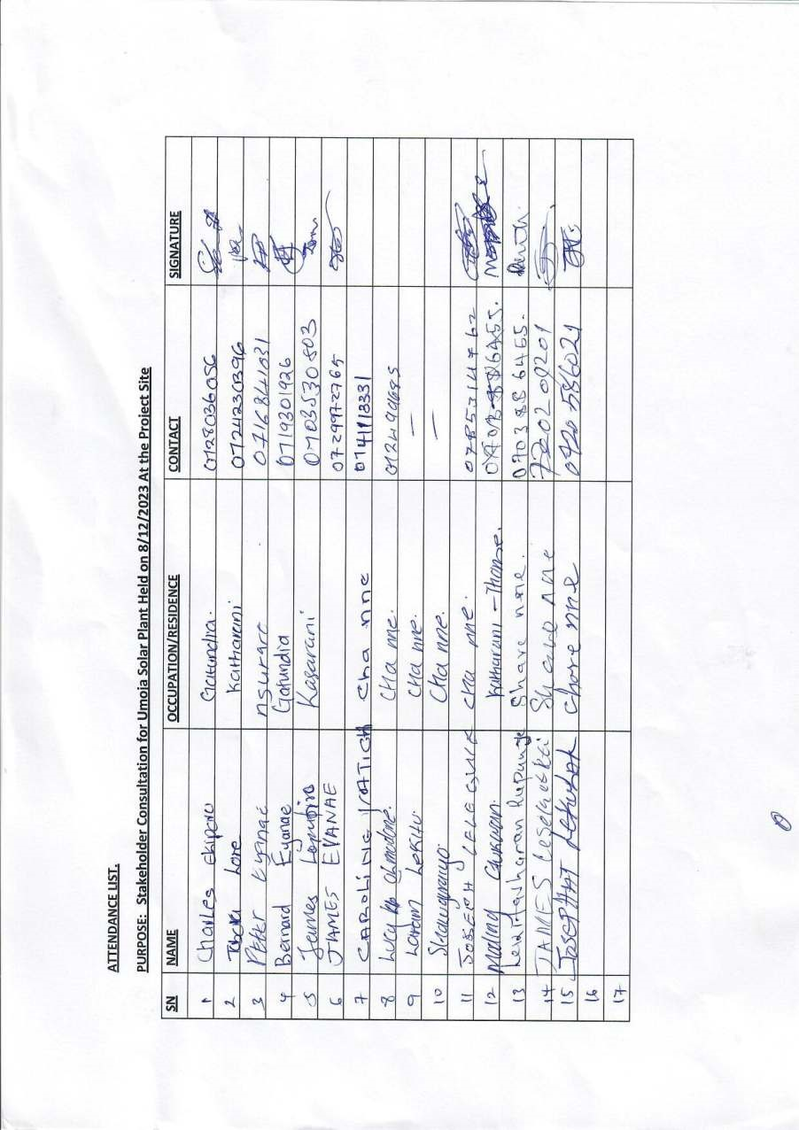
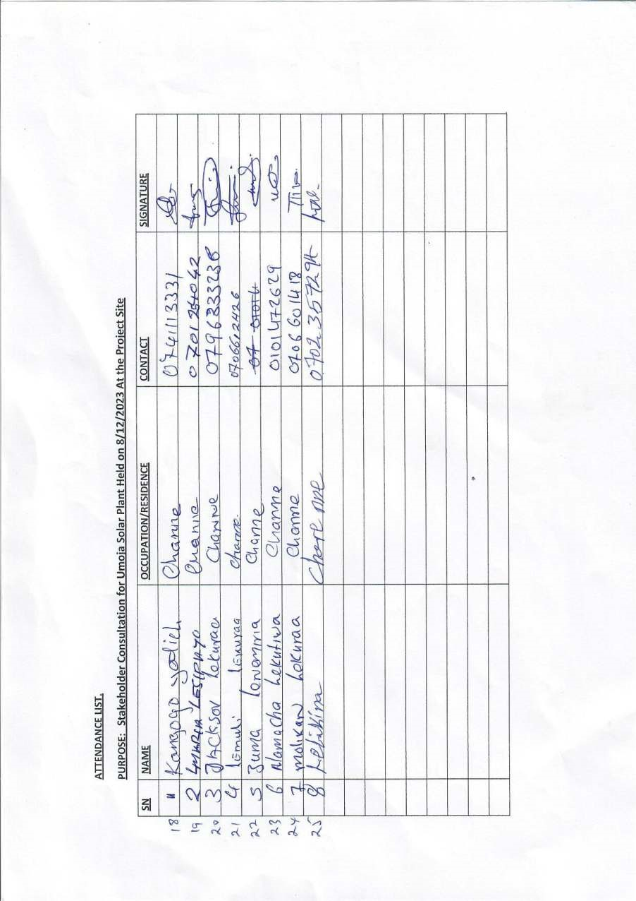
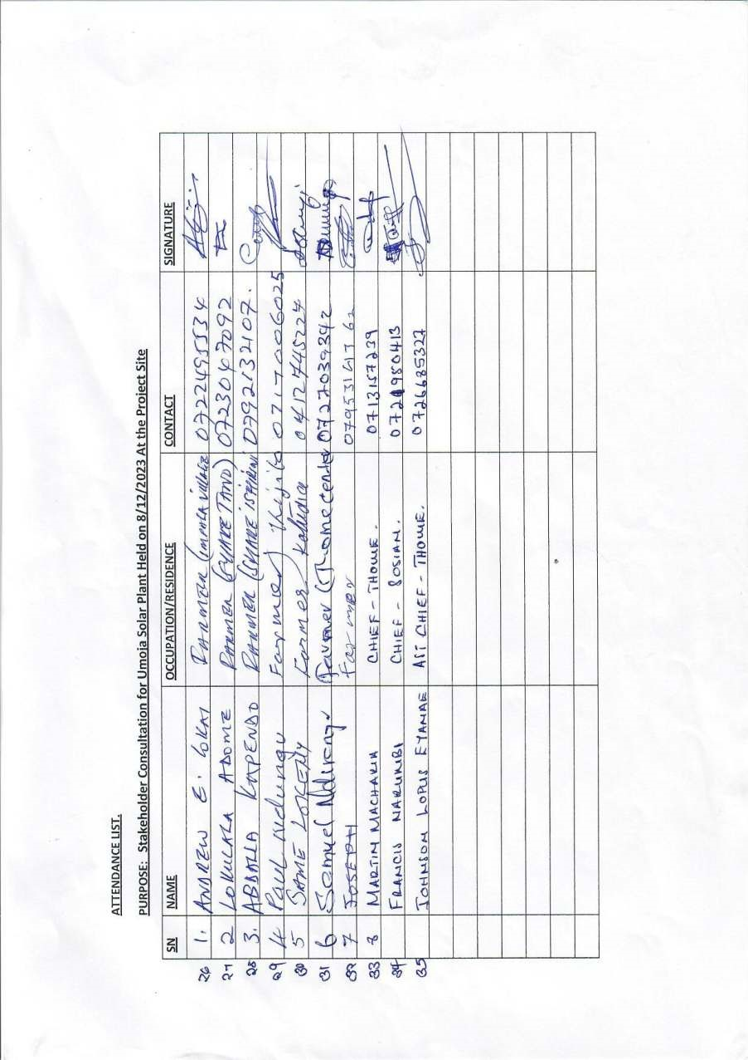
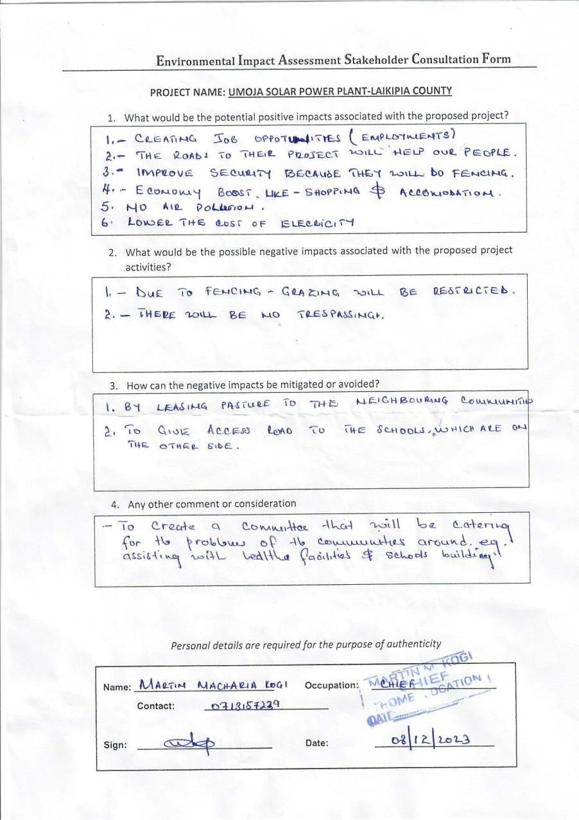
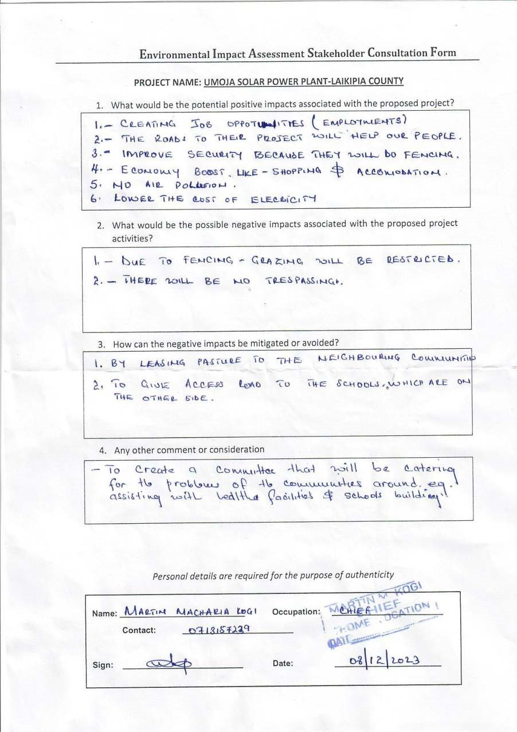
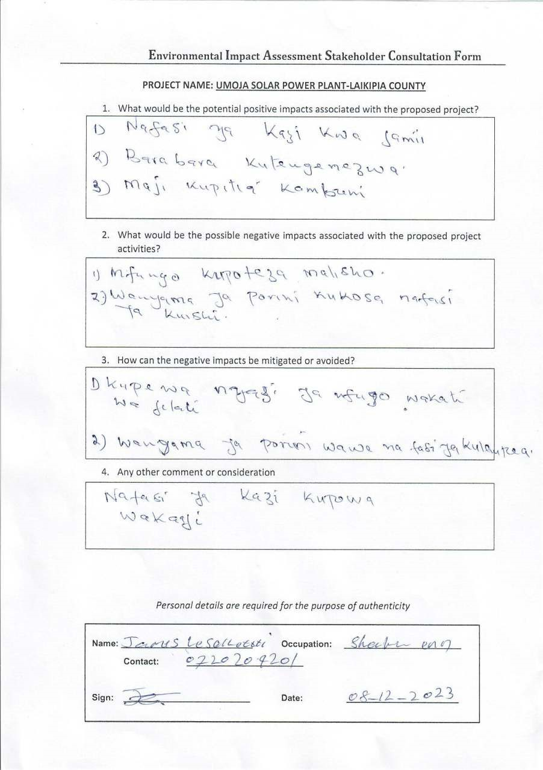
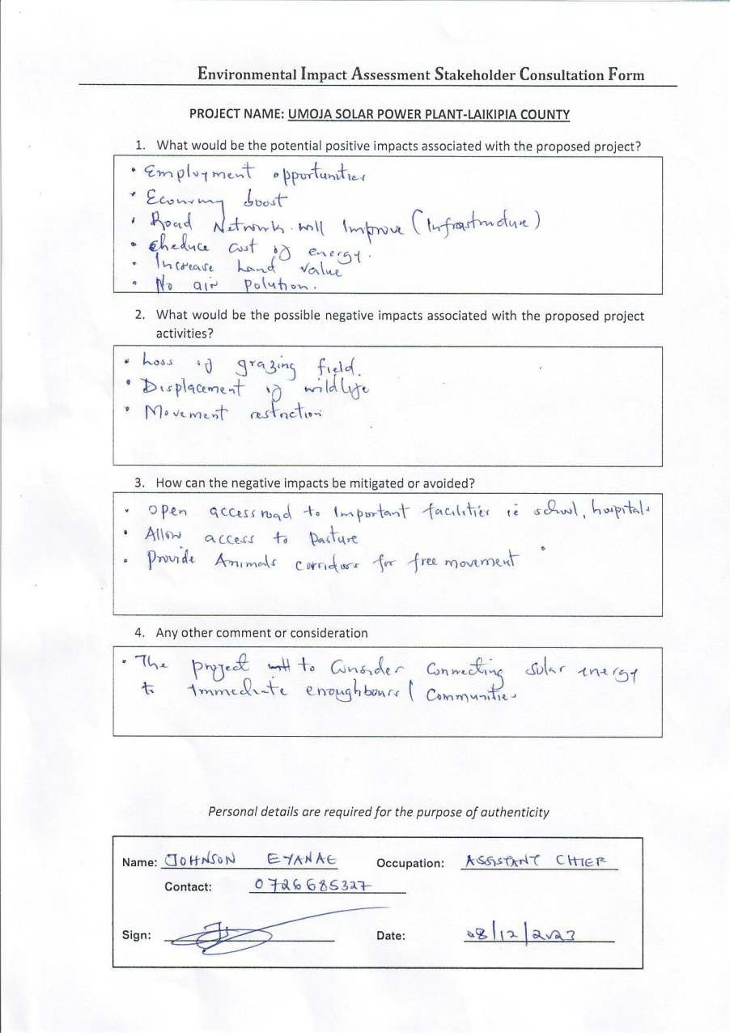
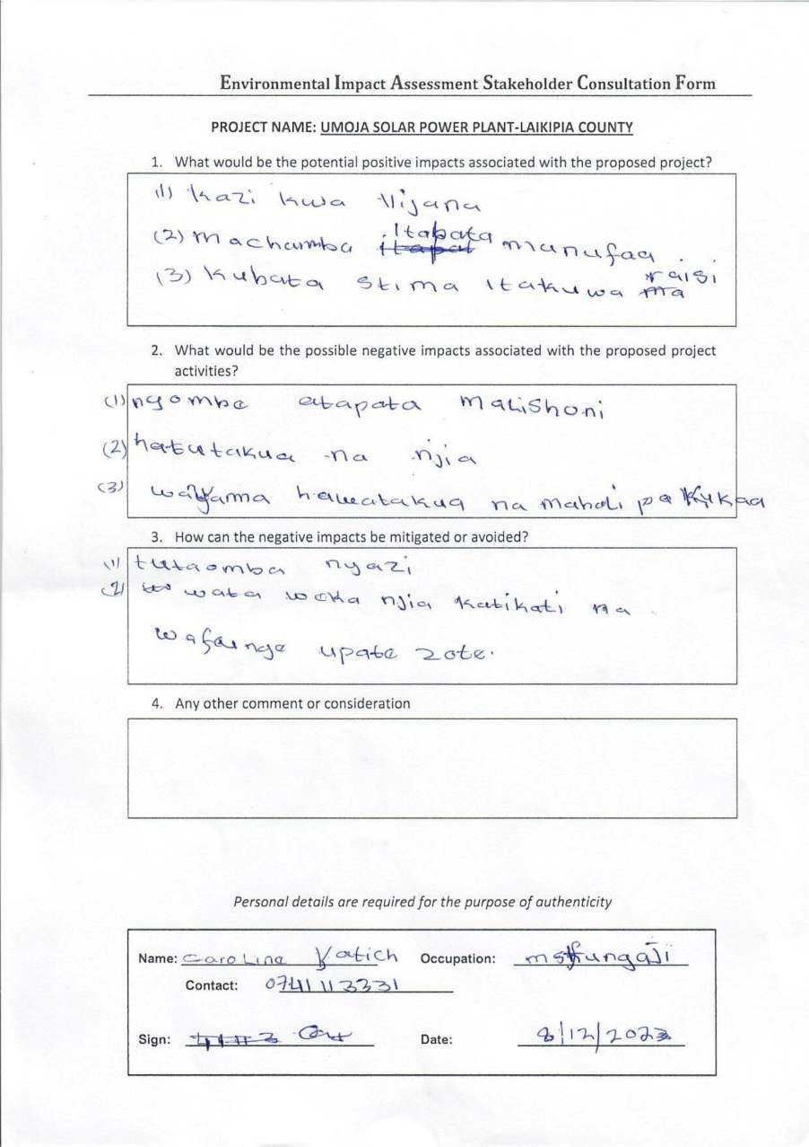
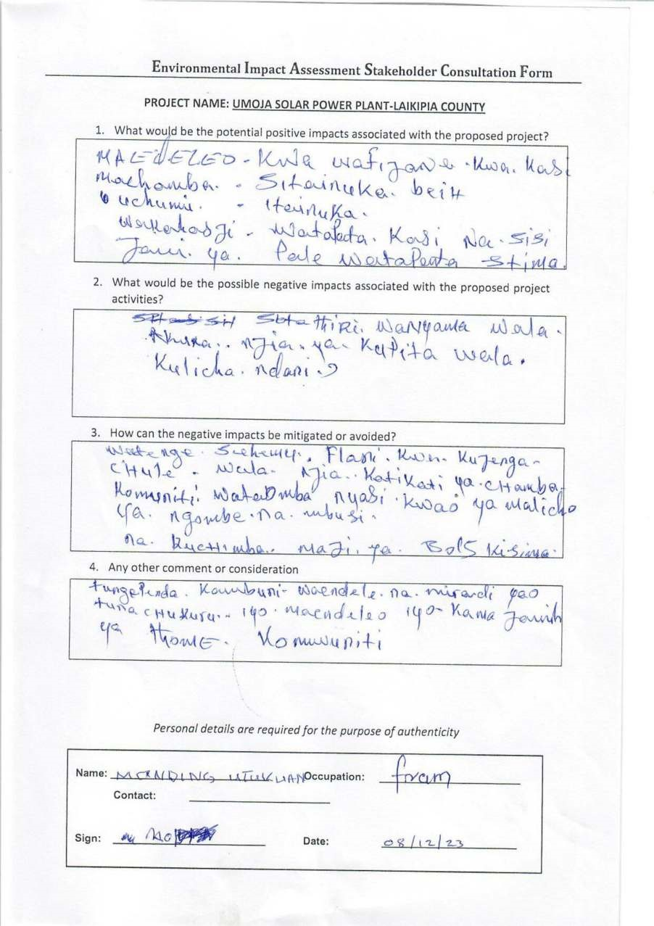
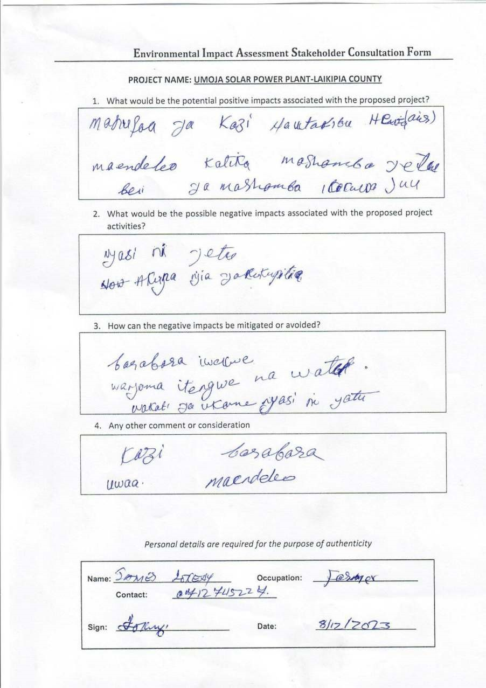
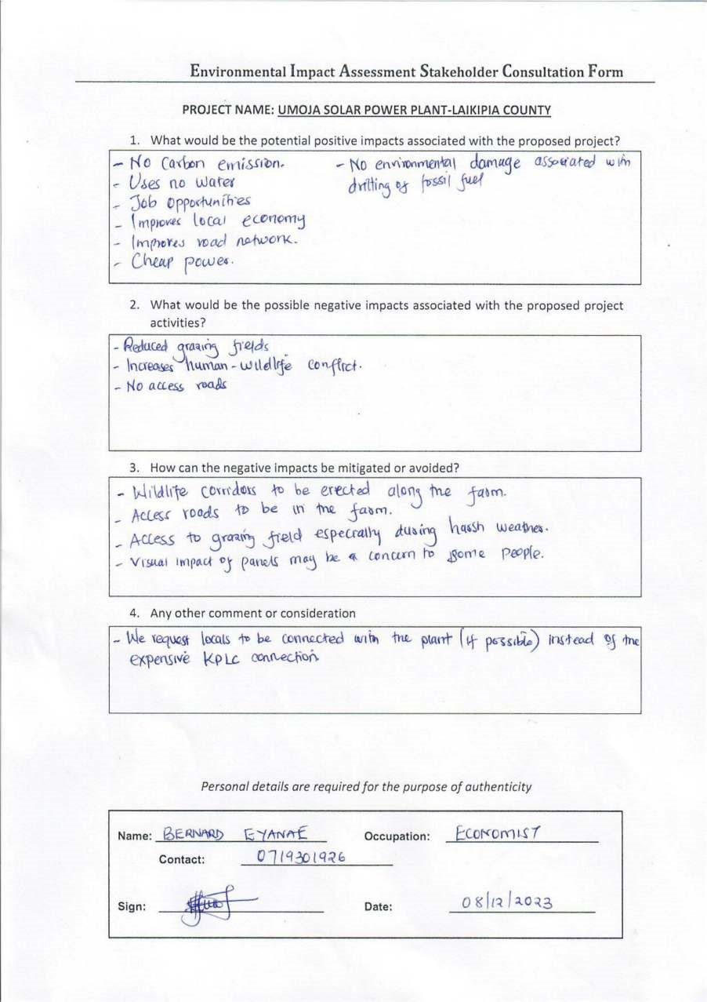

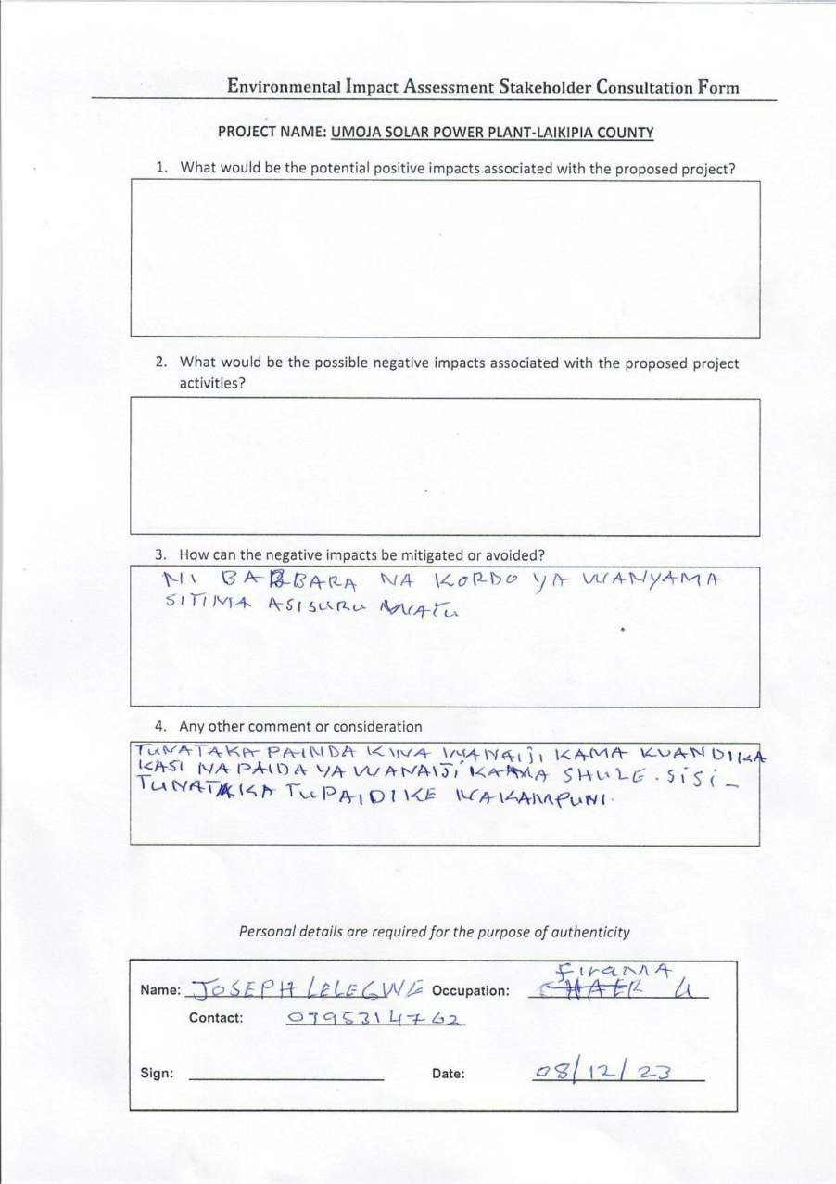
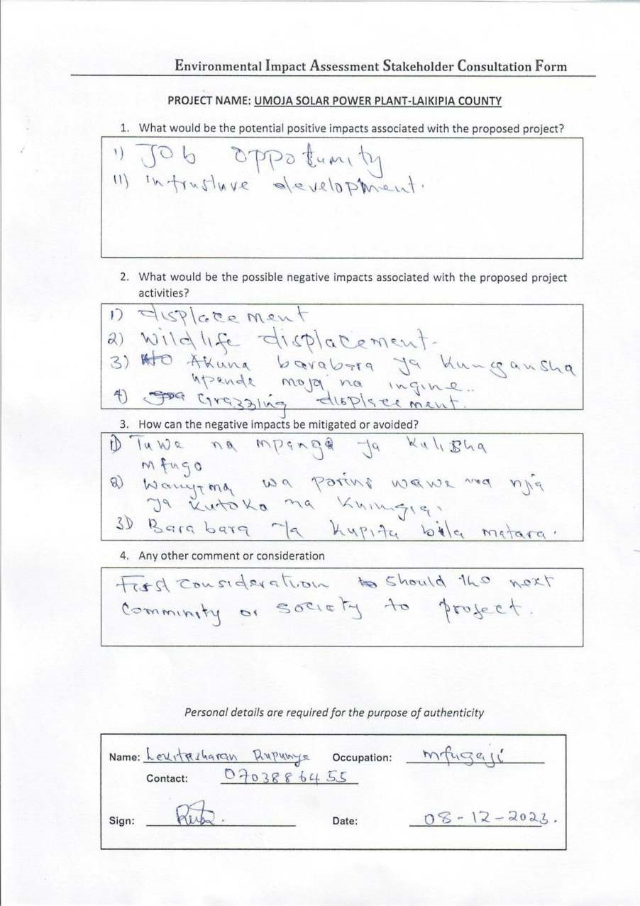
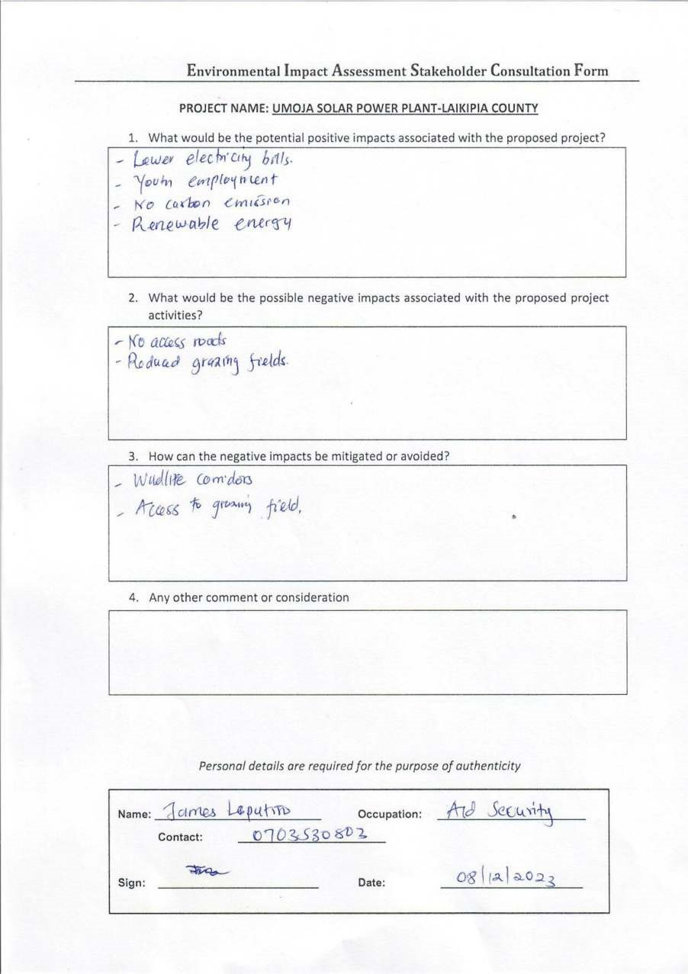
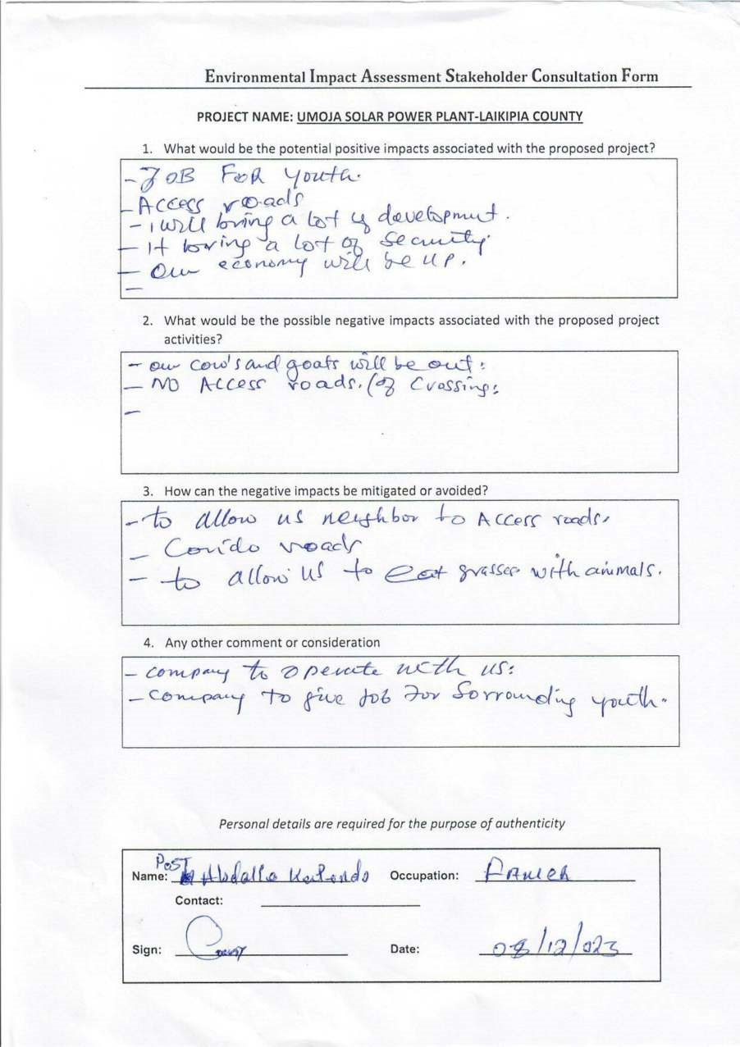
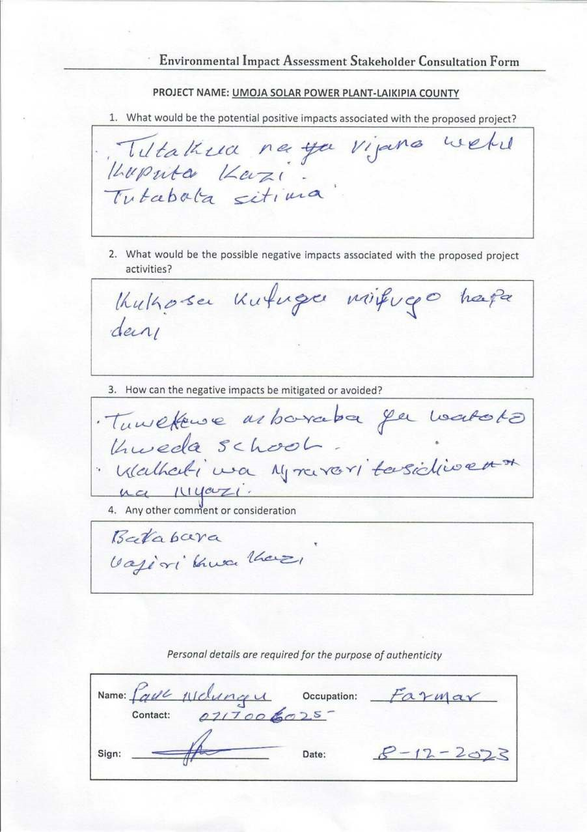
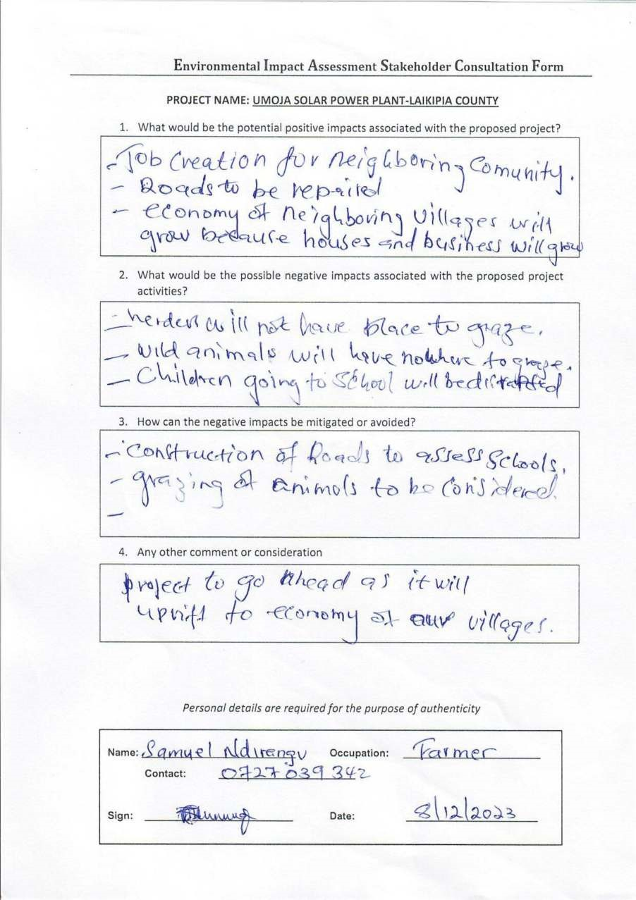
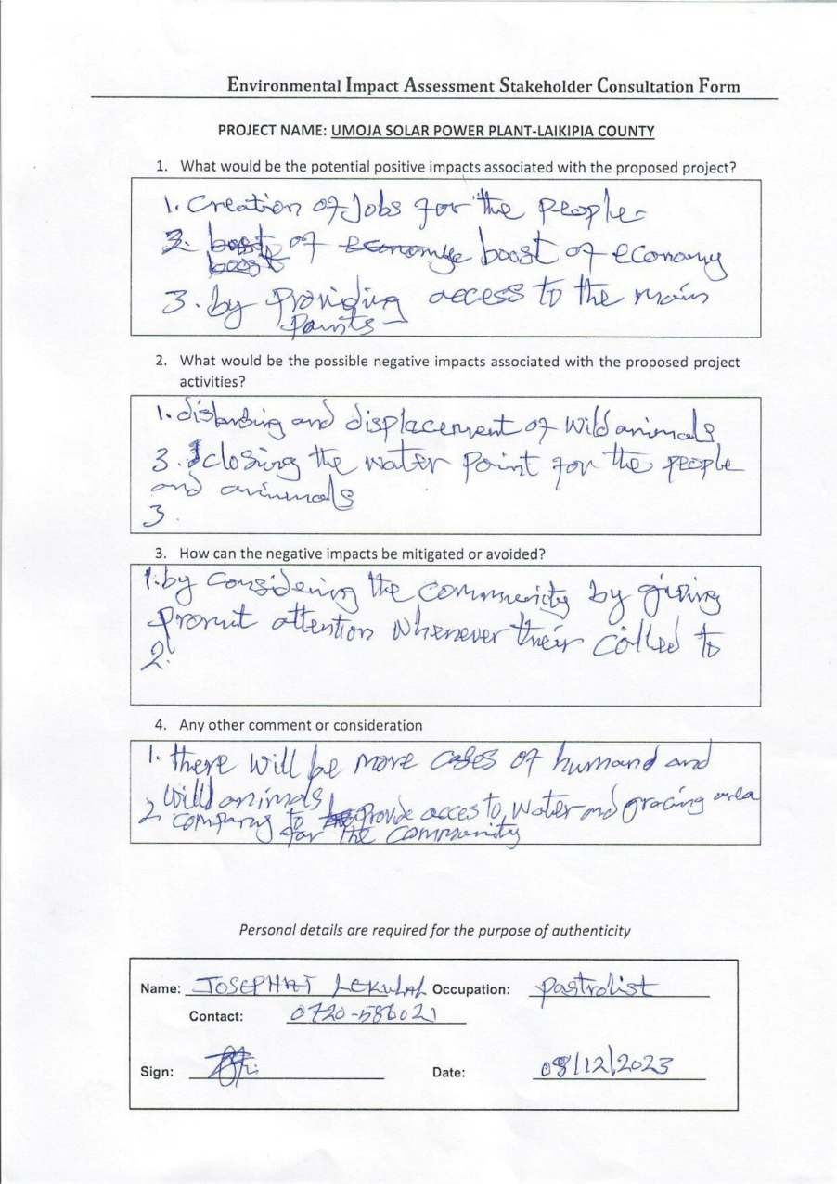
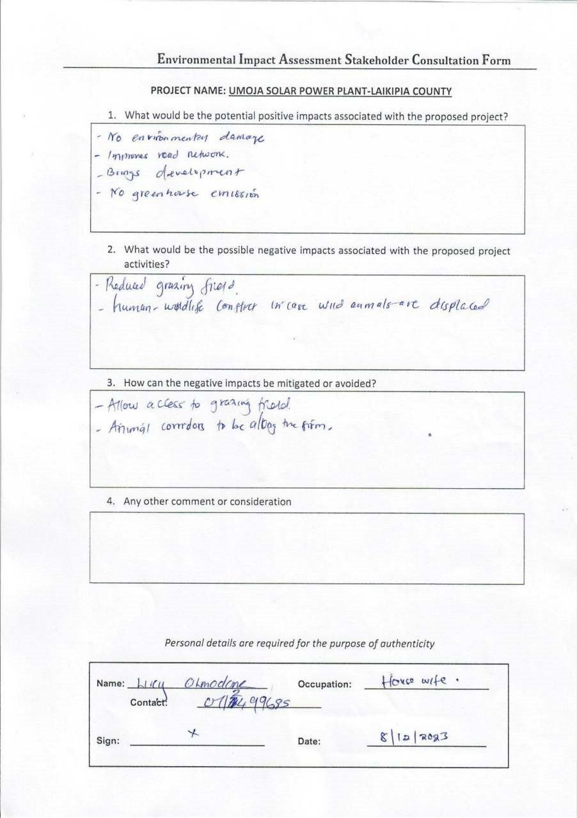

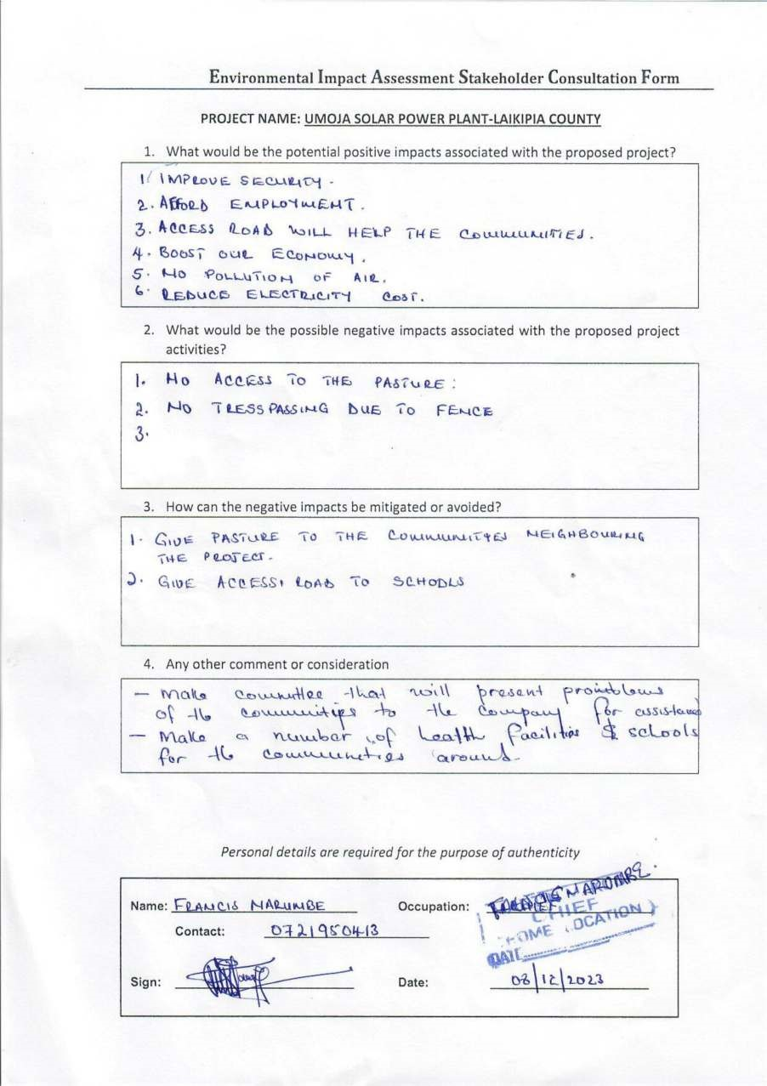
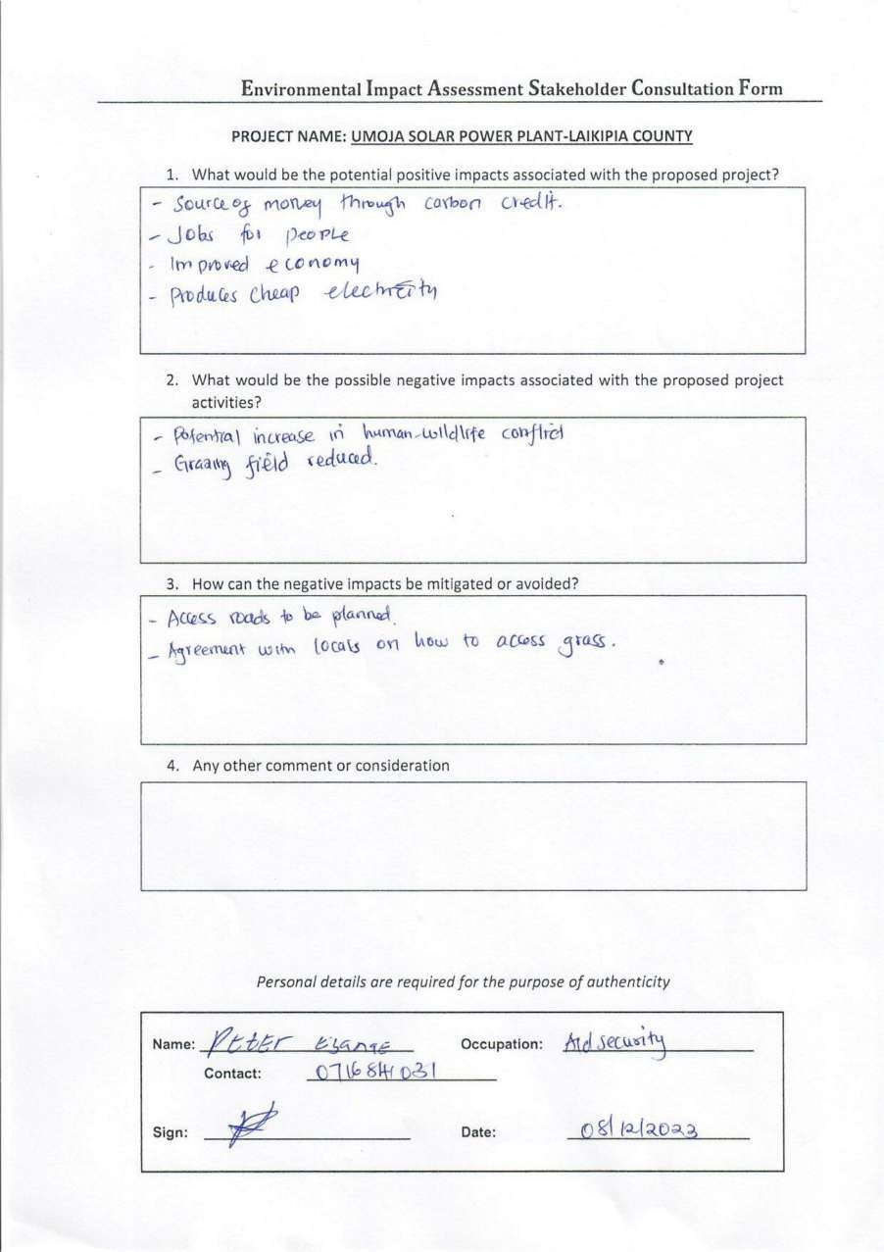
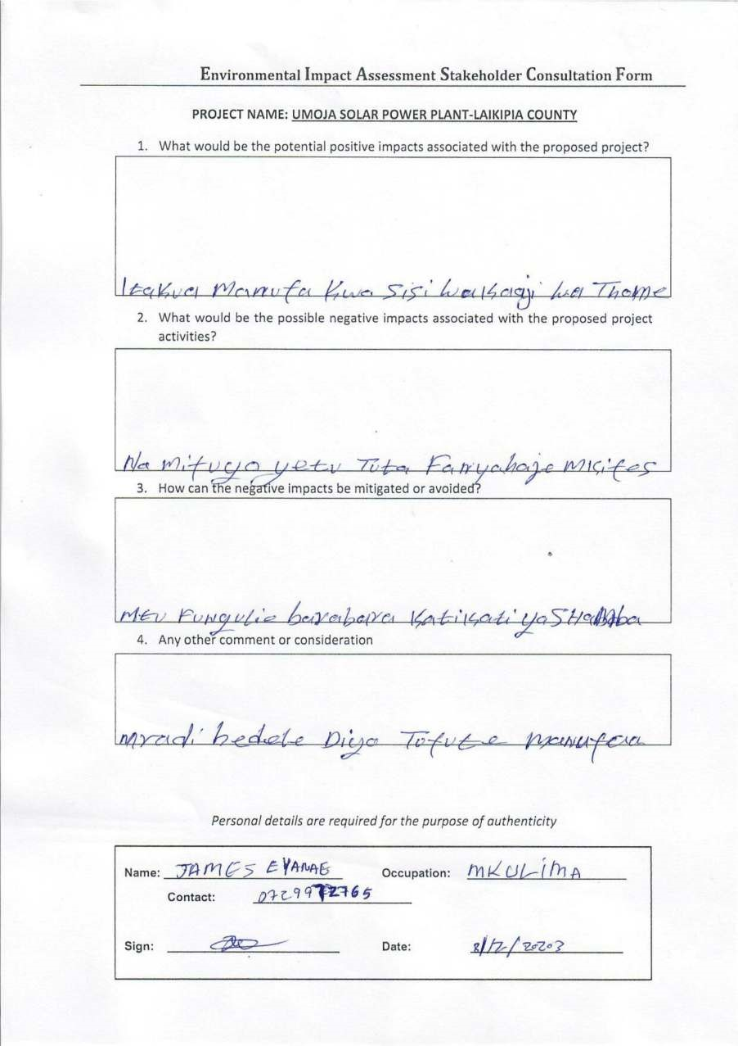
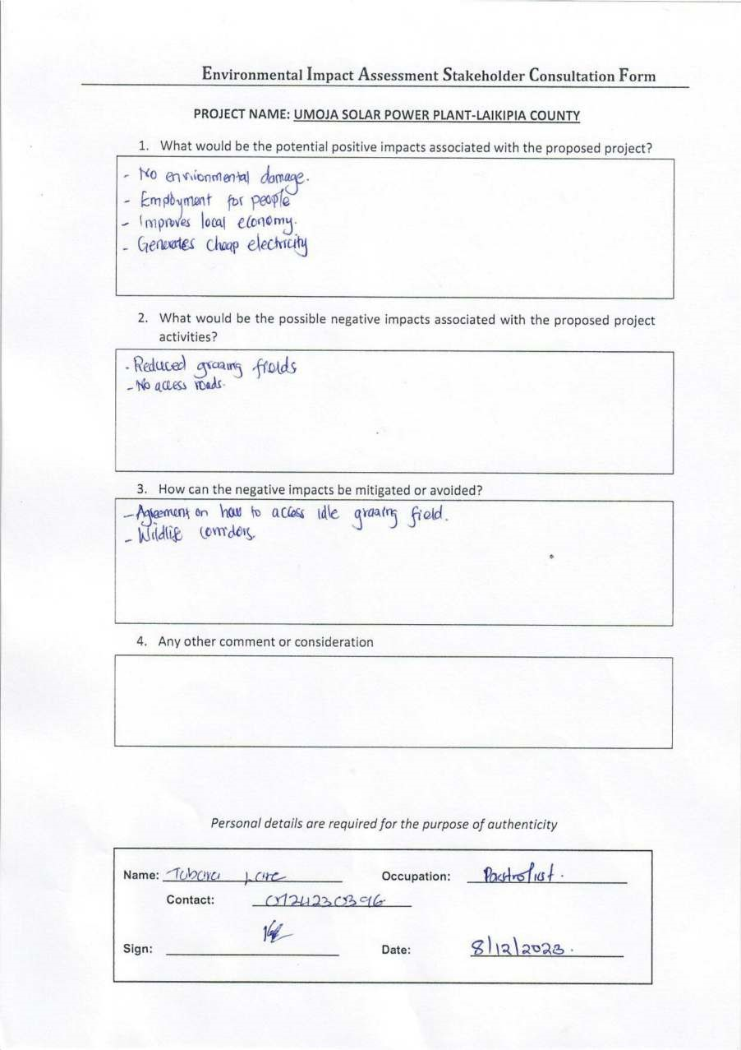
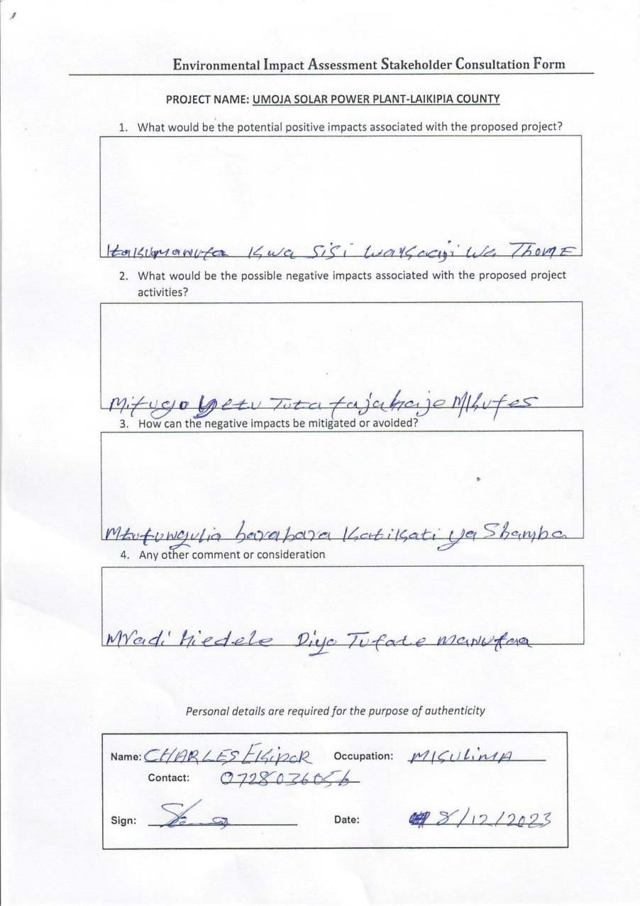
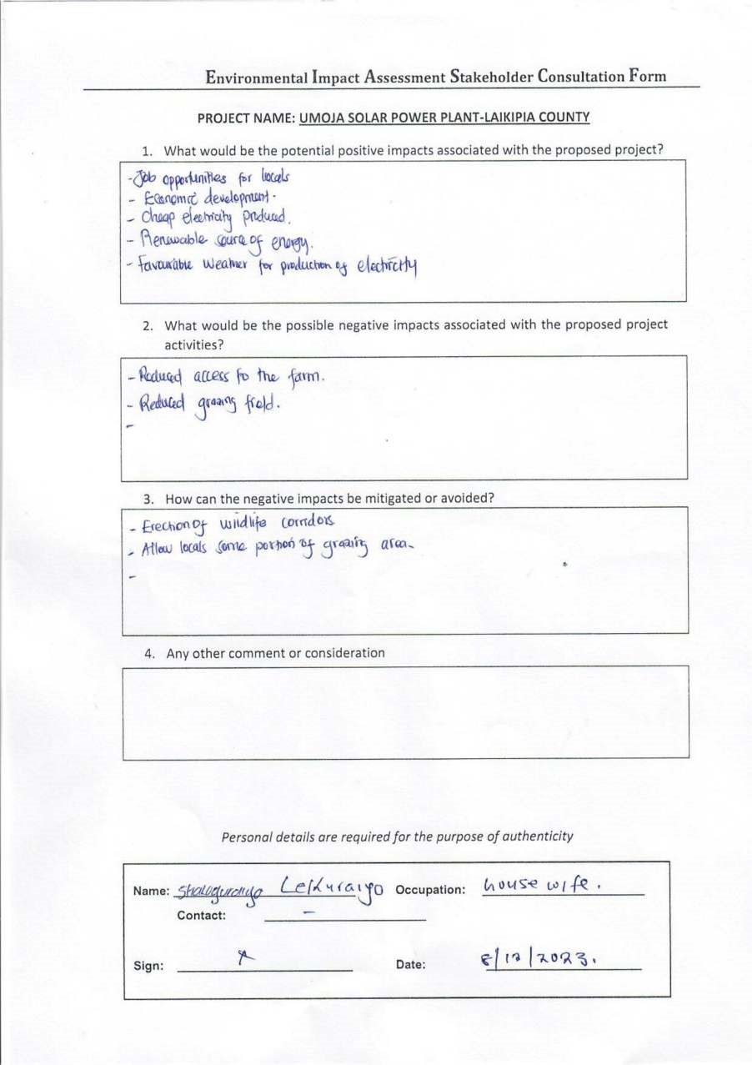
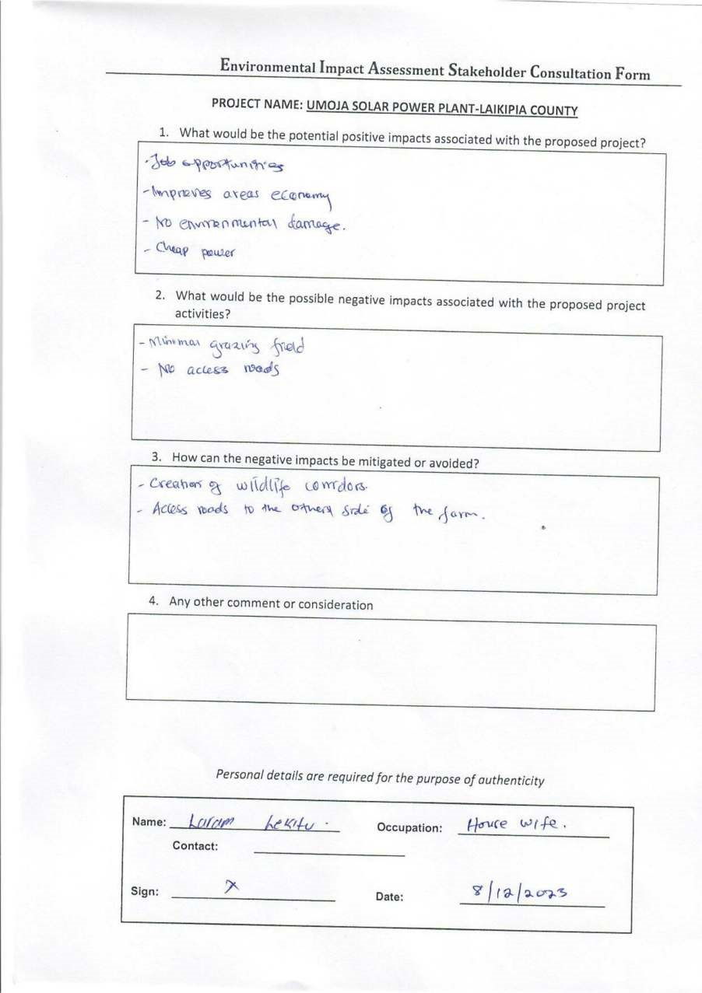
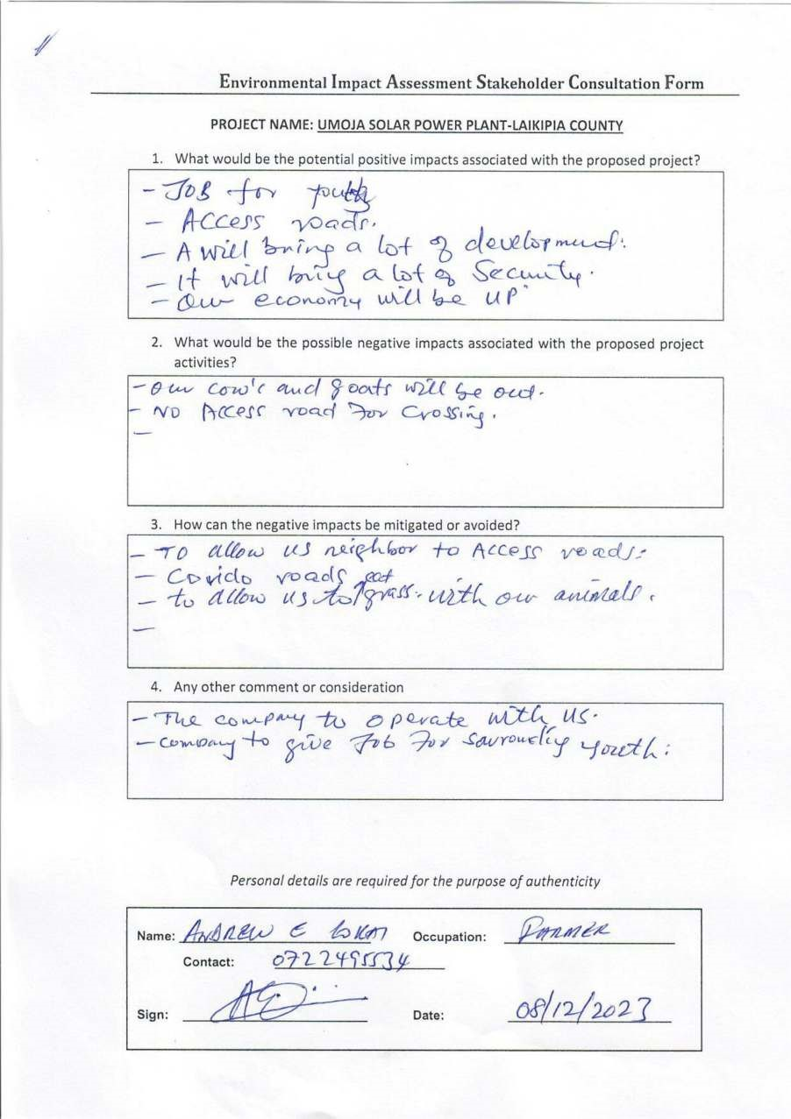
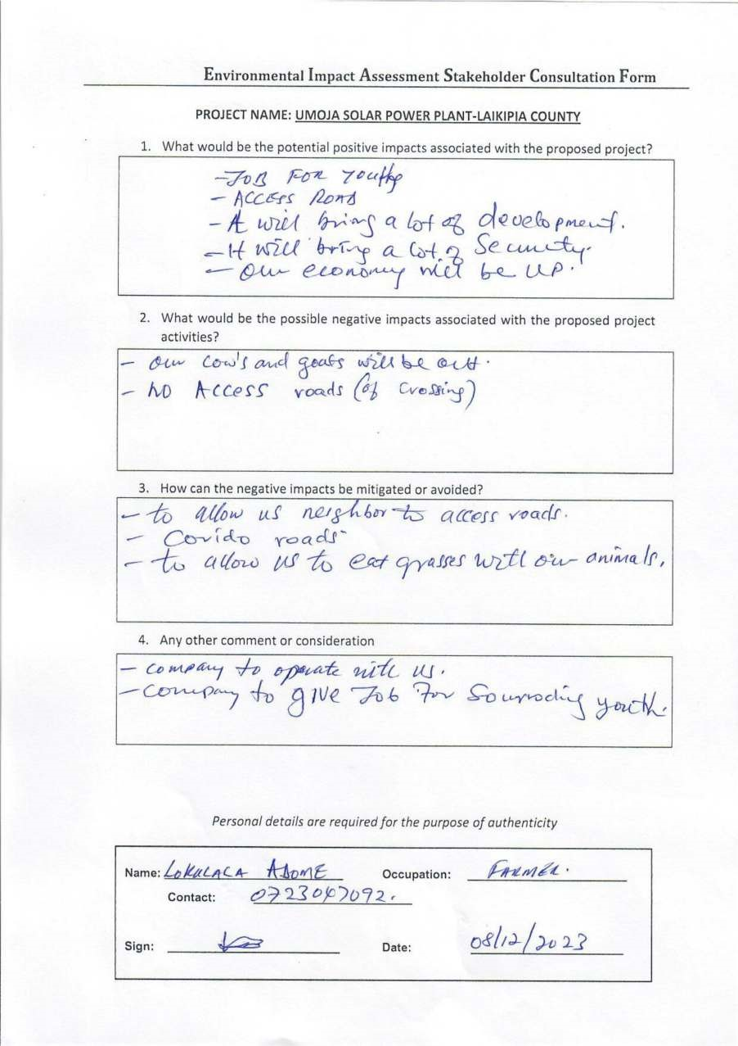
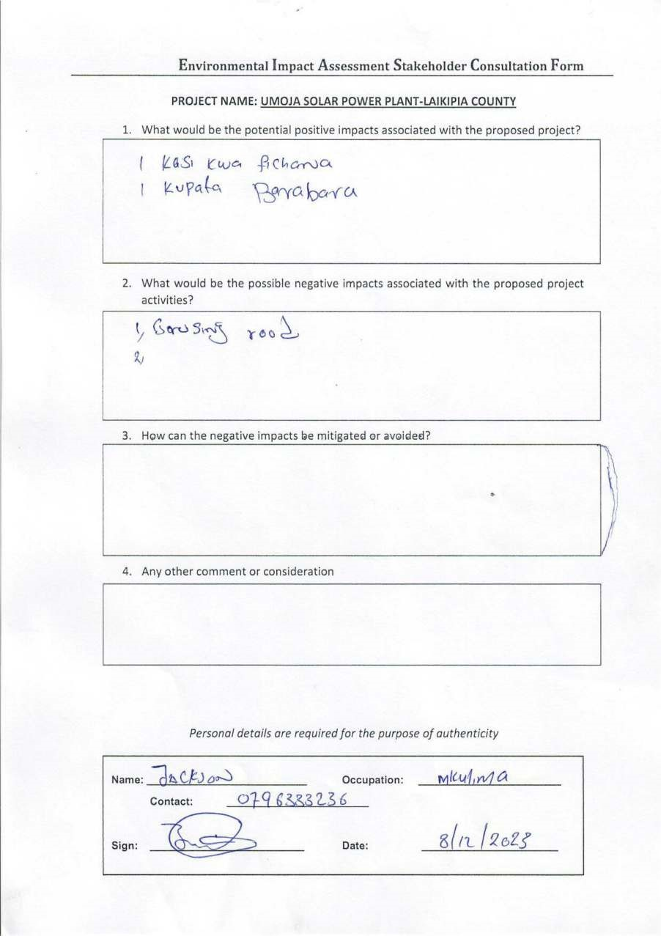
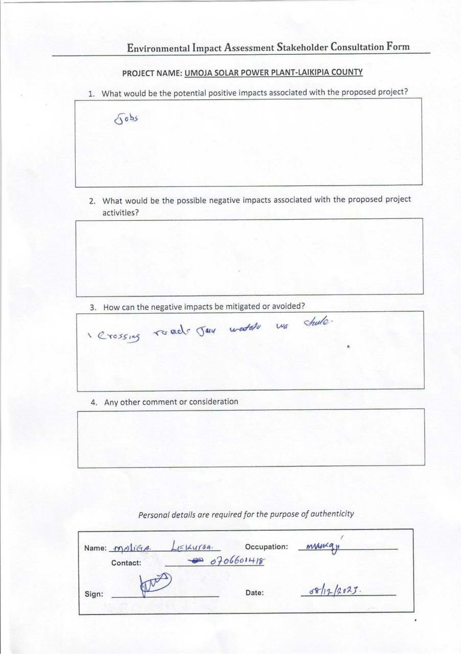
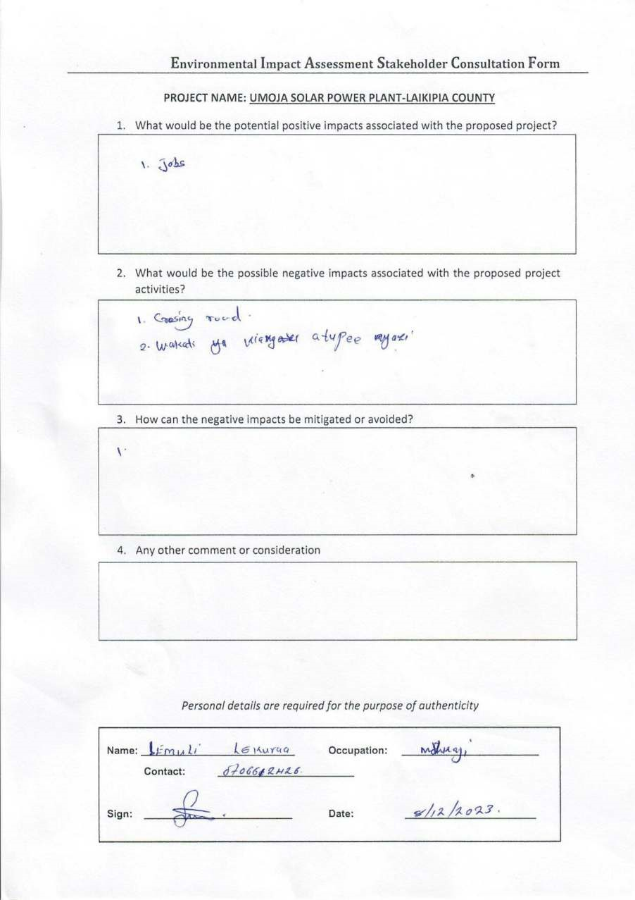

APPENDIX B

PROPONENT’S REGISTRATION DOCUMENTS

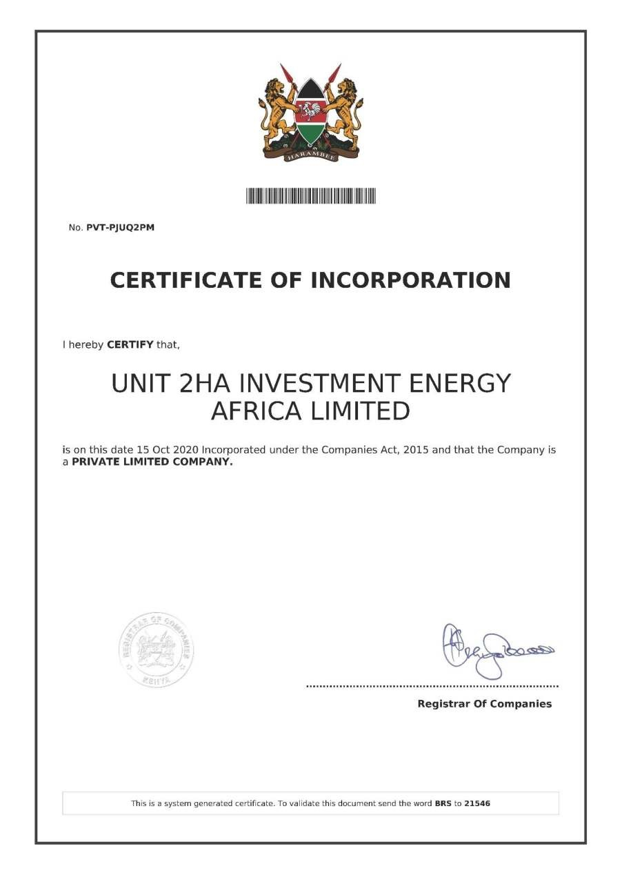
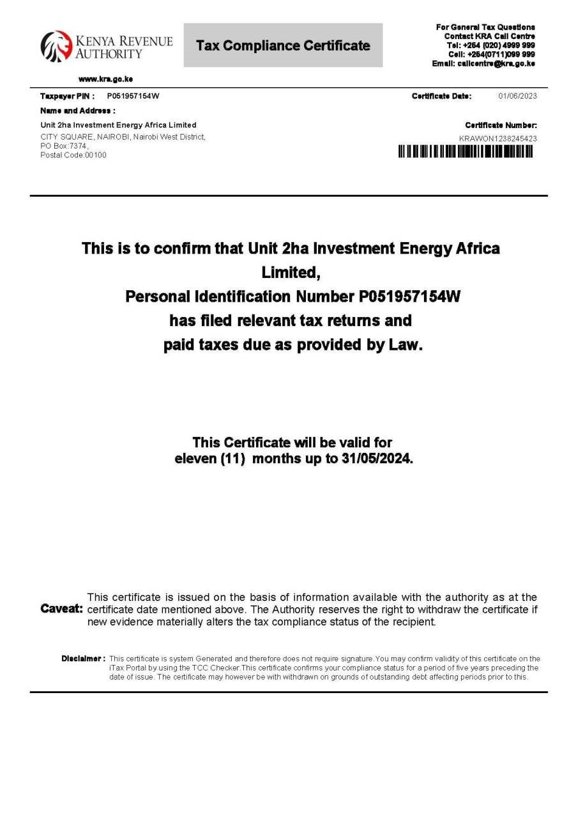
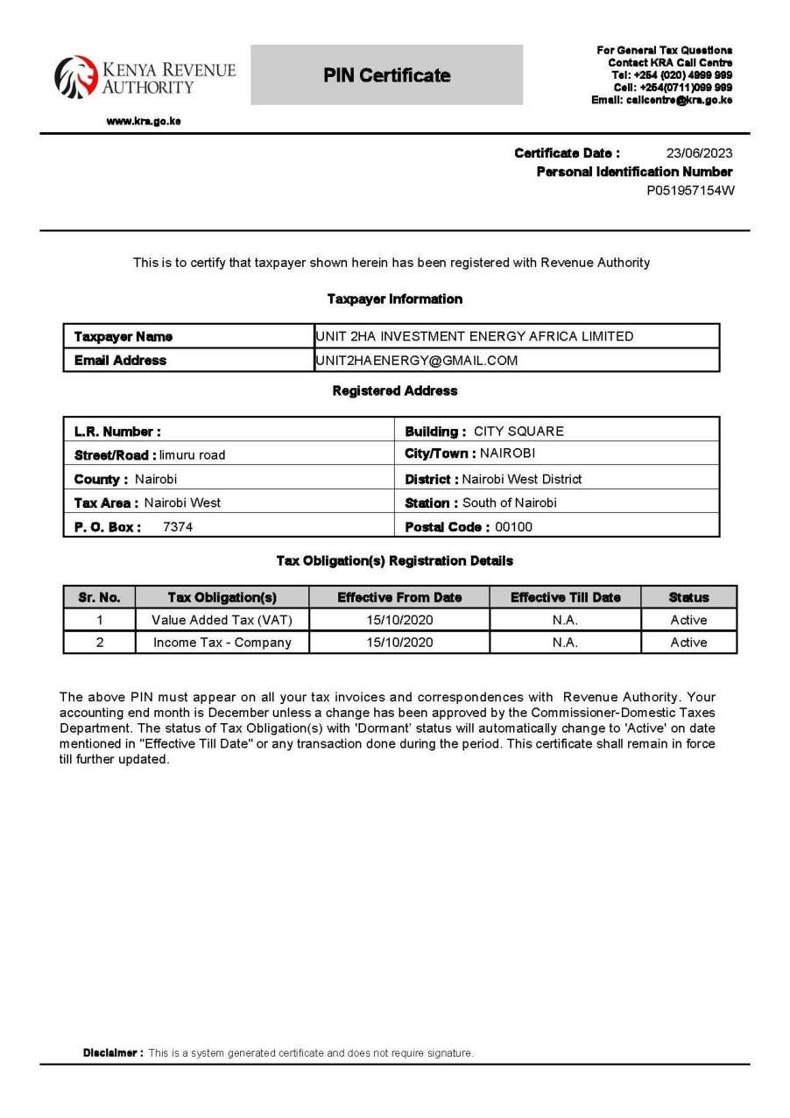

APPENDIX C

LAND OWNERSHIP DOCUMENTS

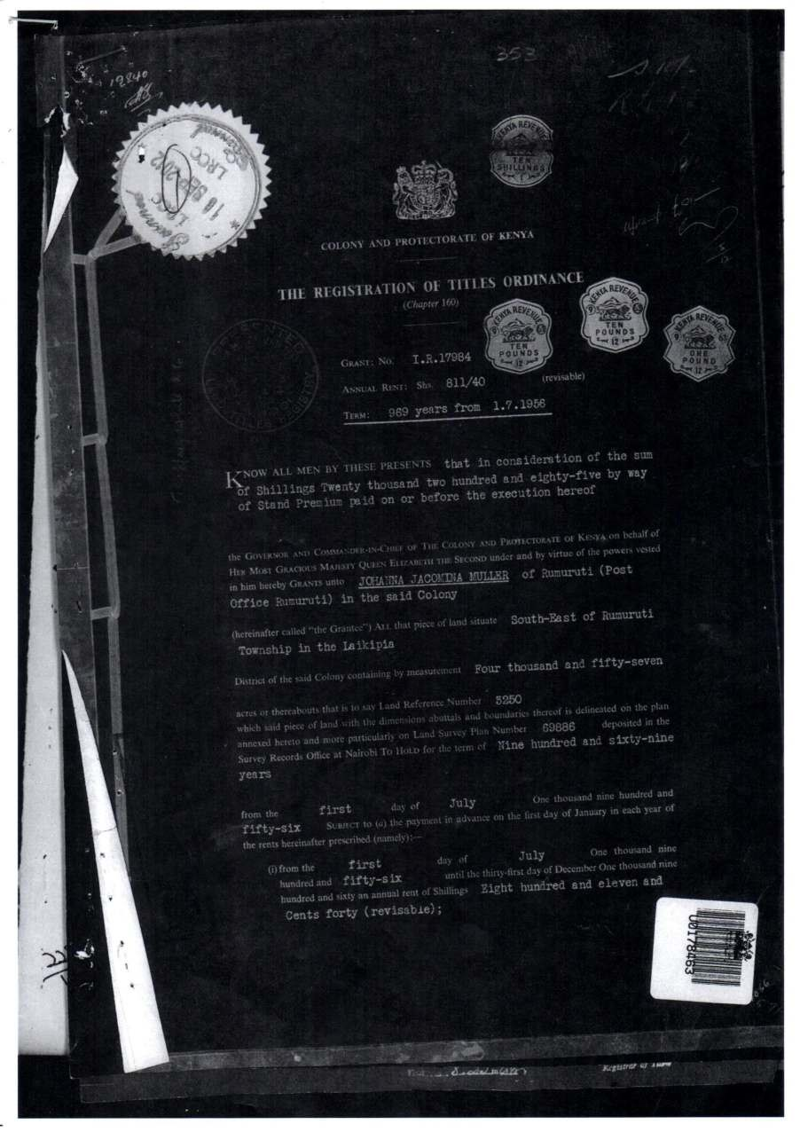

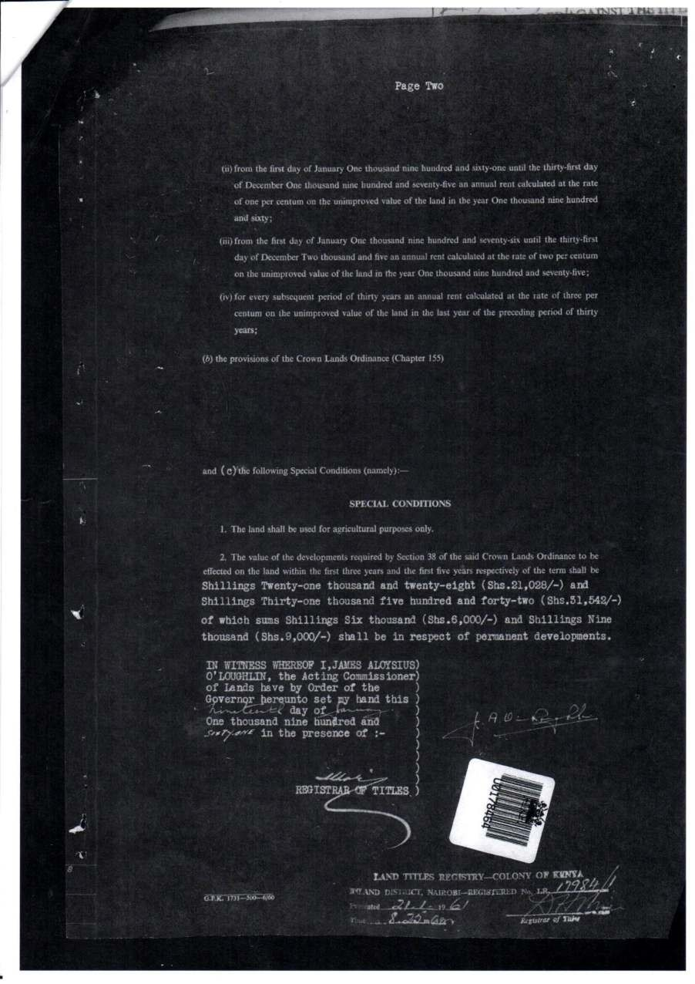
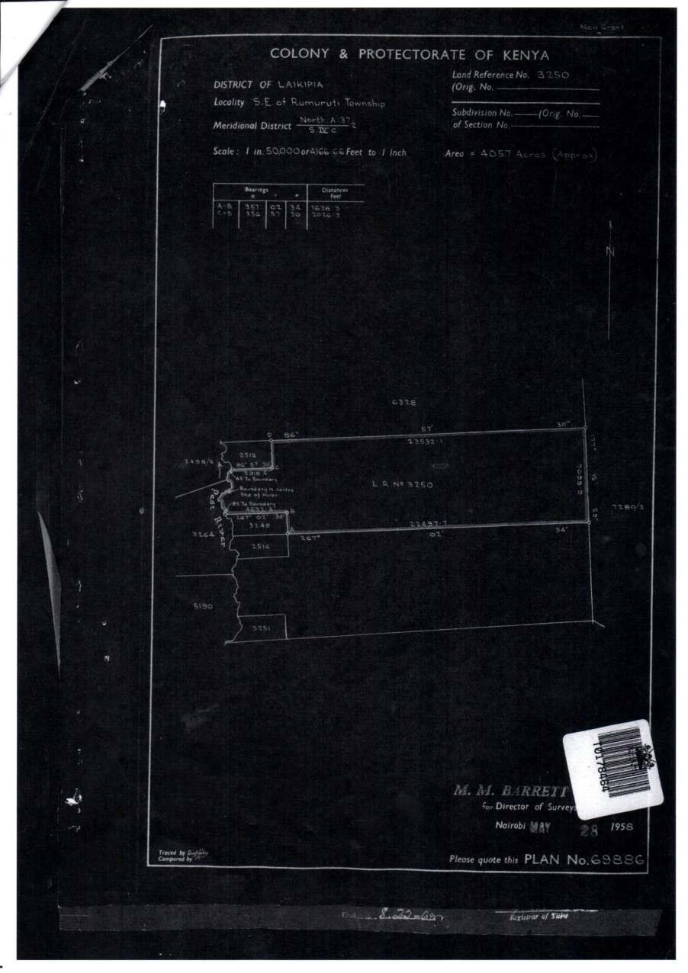
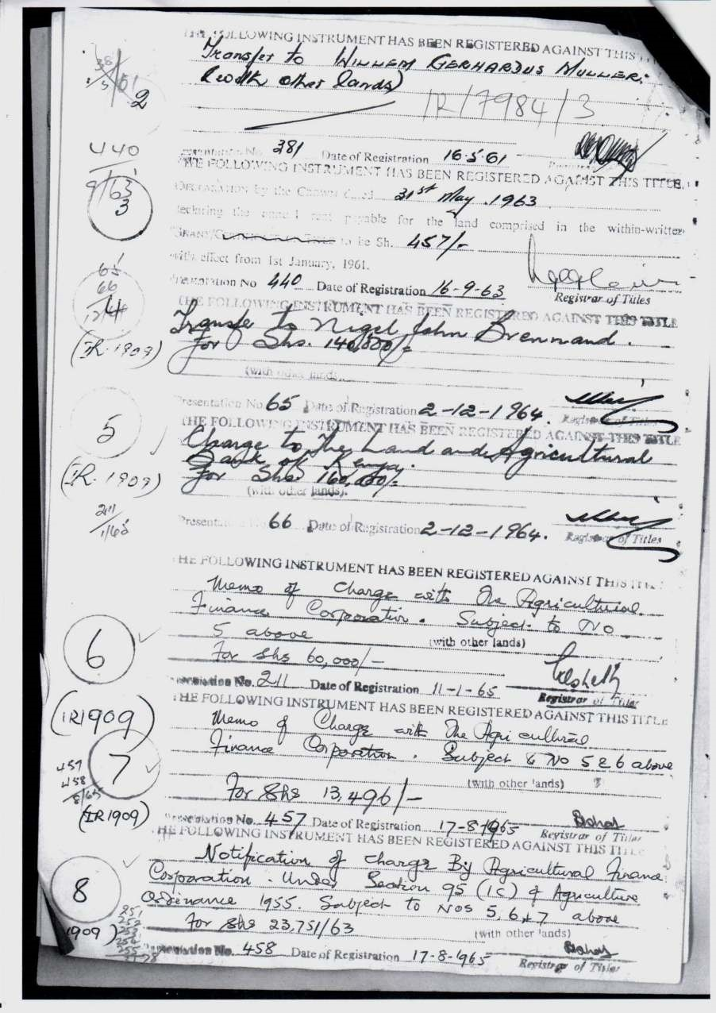
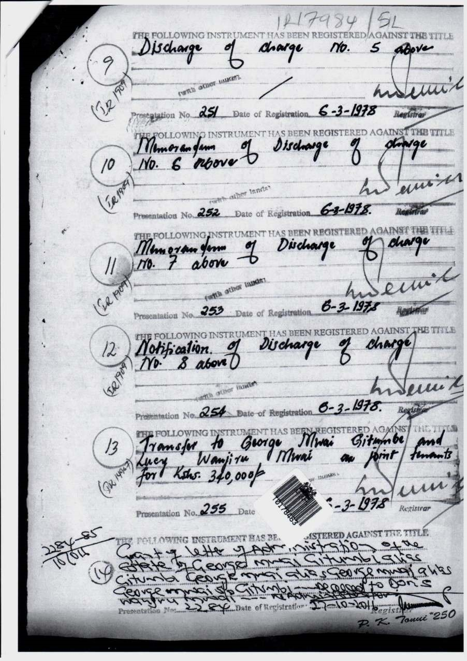
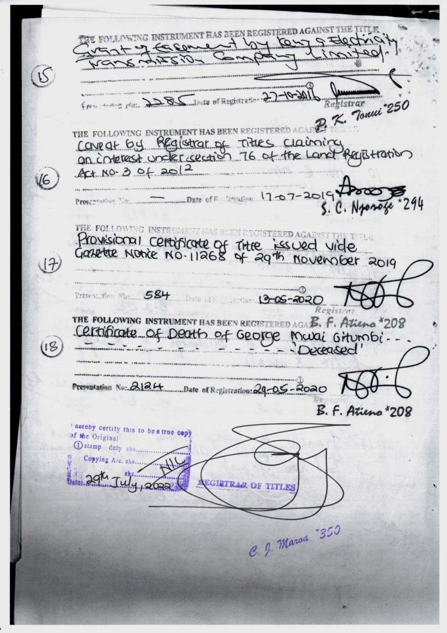

APPENDIX D

BILL OF QUANTITIES

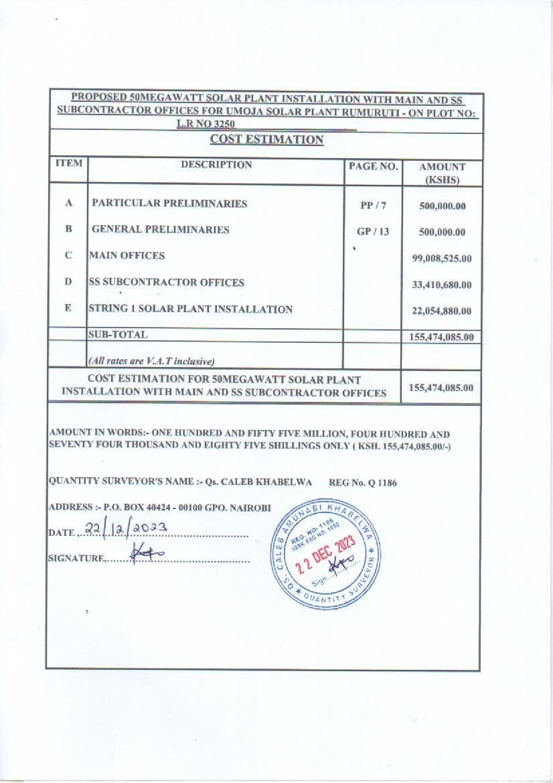





APPENDIX E

PROJECT DESIGN

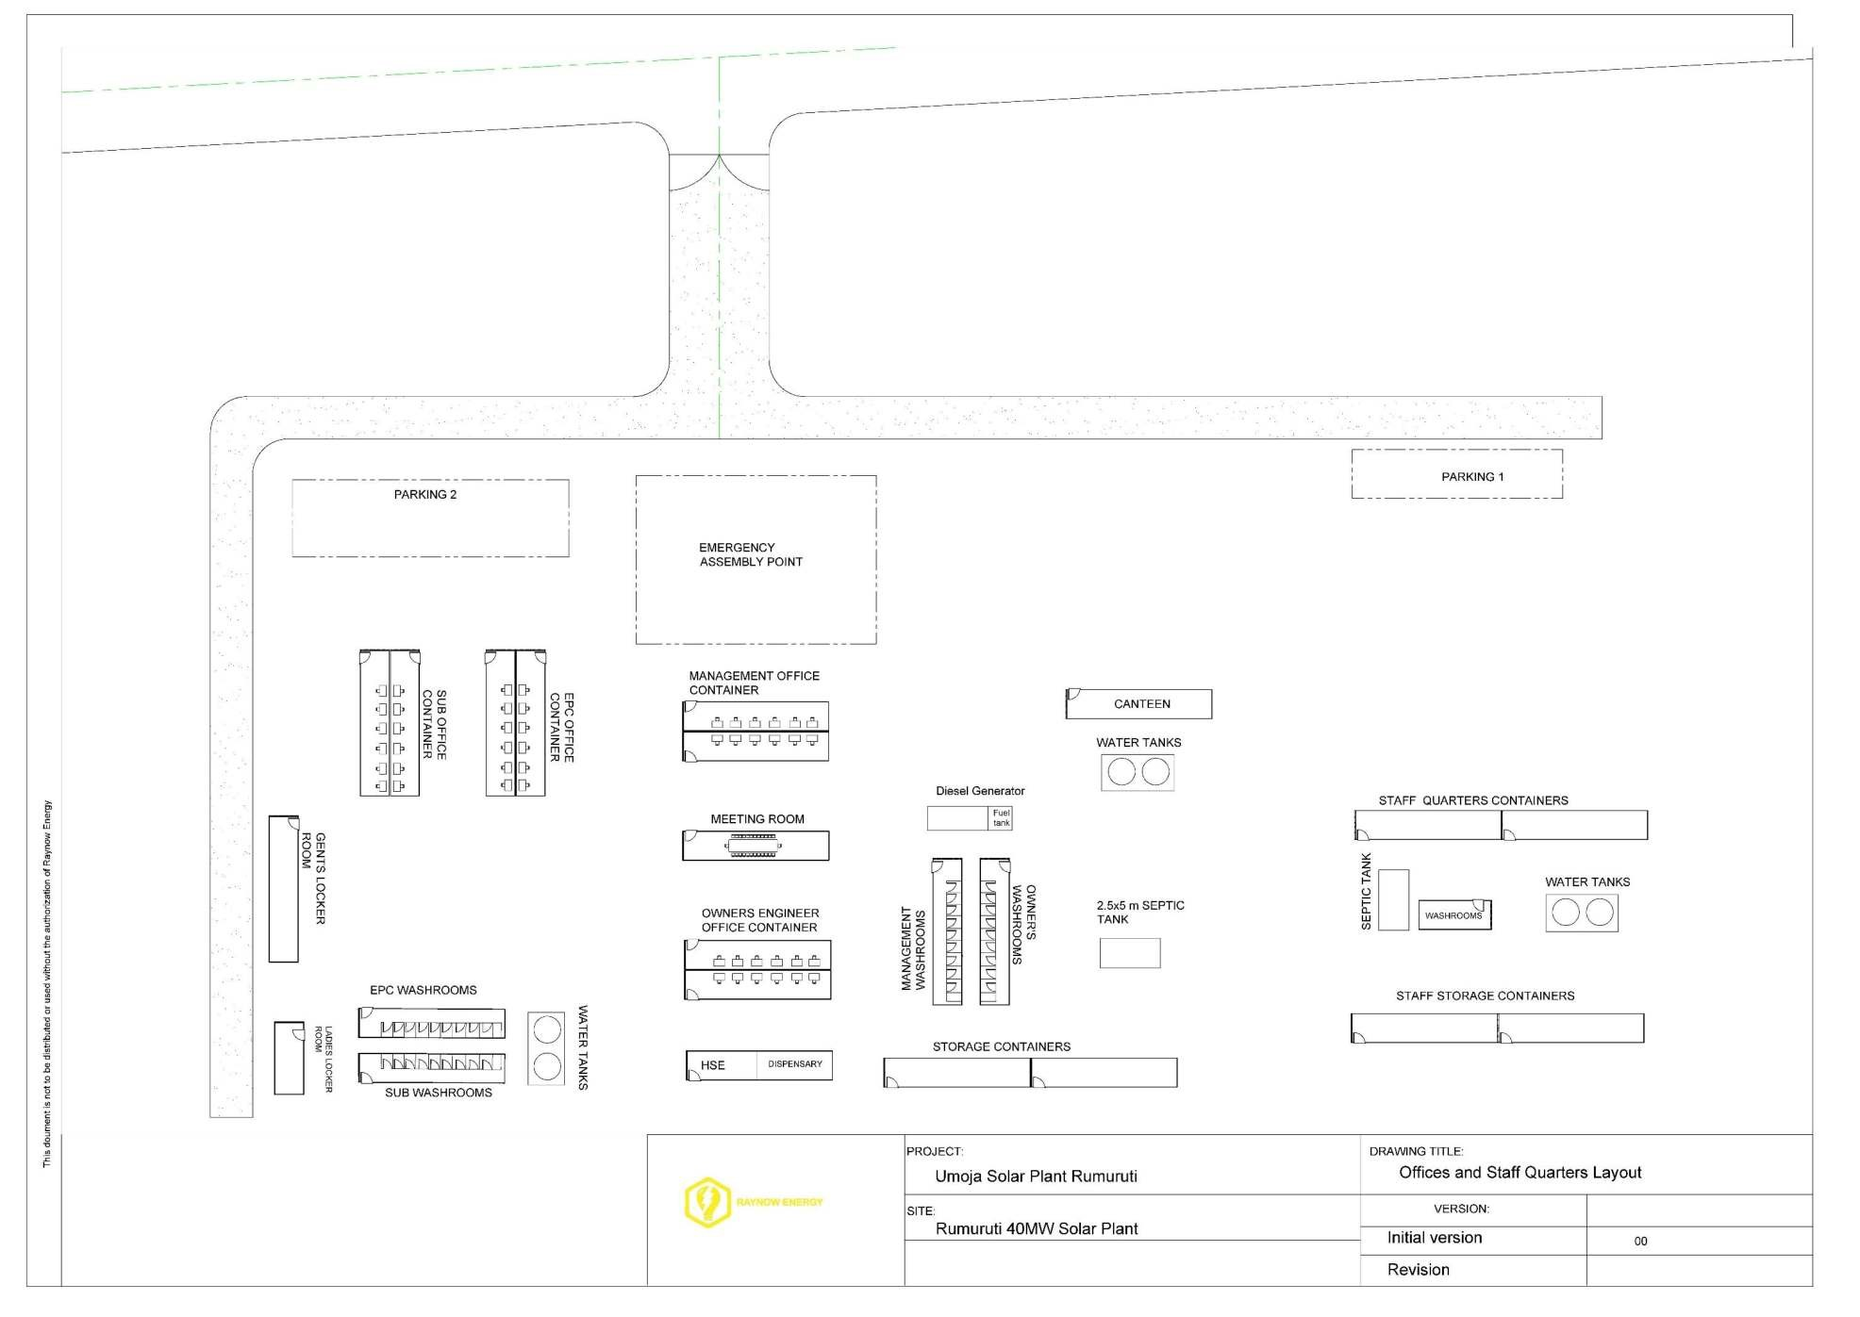

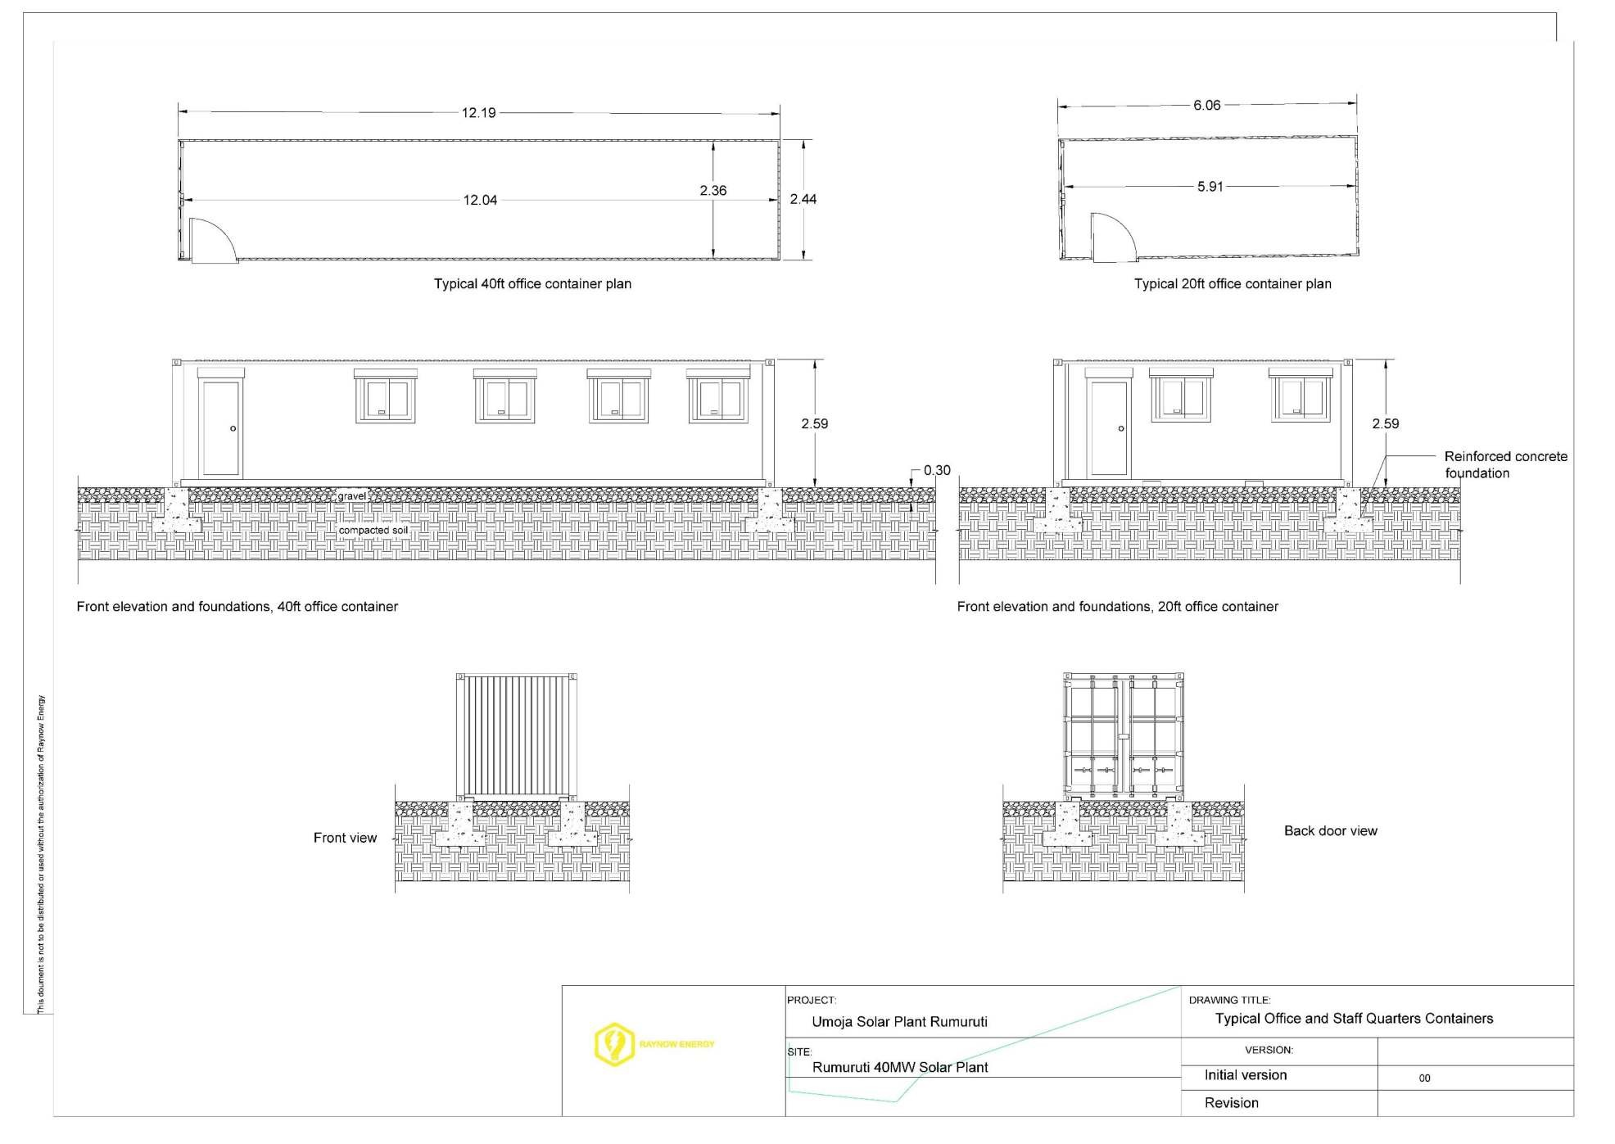
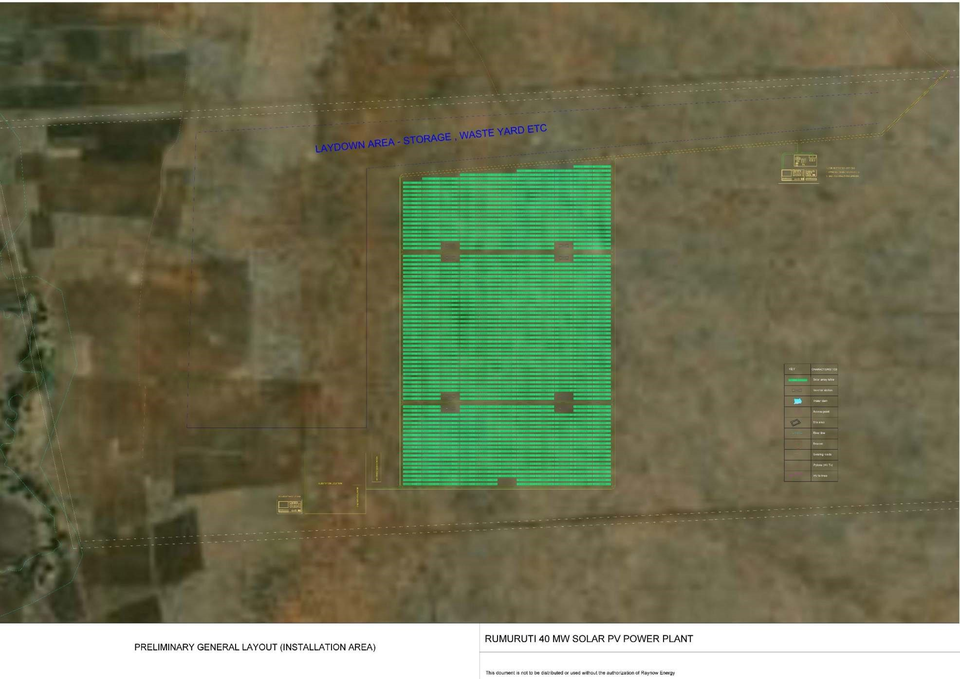
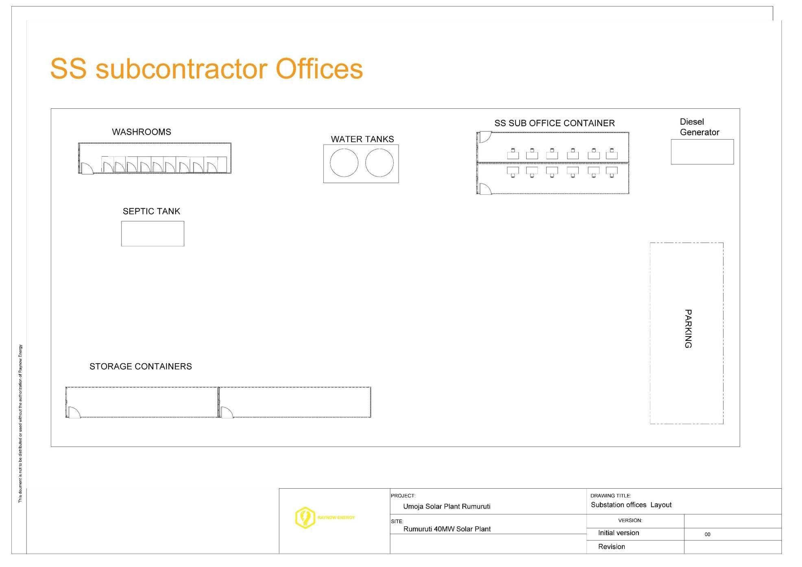
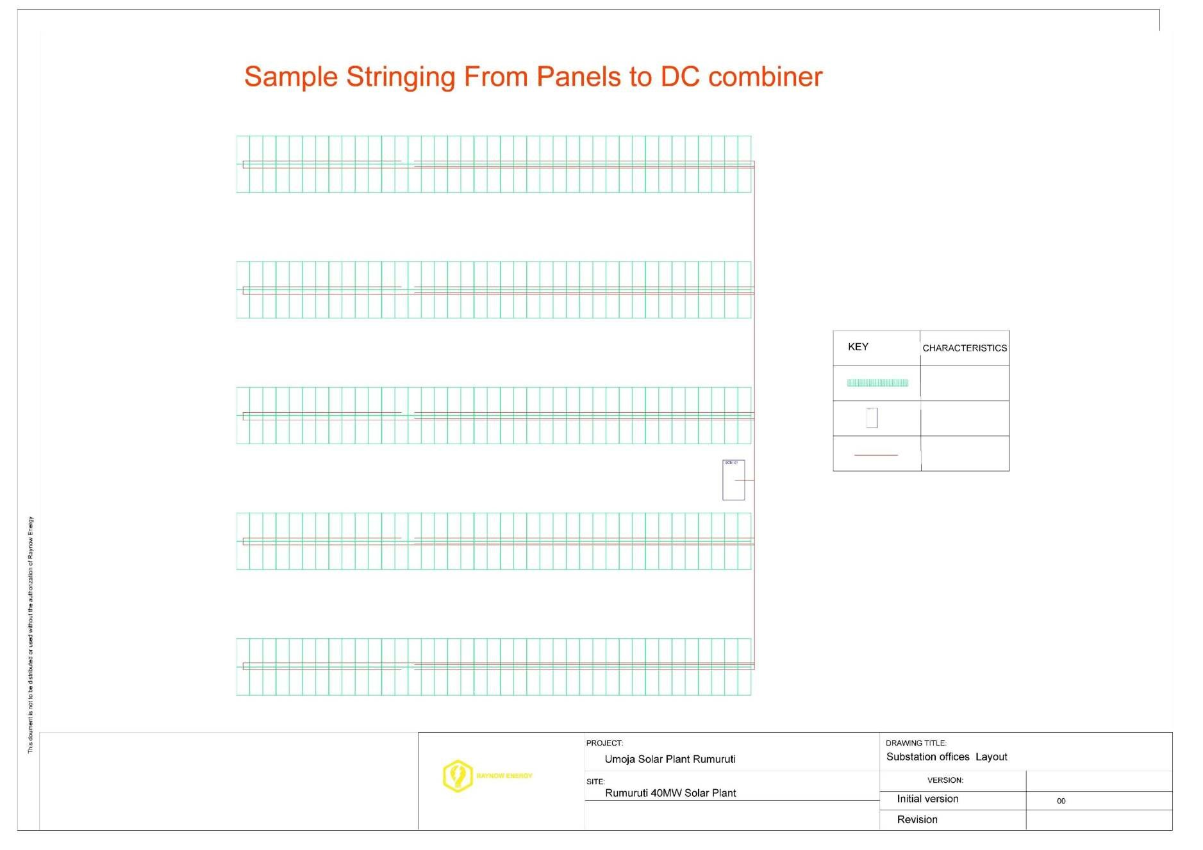

APPENDIX F EXPERT PRACTISING LICENSE

106
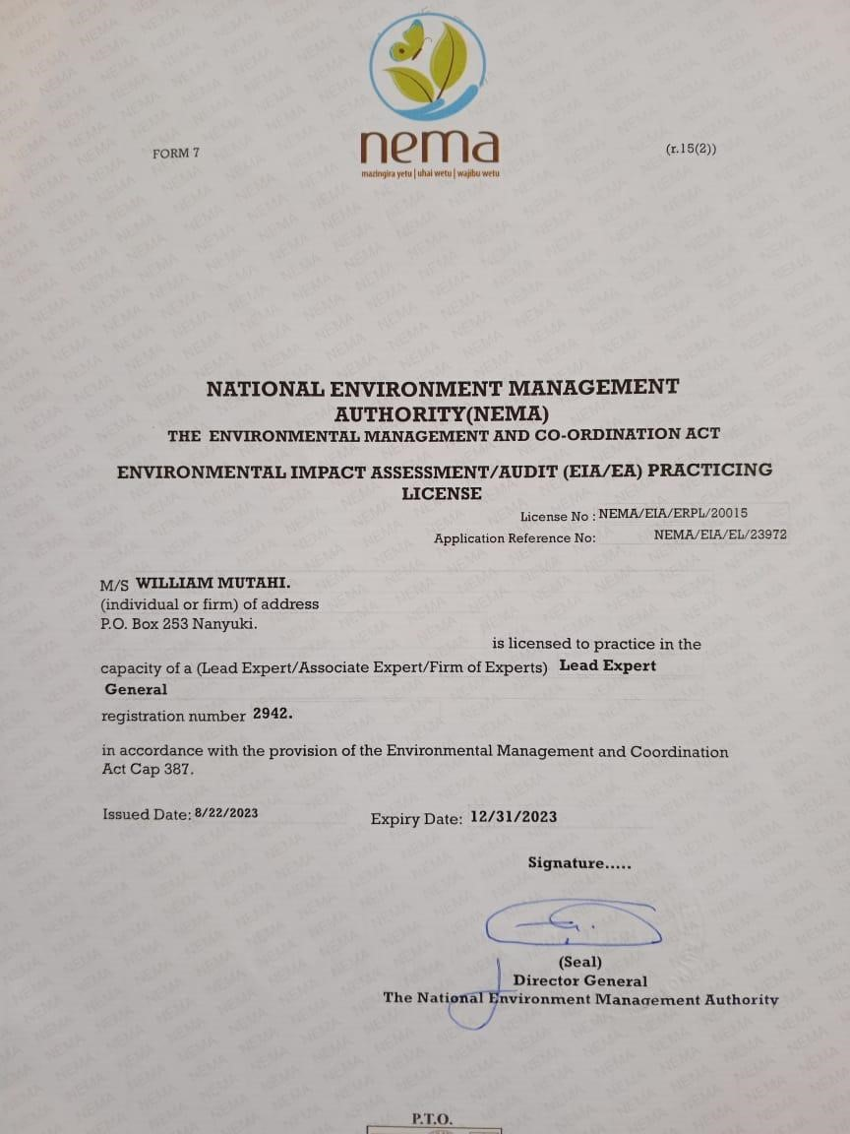

107

